UNITED STATES
SECURITIES AND EXCHANGE COMMISSION
Washington, D.C. 20549

FORM 6-K

REPORT OF FOREIGN PRIVATE ISSUER
PURSUANT TO RULE 13a-16 OR 15d-16 UNDER
THE SECURITIES EXCHANGE ACT OF 1934

For the month of January 2026

Commission File Number: 001-39436

KE Holdings Inc.
(Registrant’s Name)

Oriental Electronic Technology Building,
No. 2 Chuangye Road, Haidian District,
Beijing 100086
People’s Republic of China
(Address of Principal Executive Offices)

Indicate by check mark whether the registrant files or will file annual reports under cover Form 20-F or Form 40-F.

Form 20-F ☒ Form 40-F ☐

EXHIBIT INDEX

Exhibit No. |  | Description
99.1 |  | Next Day Disclosure Return Dated December 29, 2025
99.2 |  | Next Day Disclosure Return Dated December 30, 2025
99.3 |  | Next Day Disclosure Return Dated December 31, 2025
99.4 |  | Next Day Disclosure Return Dated January 2, 2026

SIGNATURES

Pursuant to the requirements of the Securities Exchange Act of 1934, the registrant has duly caused this report to be signed on its behalf by the undersigned, thereunto duly authorized.

 | KE Holdings Inc.
 | By | : | /s/ XU Tao
 | Name | : | XU Tao
 | Title | : | Chief Financial Officer

Date: January 5, 2026

Exhibit 99.1

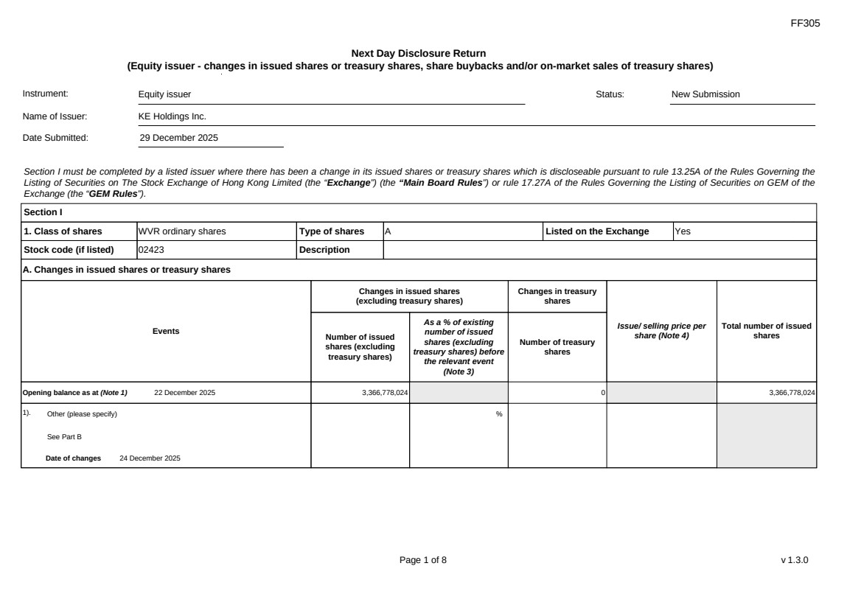 | FF305 Page 1 of 8 v 1.3.0 Next Day Disclosure Return (Equity issuer - changes in issued shares or treasury shares, share buybacks and/or on-market sales of treasury shares) Instrument: Equity issuer Status: New Submission Name of Issuer: KE Holdings Inc. Date Submitted: 29 December 2025 Section I must be completed by a listed issuer where there has been a change in its issued shares or treasury shares which is discloseable pursuant to rule 13.25A of the Rules Governing the Listing of Securities on The Stock Exchange of Hong Kong Limited (the “Exchange”) (the “Main Board Rules”) or rule 17.27A of the Rules Governing the Listing of Securities on GEM of the Exchange (the “GEM Rules”). Section I 1. Class of shares WVR ordinary shares Type of shares A Listed on the Exchange Yes Stock code (if listed) 02423 Description A. Changes in issued shares or treasury shares Events Changes in issued shares (excluding treasury shares) Number of issued shares (excluding treasury shares) As a % of existing number of issued shares (excluding treasury shares) before the relevant event (Note 3) Changes in treasury shares Number of treasury shares Issue/ selling price per share (Note 4) Total number of issued shares Opening balance as at (Note 1) 22 December 2025 3,366,778,024 0 3,366,778,024 1). Other (please specify) See Part B Date of changes 24 December 2025 %
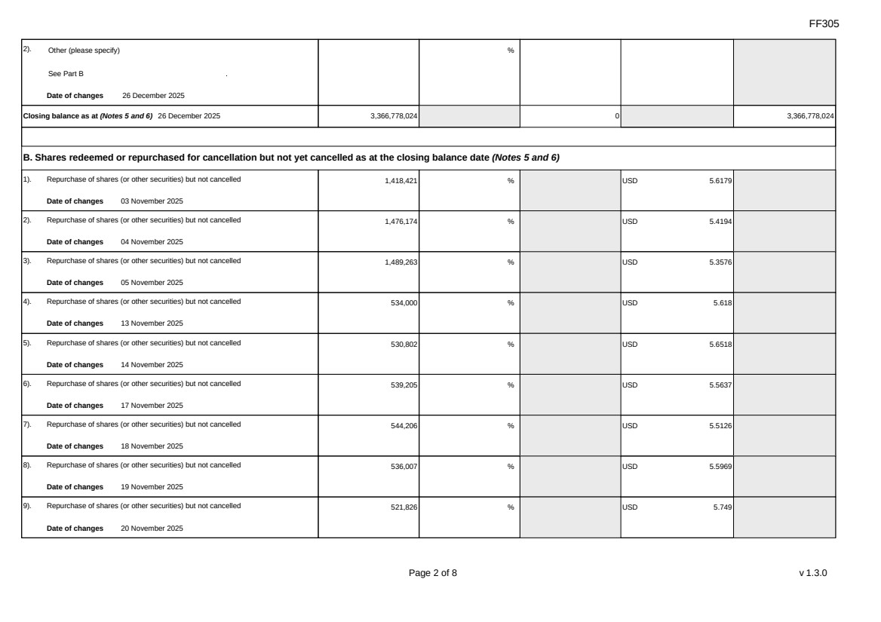 | FF305 Page 2 of 8 v 1.3.0 2). Other (please specify) See Part B Date of changes 26 December 2025 % Closing balance as at (Notes 5 and 6) 26 December 2025 3,366,778,024 0 3,366,778,024 B. Shares redeemed or repurchased for cancellation but not yet cancelled as at the closing balance date (Notes 5 and 6) 1). Repurchase of shares (or other securities) but not cancelled Date of changes 03 November 2025 1,418,421 % USD 5.6179 2). Repurchase of shares (or other securities) but not cancelled Date of changes 04 November 2025 1,476,174 % USD 5.4194 3). Repurchase of shares (or other securities) but not cancelled Date of changes 05 November 2025 1,489,263 % USD 5.3576 4). Repurchase of shares (or other securities) but not cancelled Date of changes 13 November 2025 534,000 % USD 5.618 5). Repurchase of shares (or other securities) but not cancelled Date of changes 14 November 2025 530,802 % USD 5.6518 6). Repurchase of shares (or other securities) but not cancelled Date of changes 17 November 2025 539,205 % USD 5.5637 7). Repurchase of shares (or other securities) but not cancelled Date of changes 18 November 2025 544,206 % USD 5.5126 8). Repurchase of shares (or other securities) but not cancelled Date of changes 19 November 2025 536,007 % USD 5.5969 9). Repurchase of shares (or other securities) but not cancelled Date of changes 20 November 2025 521,826 % USD 5.749
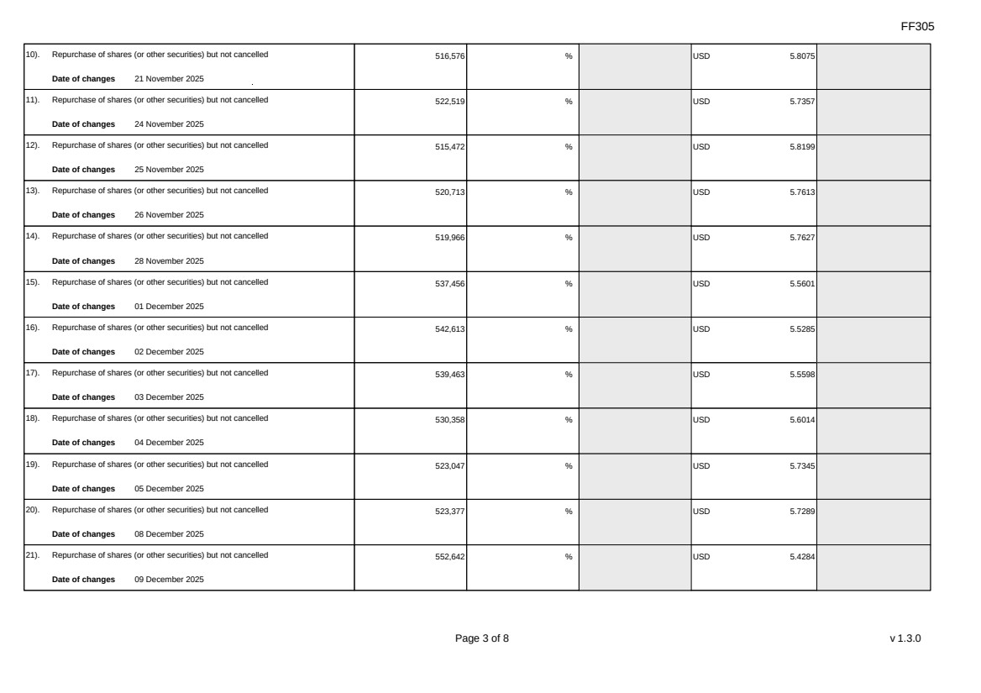 | FF305 Page 3 of 8 v 1.3.0 10). Repurchase of shares (or other securities) but not cancelled Date of changes 21 November 2025 516,576 % USD 5.8075 11). Repurchase of shares (or other securities) but not cancelled Date of changes 24 November 2025 522,519 % USD 5.7357 12). Repurchase of shares (or other securities) but not cancelled Date of changes 25 November 2025 515,472 % USD 5.8199 13). Repurchase of shares (or other securities) but not cancelled Date of changes 26 November 2025 520,713 % USD 5.7613 14). Repurchase of shares (or other securities) but not cancelled Date of changes 28 November 2025 519,966 % USD 5.7627 15). Repurchase of shares (or other securities) but not cancelled Date of changes 01 December 2025 537,456 % USD 5.5601 16). Repurchase of shares (or other securities) but not cancelled Date of changes 02 December 2025 542,613 % USD 5.5285 17). Repurchase of shares (or other securities) but not cancelled Date of changes 03 December 2025 539,463 % USD 5.5598 18). Repurchase of shares (or other securities) but not cancelled Date of changes 04 December 2025 530,358 % USD 5.6014 19). Repurchase of shares (or other securities) but not cancelled Date of changes 05 December 2025 523,047 % USD 5.7345 20). Repurchase of shares (or other securities) but not cancelled Date of changes 08 December 2025 523,377 % USD 5.7289 21). Repurchase of shares (or other securities) but not cancelled Date of changes 09 December 2025 552,642 % USD 5.4284
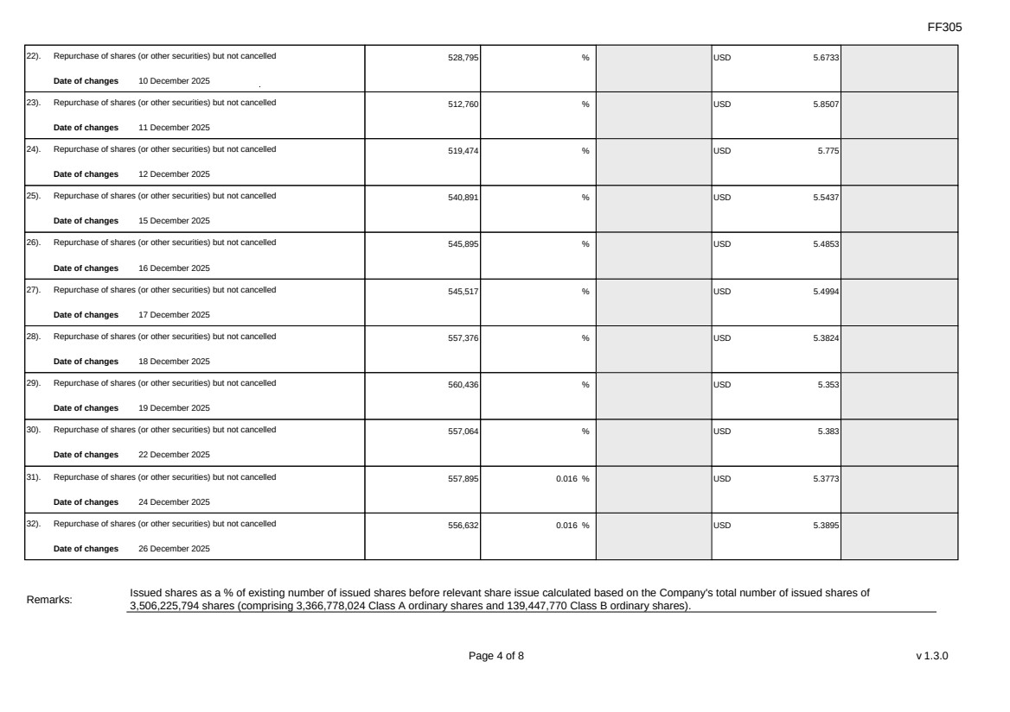 | FF305 Page 4 of 8 v 1.3.0 22). Repurchase of shares (or other securities) but not cancelled Date of changes 10 December 2025 528,795 % USD 5.6733 23). Repurchase of shares (or other securities) but not cancelled Date of changes 11 December 2025 512,760 % USD 5.8507 24). Repurchase of shares (or other securities) but not cancelled Date of changes 12 December 2025 519,474 % USD 5.775 25). Repurchase of shares (or other securities) but not cancelled Date of changes 15 December 2025 540,891 % USD 5.5437 26). Repurchase of shares (or other securities) but not cancelled Date of changes 16 December 2025 545,895 % USD 5.4853 27). Repurchase of shares (or other securities) but not cancelled Date of changes 17 December 2025 545,517 % USD 5.4994 28). Repurchase of shares (or other securities) but not cancelled Date of changes 18 December 2025 557,376 % USD 5.3824 29). Repurchase of shares (or other securities) but not cancelled Date of changes 19 December 2025 560,436 % USD 5.353 30). Repurchase of shares (or other securities) but not cancelled Date of changes 22 December 2025 557,064 % USD 5.383 31). Repurchase of shares (or other securities) but not cancelled Date of changes 24 December 2025 557,895 0.016 % USD 5.3773 32). Repurchase of shares (or other securities) but not cancelled Date of changes 26 December 2025 556,632 0.016 % USD 5.3895 Remarks: Issued shares as a % of existing number of issued shares before relevant share issue calculated based on the Company's total number of issued shares of 3,506,225,794 shares (comprising 3,366,778,024 Class A ordinary shares and 139,447,770 Class B ordinary shares).
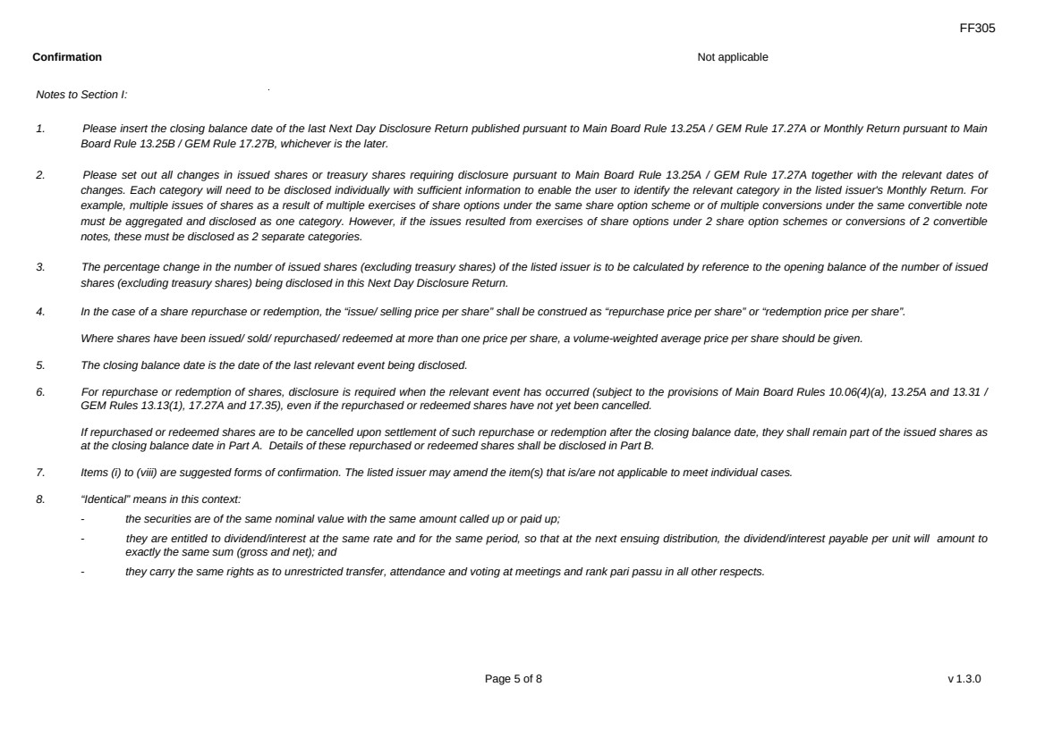 | FF305 Page 5 of 8 v 1.3.0 Confirmation Not applicable Notes to Section I: 1. Please insert the closing balance date of the last Next Day Disclosure Return published pursuant to Main Board Rule 13.25A / GEM Rule 17.27A or Monthly Return pursuant to Main Board Rule 13.25B / GEM Rule 17.27B, whichever is the later. 2. Please set out all changes in issued shares or treasury shares requiring disclosure pursuant to Main Board Rule 13.25A / GEM Rule 17.27A together with the relevant dates of changes. Each category will need to be disclosed individually with sufficient information to enable the user to identify the relevant category in the listed issuer's Monthly Return. For example, multiple issues of shares as a result of multiple exercises of share options under the same share option scheme or of multiple conversions under the same convertible note must be aggregated and disclosed as one category. However, if the issues resulted from exercises of share options under 2 share option schemes or conversions of 2 convertible notes, these must be disclosed as 2 separate categories. 3. The percentage change in the number of issued shares (excluding treasury shares) of the listed issuer is to be calculated by reference to the opening balance of the number of issued shares (excluding treasury shares) being disclosed in this Next Day Disclosure Return. 4. In the case of a share repurchase or redemption, the “issue/ selling price per share” shall be construed as “repurchase price per share” or “redemption price per share”. Where shares have been issued/ sold/ repurchased/ redeemed at more than one price per share, a volume-weighted average price per share should be given. 5. The closing balance date is the date of the last relevant event being disclosed. 6. For repurchase or redemption of shares, disclosure is required when the relevant event has occurred (subject to the provisions of Main Board Rules 10.06(4)(a), 13.25A and 13.31 / GEM Rules 13.13(1), 17.27A and 17.35), even if the repurchased or redeemed shares have not yet been cancelled. If repurchased or redeemed shares are to be cancelled upon settlement of such repurchase or redemption after the closing balance date, they shall remain part of the issued shares as at the closing balance date in Part A. Details of these repurchased or redeemed shares shall be disclosed in Part B. 7. Items (i) to (viii) are suggested forms of confirmation. The listed issuer may amend the item(s) that is/are not applicable to meet individual cases. 8. “Identical” means in this context: - the securities are of the same nominal value with the same amount called up or paid up; - they are entitled to dividend/interest at the same rate and for the same period, so that at the next ensuing distribution, the dividend/interest payable per unit will amount to exactly the same sum (gross and net); and - they carry the same rights as to unrestricted transfer, attendance and voting at meetings and rank pari passu in all other respects.
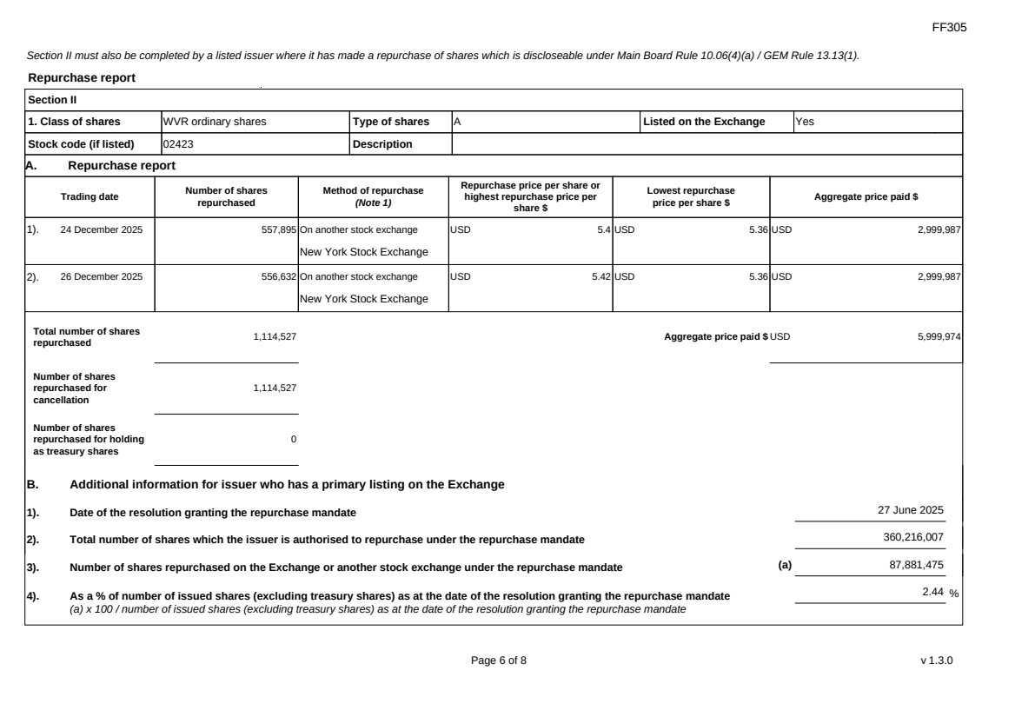 | FF305 Page 6 of 8 v 1.3.0 Section II must also be completed by a listed issuer where it has made a repurchase of shares which is discloseable under Main Board Rule 10.06(4)(a) / GEM Rule 13.13(1). Repurchase report Section II 1. Class of shares WVR ordinary shares Type of shares A Listed on the Exchange Yes Stock code (if listed) 02423 Description A. Repurchase report Trading date Number of shares repurchased Method of repurchase (Note 1) Repurchase price per share or highest repurchase price per share $ Lowest repurchase price per share $ Aggregate price paid $ 1). 24 December 2025 557,895 On another stock exchange New York Stock Exchange USD 5.4 USD 5.36 USD 2,999,987 2). 26 December 2025 556,632 On another stock exchange New York Stock Exchange USD 5.42 USD 5.36 USD 2,999,987 Total number of shares repurchased 1,114,527 Aggregate price paid $ USD 5,999,974 Number of shares repurchased for cancellation 1,114,527 Number of shares repurchased for holding as treasury shares 0 B. Additional information for issuer who has a primary listing on the Exchange 1). Date of the resolution granting the repurchase mandate 27 June 2025 2). Total number of shares which the issuer is authorised to repurchase under the repurchase mandate 360,216,007 3). Number of shares repurchased on the Exchange or another stock exchange under the repurchase mandate (a) 87,881,475 4). As a % of number of issued shares (excluding treasury shares) as at the date of the resolution granting the repurchase mandate (a) x 100 / number of issued shares (excluding treasury shares) as at the date of the resolution granting the repurchase mandate 2.44 %
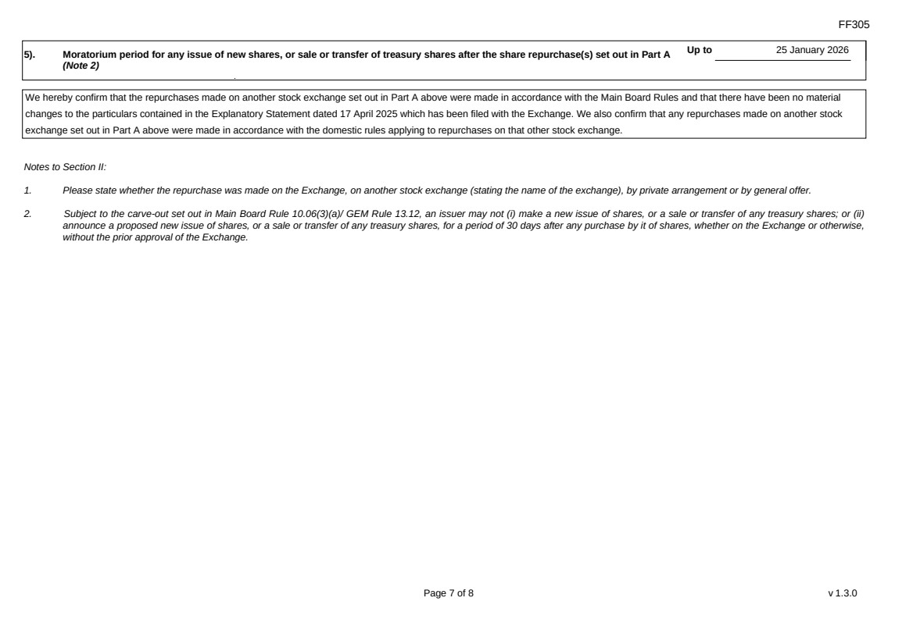 | FF305 Page 7 of 8 v 1.3.0 5). Moratorium period for any issue of new shares, or sale or transfer of treasury shares after the share repurchase(s) set out in Part A (Note 2) Up to 25 January 2026 We hereby confirm that the repurchases made on another stock exchange set out in Part A above were made in accordance with the Main Board Rules and that there have been no material changes to the particulars contained in the Explanatory Statement dated 17 April 2025 which has been filed with the Exchange. We also confirm that any repurchases made on another stock exchange set out in Part A above were made in accordance with the domestic rules applying to repurchases on that other stock exchange. Notes to Section II: 1. Please state whether the repurchase was made on the Exchange, on another stock exchange (stating the name of the exchange), by private arrangement or by general offer. 2. Subject to the carve-out set out in Main Board Rule 10.06(3)(a)/ GEM Rule 13.12, an issuer may not (i) make a new issue of shares, or a sale or transfer of any treasury shares; or (ii) announce a proposed new issue of shares, or a sale or transfer of any treasury shares, for a period of 30 days after any purchase by it of shares, whether on the Exchange or otherwise, without the prior approval of the Exchange.
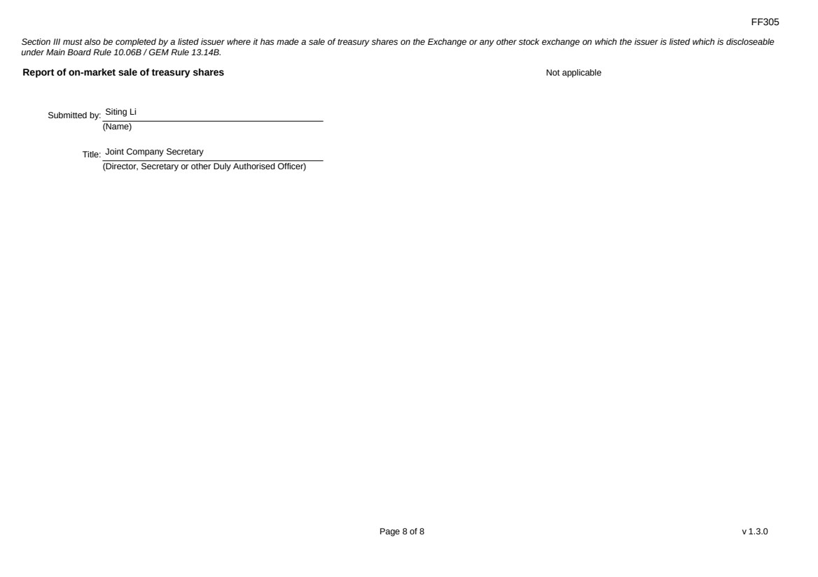 | FF305 Page 8 of 8 v 1.3.0 Section III must also be completed by a listed issuer where it has made a sale of treasury shares on the Exchange or any other stock exchange on which the issuer is listed which is discloseable under Main Board Rule 10.06B / GEM Rule 13.14B. Report of on-market sale of treasury shares Not applicable Submitted by: Siting Li (Name) Title: Joint Company Secretary (Director, Secretary or other Duly Authorised Officer)
Exhibit 99.2

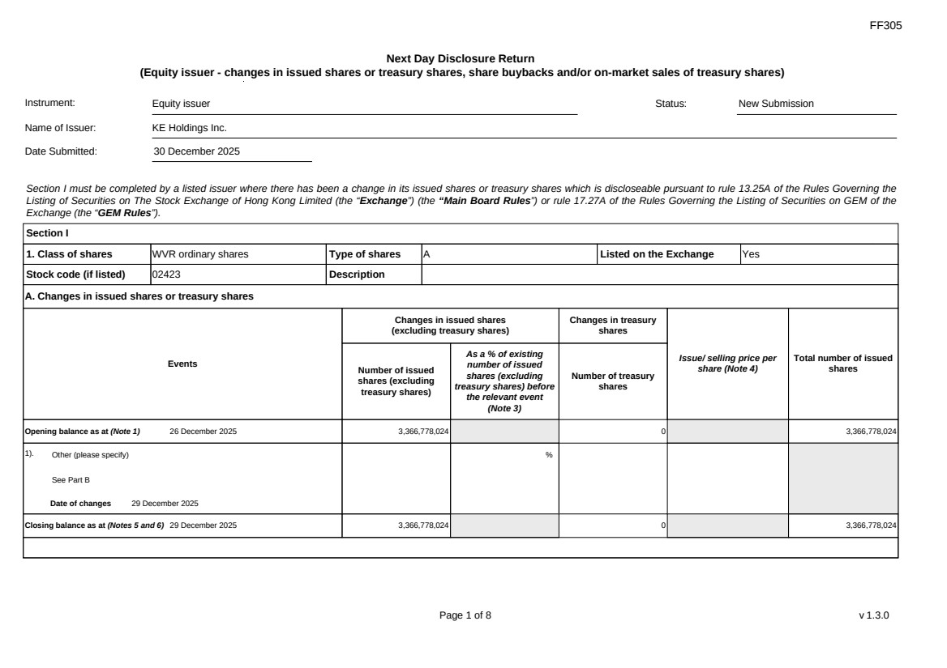 | FF305 Page 1 of 8 v 1.3.0 Next Day Disclosure Return (Equity issuer - changes in issued shares or treasury shares, share buybacks and/or on-market sales of treasury shares) Instrument: Equity issuer Status: New Submission Name of Issuer: KE Holdings Inc. Date Submitted: 30 December 2025 Section I must be completed by a listed issuer where there has been a change in its issued shares or treasury shares which is discloseable pursuant to rule 13.25A of the Rules Governing the Listing of Securities on The Stock Exchange of Hong Kong Limited (the “Exchange”) (the “Main Board Rules”) or rule 17.27A of the Rules Governing the Listing of Securities on GEM of the Exchange (the “GEM Rules”). Section I 1. Class of shares WVR ordinary shares Type of shares A Listed on the Exchange Yes Stock code (if listed) 02423 Description A. Changes in issued shares or treasury shares Events Changes in issued shares (excluding treasury shares) Number of issued shares (excluding treasury shares) As a % of existing number of issued shares (excluding treasury shares) before the relevant event (Note 3) Changes in treasury shares Number of treasury shares Issue/ selling price per share (Note 4) Total number of issued shares Opening balance as at (Note 1) 26 December 2025 3,366,778,024 0 3,366,778,024 1). Other (please specify) See Part B Date of changes 29 December 2025 % Closing balance as at (Notes 5 and 6) 29 December 2025 3,366,778,024 0 3,366,778,024
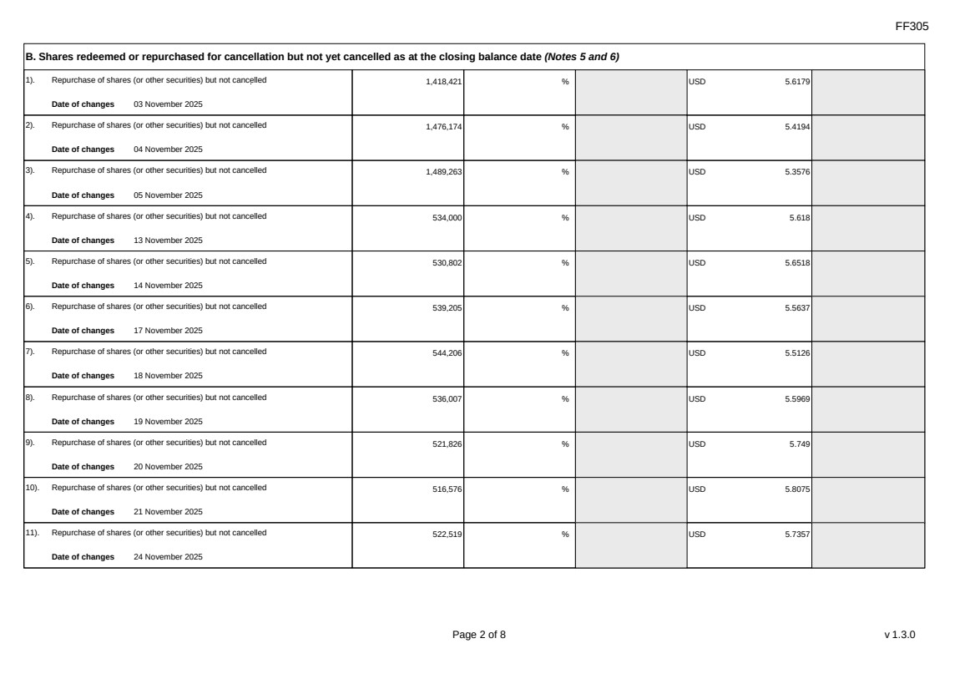 | FF305 Page 2 of 8 v 1.3.0 B. Shares redeemed or repurchased for cancellation but not yet cancelled as at the closing balance date (Notes 5 and 6) 1). Repurchase of shares (or other securities) but not cancelled Date of changes 03 November 2025 1,418,421 % USD 5.6179 2). Repurchase of shares (or other securities) but not cancelled Date of changes 04 November 2025 1,476,174 % USD 5.4194 3). Repurchase of shares (or other securities) but not cancelled Date of changes 05 November 2025 1,489,263 % USD 5.3576 4). Repurchase of shares (or other securities) but not cancelled Date of changes 13 November 2025 534,000 % USD 5.618 5). Repurchase of shares (or other securities) but not cancelled Date of changes 14 November 2025 530,802 % USD 5.6518 6). Repurchase of shares (or other securities) but not cancelled Date of changes 17 November 2025 539,205 % USD 5.5637 7). Repurchase of shares (or other securities) but not cancelled Date of changes 18 November 2025 544,206 % USD 5.5126 8). Repurchase of shares (or other securities) but not cancelled Date of changes 19 November 2025 536,007 % USD 5.5969 9). Repurchase of shares (or other securities) but not cancelled Date of changes 20 November 2025 521,826 % USD 5.749 10). Repurchase of shares (or other securities) but not cancelled Date of changes 21 November 2025 516,576 % USD 5.8075 11). Repurchase of shares (or other securities) but not cancelled Date of changes 24 November 2025 522,519 % USD 5.7357
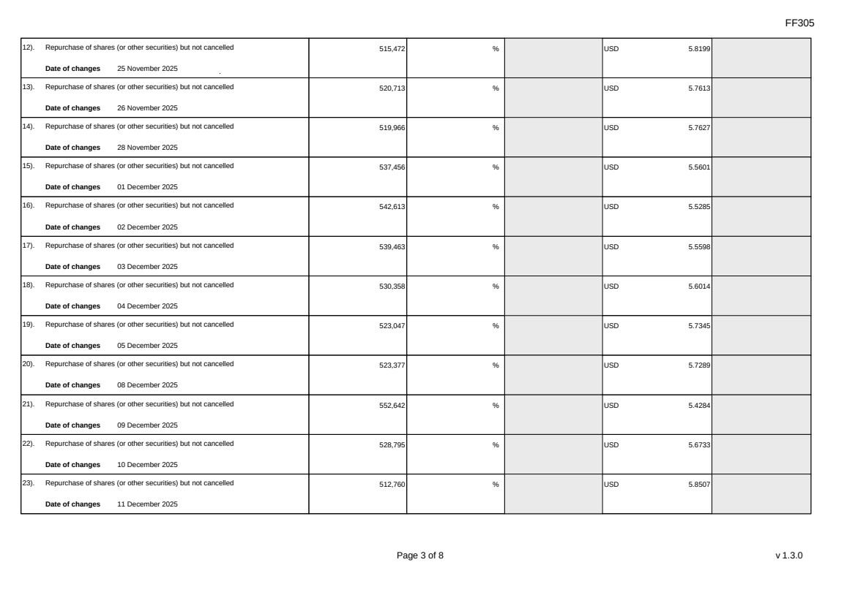 | FF305 Page 3 of 8 v 1.3.0 12). Repurchase of shares (or other securities) but not cancelled Date of changes 25 November 2025 515,472 % USD 5.8199 13). Repurchase of shares (or other securities) but not cancelled Date of changes 26 November 2025 520,713 % USD 5.7613 14). Repurchase of shares (or other securities) but not cancelled Date of changes 28 November 2025 519,966 % USD 5.7627 15). Repurchase of shares (or other securities) but not cancelled Date of changes 01 December 2025 537,456 % USD 5.5601 16). Repurchase of shares (or other securities) but not cancelled Date of changes 02 December 2025 542,613 % USD 5.5285 17). Repurchase of shares (or other securities) but not cancelled Date of changes 03 December 2025 539,463 % USD 5.5598 18). Repurchase of shares (or other securities) but not cancelled Date of changes 04 December 2025 530,358 % USD 5.6014 19). Repurchase of shares (or other securities) but not cancelled Date of changes 05 December 2025 523,047 % USD 5.7345 20). Repurchase of shares (or other securities) but not cancelled Date of changes 08 December 2025 523,377 % USD 5.7289 21). Repurchase of shares (or other securities) but not cancelled Date of changes 09 December 2025 552,642 % USD 5.4284 22). Repurchase of shares (or other securities) but not cancelled Date of changes 10 December 2025 528,795 % USD 5.6733 23). Repurchase of shares (or other securities) but not cancelled Date of changes 11 December 2025 512,760 % USD 5.8507
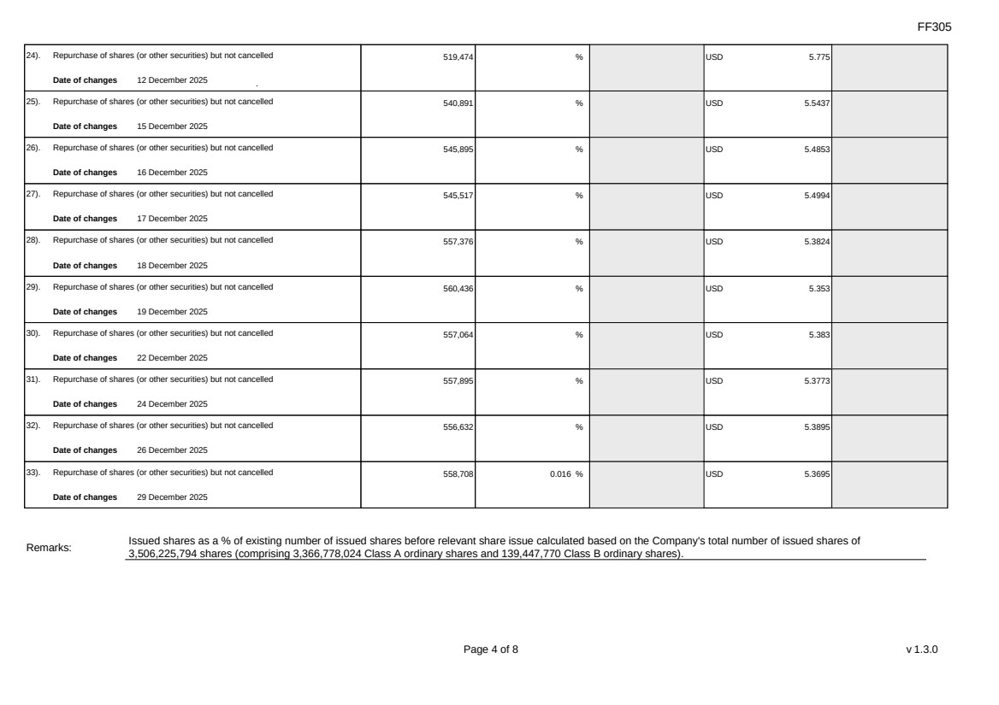 | FF305 Page 4 of 8 v 1.3.0 24). Repurchase of shares (or other securities) but not cancelled Date of changes 12 December 2025 519,474 % USD 5.775 25). Repurchase of shares (or other securities) but not cancelled Date of changes 15 December 2025 540,891 % USD 5.5437 26). Repurchase of shares (or other securities) but not cancelled Date of changes 16 December 2025 545,895 % USD 5.4853 27). Repurchase of shares (or other securities) but not cancelled Date of changes 17 December 2025 545,517 % USD 5.4994 28). Repurchase of shares (or other securities) but not cancelled Date of changes 18 December 2025 557,376 % USD 5.3824 29). Repurchase of shares (or other securities) but not cancelled Date of changes 19 December 2025 560,436 % USD 5.353 30). Repurchase of shares (or other securities) but not cancelled Date of changes 22 December 2025 557,064 % USD 5.383 31). Repurchase of shares (or other securities) but not cancelled Date of changes 24 December 2025 557,895 % USD 5.3773 32). Repurchase of shares (or other securities) but not cancelled Date of changes 26 December 2025 556,632 % USD 5.3895 33). Repurchase of shares (or other securities) but not cancelled Date of changes 29 December 2025 558,708 0.016 % USD 5.3695 Remarks: Issued shares as a % of existing number of issued shares before relevant share issue calculated based on the Company's total number of issued shares of 3,506,225,794 shares (comprising 3,366,778,024 Class A ordinary shares and 139,447,770 Class B ordinary shares).
FF305 Page 5 of 8 v 1.3.0 Confirmation Not applicable Notes to Section I: 1. Please insert the closing balance date of the last Next Day Disclosure Return published pursuant to Main Board Rule 13.25A / GEM Rule 17.27A or Monthly Return pursuant to Main Board Rule 13.25B / GEM Rule 17.27B, whichever is the later. 2. Please set out all changes in issued shares or treasury shares requiring disclosure pursuant to Main Board Rule 13.25A / GEM Rule 17.27A together with the relevant dates of changes. Each category will need to be disclosed individually with sufficient information to enable the user to identify the relevant category in the listed issuer's Monthly Return. For example, multiple issues of shares as a result of multiple exercises of share options under the same share option scheme or of multiple conversions under the same convertible note must be aggregated and disclosed as one category. However, if the issues resulted from exercises of share options under 2 share option schemes or conversions of 2 convertible notes, these must be disclosed as 2 separate categories. 3. The percentage change in the number of issued shares (excluding treasury shares) of the listed issuer is to be calculated by reference to the opening balance of the number of issued shares (excluding treasury shares) being disclosed in this Next Day Disclosure Return. 4. In the case of a share repurchase or redemption, the “issue/ selling price per share” shall be construed as “repurchase price per share” or “redemption price per share”. Where shares have been issued/ sold/ repurchased/ redeemed at more than one price per share, a volume-weighted average price per share should be given. 5. The closing balance date is the date of the last relevant event being disclosed. 6. For repurchase or redemption of shares, disclosure is required when the relevant event has occurred (subject to the provisions of Main Board Rules 10.06(4)(a), 13.25A and 13.31 / GEM Rules 13.13(1), 17.27A and 17.35), even if the repurchased or redeemed shares have not yet been cancelled. If repurchased or redeemed shares are to be cancelled upon settlement of such repurchase or redemption after the closing balance date, they shall remain part of the issued shares as at the closing balance date in Part A. Details of these repurchased or redeemed shares shall be disclosed in Part B. 7. Items (i) to (viii) are suggested forms of confirmation. The listed issuer may amend the item(s) that is/are not applicable to meet individual cases. 8. “Identical” means in this context: - the securities are of the same nominal value with the same amount called up or paid up; - they are entitled to dividend/interest at the same rate and for the same period, so that at the next ensuing distribution, the dividend/interest payable per unit will amount to exactly the same sum (gross and net); and - they carry the same rights as to unrestricted transfer, attendance and voting at meetings and rank pari passu in all other respects.
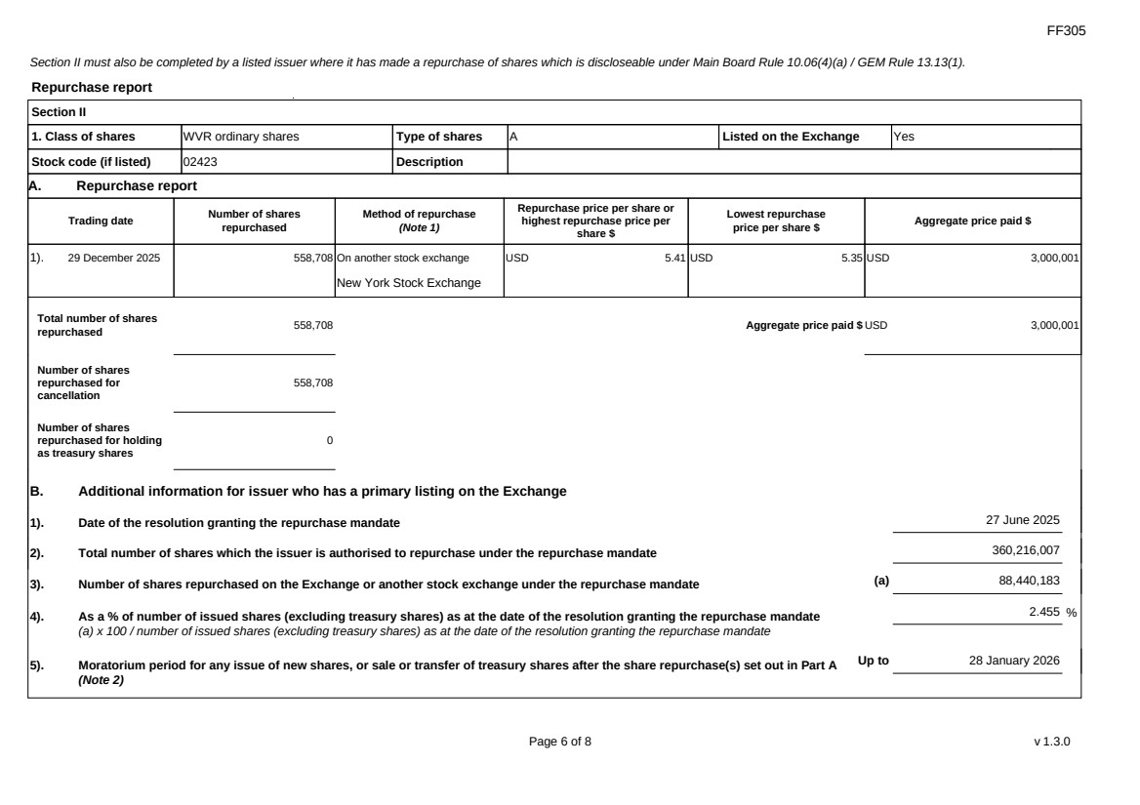 | FF305 Page 6 of 8 v 1.3.0 Section II must also be completed by a listed issuer where it has made a repurchase of shares which is discloseable under Main Board Rule 10.06(4)(a) / GEM Rule 13.13(1). Repurchase report Section II 1. Class of shares WVR ordinary shares Type of shares A Listed on the Exchange Yes Stock code (if listed) 02423 Description A. Repurchase report Trading date Number of shares repurchased Method of repurchase (Note 1) Repurchase price per share or highest repurchase price per share $ Lowest repurchase price per share $ Aggregate price paid $ 1). 29 December 2025 558,708 On another stock exchange New York Stock Exchange USD 5.41 USD 5.35 USD 3,000,001 Total number of shares repurchased 558,708 Aggregate price paid $ USD 3,000,001 Number of shares repurchased for cancellation 558,708 Number of shares repurchased for holding as treasury shares 0 B. Additional information for issuer who has a primary listing on the Exchange 1). Date of the resolution granting the repurchase mandate 27 June 2025 2). Total number of shares which the issuer is authorised to repurchase under the repurchase mandate 360,216,007 3). Number of shares repurchased on the Exchange or another stock exchange under the repurchase mandate (a) 88,440,183 4). As a % of number of issued shares (excluding treasury shares) as at the date of the resolution granting the repurchase mandate (a) x 100 / number of issued shares (excluding treasury shares) as at the date of the resolution granting the repurchase mandate 2.455 % 5). Moratorium period for any issue of new shares, or sale or transfer of treasury shares after the share repurchase(s) set out in Part A (Note 2) Up to 28 January 2026
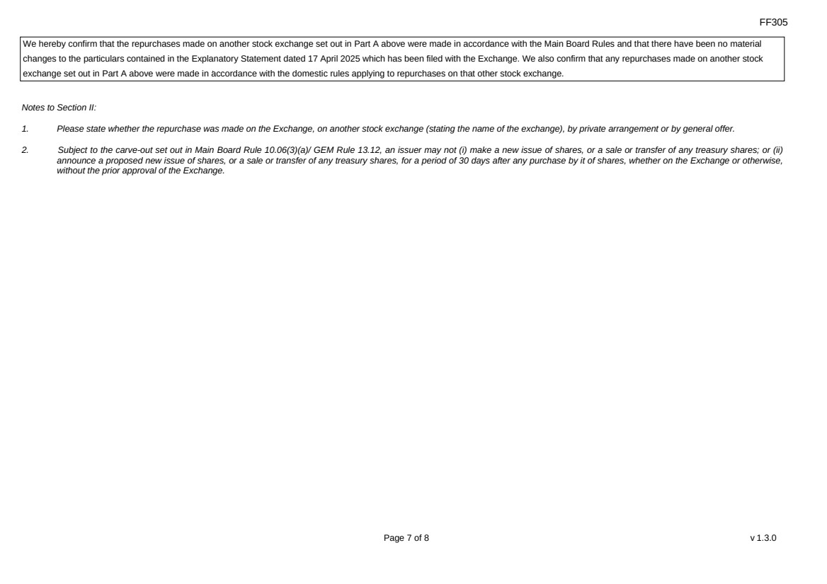 | FF305 Page 7 of 8 v 1.3.0 We hereby confirm that the repurchases made on another stock exchange set out in Part A above were made in accordance with the Main Board Rules and that there have been no material changes to the particulars contained in the Explanatory Statement dated 17 April 2025 which has been filed with the Exchange. We also confirm that any repurchases made on another stock exchange set out in Part A above were made in accordance with the domestic rules applying to repurchases on that other stock exchange. Notes to Section II: 1. Please state whether the repurchase was made on the Exchange, on another stock exchange (stating the name of the exchange), by private arrangement or by general offer. 2. Subject to the carve-out set out in Main Board Rule 10.06(3)(a)/ GEM Rule 13.12, an issuer may not (i) make a new issue of shares, or a sale or transfer of any treasury shares; or (ii) announce a proposed new issue of shares, or a sale or transfer of any treasury shares, for a period of 30 days after any purchase by it of shares, whether on the Exchange or otherwise, without the prior approval of the Exchange.
FF305 Page 8 of 8 v 1.3.0 Section III must also be completed by a listed issuer where it has made a sale of treasury shares on the Exchange or any other stock exchange on which the issuer is listed which is discloseable under Main Board Rule 10.06B / GEM Rule 13.14B. Report of on-market sale of treasury shares Not applicable Submitted by: Siting Li (Name) Title: Joint Company Secretary (Director, Secretary or other Duly Authorised Officer)
Exhibit 99.3

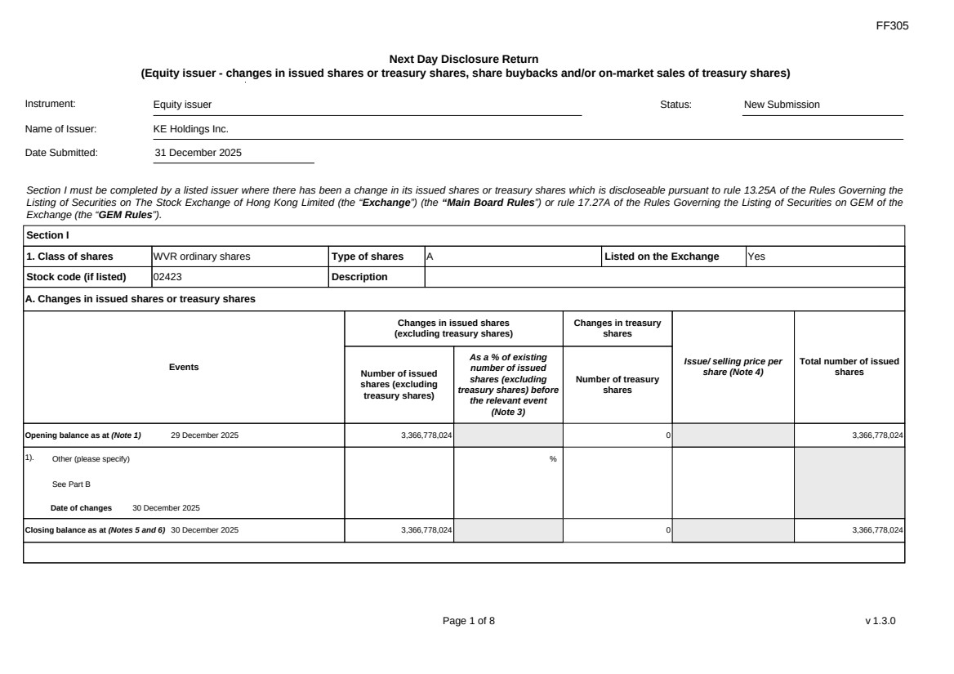 | FF305 Page 1 of 8 v 1.3.0 Next Day Disclosure Return (Equity issuer - changes in issued shares or treasury shares, share buybacks and/or on-market sales of treasury shares) Instrument: Equity issuer Status: New Submission Name of Issuer: KE Holdings Inc. Date Submitted: 31 December 2025 Section I must be completed by a listed issuer where there has been a change in its issued shares or treasury shares which is discloseable pursuant to rule 13.25A of the Rules Governing the Listing of Securities on The Stock Exchange of Hong Kong Limited (the “Exchange”) (the “Main Board Rules”) or rule 17.27A of the Rules Governing the Listing of Securities on GEM of the Exchange (the “GEM Rules”). Section I 1. Class of shares WVR ordinary shares Type of shares A Listed on the Exchange Yes Stock code (if listed) 02423 Description A. Changes in issued shares or treasury shares Events Changes in issued shares (excluding treasury shares) Number of issued shares (excluding treasury shares) As a % of existing number of issued shares (excluding treasury shares) before the relevant event (Note 3) Changes in treasury shares Number of treasury shares Issue/ selling price per share (Note 4) Total number of issued shares Opening balance as at (Note 1) 29 December 2025 3,366,778,024 0 3,366,778,024 1). Other (please specify) See Part B Date of changes 30 December 2025 % Closing balance as at (Notes 5 and 6) 30 December 2025 3,366,778,024 0 3,366,778,024
FF305 Page 2 of 8 v 1.3.0 B. Shares redeemed or repurchased for cancellation but not yet cancelled as at the closing balance date (Notes 5 and 6) 1). Repurchase of shares (or other securities) but not cancelled Date of changes 03 November 2025 1,418,421 % USD 5.6179 2). Repurchase of shares (or other securities) but not cancelled Date of changes 04 November 2025 1,476,174 % USD 5.4194 3). Repurchase of shares (or other securities) but not cancelled Date of changes 05 November 2025 1,489,263 % USD 5.3576 4). Repurchase of shares (or other securities) but not cancelled Date of changes 13 November 2025 534,000 % USD 5.618 5). Repurchase of shares (or other securities) but not cancelled Date of changes 14 November 2025 530,802 % USD 5.6518 6). Repurchase of shares (or other securities) but not cancelled Date of changes 17 November 2025 539,205 % USD 5.5637 7). Repurchase of shares (or other securities) but not cancelled Date of changes 18 November 2025 544,206 % USD 5.5126 8). Repurchase of shares (or other securities) but not cancelled Date of changes 19 November 2025 536,007 % USD 5.5969 9). Repurchase of shares (or other securities) but not cancelled Date of changes 20 November 2025 521,826 % USD 5.749 10). Repurchase of shares (or other securities) but not cancelled Date of changes 21 November 2025 516,576 % USD 5.8075 11). Repurchase of shares (or other securities) but not cancelled Date of changes 24 November 2025 522,519 % USD 5.7357
FF305 Page 3 of 8 v 1.3.0 12). Repurchase of shares (or other securities) but not cancelled Date of changes 25 November 2025 515,472 % USD 5.8199 13). Repurchase of shares (or other securities) but not cancelled Date of changes 26 November 2025 520,713 % USD 5.7613 14). Repurchase of shares (or other securities) but not cancelled Date of changes 28 November 2025 519,966 % USD 5.7627 15). Repurchase of shares (or other securities) but not cancelled Date of changes 01 December 2025 537,456 % USD 5.5601 16). Repurchase of shares (or other securities) but not cancelled Date of changes 02 December 2025 542,613 % USD 5.5285 17). Repurchase of shares (or other securities) but not cancelled Date of changes 03 December 2025 539,463 % USD 5.5598 18). Repurchase of shares (or other securities) but not cancelled Date of changes 04 December 2025 530,358 % USD 5.6014 19). Repurchase of shares (or other securities) but not cancelled Date of changes 05 December 2025 523,047 % USD 5.7345 20). Repurchase of shares (or other securities) but not cancelled Date of changes 08 December 2025 523,377 % USD 5.7289 21). Repurchase of shares (or other securities) but not cancelled Date of changes 09 December 2025 552,642 % USD 5.4284 22). Repurchase of shares (or other securities) but not cancelled Date of changes 10 December 2025 528,795 % USD 5.6733 23). Repurchase of shares (or other securities) but not cancelled Date of changes 11 December 2025 512,760 % USD 5.8507
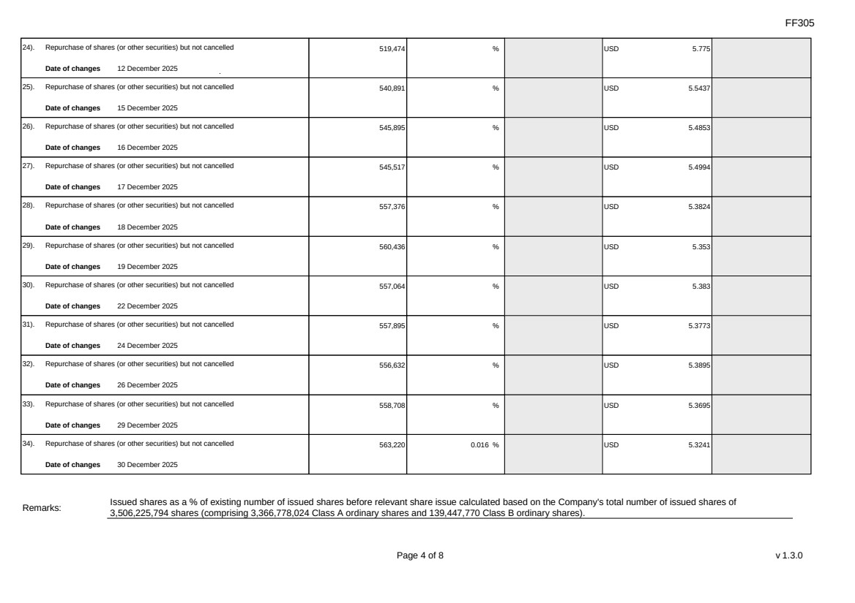 | FF305 Page 4 of 8 v 1.3.0 24). Repurchase of shares (or other securities) but not cancelled Date of changes 12 December 2025 519,474 % USD 5.775 25). Repurchase of shares (or other securities) but not cancelled Date of changes 15 December 2025 540,891 % USD 5.5437 26). Repurchase of shares (or other securities) but not cancelled Date of changes 16 December 2025 545,895 % USD 5.4853 27). Repurchase of shares (or other securities) but not cancelled Date of changes 17 December 2025 545,517 % USD 5.4994 28). Repurchase of shares (or other securities) but not cancelled Date of changes 18 December 2025 557,376 % USD 5.3824 29). Repurchase of shares (or other securities) but not cancelled Date of changes 19 December 2025 560,436 % USD 5.353 30). Repurchase of shares (or other securities) but not cancelled Date of changes 22 December 2025 557,064 % USD 5.383 31). Repurchase of shares (or other securities) but not cancelled Date of changes 24 December 2025 557,895 % USD 5.3773 32). Repurchase of shares (or other securities) but not cancelled Date of changes 26 December 2025 556,632 % USD 5.3895 33). Repurchase of shares (or other securities) but not cancelled Date of changes 29 December 2025 558,708 % USD 5.3695 34). Repurchase of shares (or other securities) but not cancelled Date of changes 30 December 2025 563,220 0.016 % USD 5.3241 Remarks: Issued shares as a % of existing number of issued shares before relevant share issue calculated based on the Company's total number of issued shares of 3,506,225,794 shares (comprising 3,366,778,024 Class A ordinary shares and 139,447,770 Class B ordinary shares).
FF305 Page 5 of 8 v 1.3.0 Confirmation Not applicable Notes to Section I: 1. Please insert the closing balance date of the last Next Day Disclosure Return published pursuant to Main Board Rule 13.25A / GEM Rule 17.27A or Monthly Return pursuant to Main Board Rule 13.25B / GEM Rule 17.27B, whichever is the later. 2. Please set out all changes in issued shares or treasury shares requiring disclosure pursuant to Main Board Rule 13.25A / GEM Rule 17.27A together with the relevant dates of changes. Each category will need to be disclosed individually with sufficient information to enable the user to identify the relevant category in the listed issuer's Monthly Return. For example, multiple issues of shares as a result of multiple exercises of share options under the same share option scheme or of multiple conversions under the same convertible note must be aggregated and disclosed as one category. However, if the issues resulted from exercises of share options under 2 share option schemes or conversions of 2 convertible notes, these must be disclosed as 2 separate categories. 3. The percentage change in the number of issued shares (excluding treasury shares) of the listed issuer is to be calculated by reference to the opening balance of the number of issued shares (excluding treasury shares) being disclosed in this Next Day Disclosure Return. 4. In the case of a share repurchase or redemption, the “issue/ selling price per share” shall be construed as “repurchase price per share” or “redemption price per share”. Where shares have been issued/ sold/ repurchased/ redeemed at more than one price per share, a volume-weighted average price per share should be given. 5. The closing balance date is the date of the last relevant event being disclosed. 6. For repurchase or redemption of shares, disclosure is required when the relevant event has occurred (subject to the provisions of Main Board Rules 10.06(4)(a), 13.25A and 13.31 / GEM Rules 13.13(1), 17.27A and 17.35), even if the repurchased or redeemed shares have not yet been cancelled. If repurchased or redeemed shares are to be cancelled upon settlement of such repurchase or redemption after the closing balance date, they shall remain part of the issued shares as at the closing balance date in Part A. Details of these repurchased or redeemed shares shall be disclosed in Part B. 7. Items (i) to (viii) are suggested forms of confirmation. The listed issuer may amend the item(s) that is/are not applicable to meet individual cases. 8. “Identical” means in this context: - the securities are of the same nominal value with the same amount called up or paid up; - they are entitled to dividend/interest at the same rate and for the same period, so that at the next ensuing distribution, the dividend/interest payable per unit will amount to exactly the same sum (gross and net); and - they carry the same rights as to unrestricted transfer, attendance and voting at meetings and rank pari passu in all other respects.
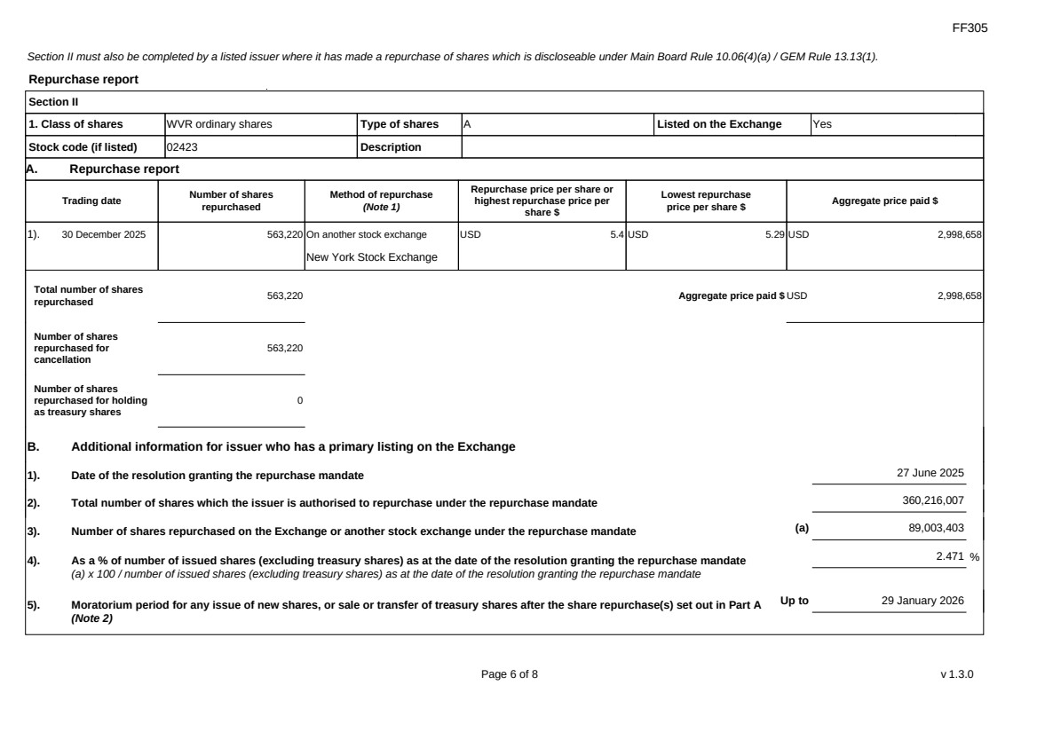 | FF305 Page 6 of 8 v 1.3.0 Section II must also be completed by a listed issuer where it has made a repurchase of shares which is discloseable under Main Board Rule 10.06(4)(a) / GEM Rule 13.13(1). Repurchase report Section II 1. Class of shares WVR ordinary shares Type of shares A Listed on the Exchange Yes Stock code (if listed) 02423 Description A. Repurchase report Trading date Number of shares repurchased Method of repurchase (Note 1) Repurchase price per share or highest repurchase price per share $ Lowest repurchase price per share $ Aggregate price paid $ 1). 30 December 2025 563,220 On another stock exchange New York Stock Exchange USD 5.4 USD 5.29 USD 2,998,658 Total number of shares repurchased 563,220 Aggregate price paid $ USD 2,998,658 Number of shares repurchased for cancellation 563,220 Number of shares repurchased for holding as treasury shares 0 B. Additional information for issuer who has a primary listing on the Exchange 1). Date of the resolution granting the repurchase mandate 27 June 2025 2). Total number of shares which the issuer is authorised to repurchase under the repurchase mandate 360,216,007 3). Number of shares repurchased on the Exchange or another stock exchange under the repurchase mandate (a) 89,003,403 4). As a % of number of issued shares (excluding treasury shares) as at the date of the resolution granting the repurchase mandate (a) x 100 / number of issued shares (excluding treasury shares) as at the date of the resolution granting the repurchase mandate 2.471 % 5). Moratorium period for any issue of new shares, or sale or transfer of treasury shares after the share repurchase(s) set out in Part A (Note 2) Up to 29 January 2026
FF305 Page 7 of 8 v 1.3.0 We hereby confirm that the repurchases made on another stock exchange set out in Part A above were made in accordance with the Main Board Rules and that there have been no material changes to the particulars contained in the Explanatory Statement dated 17 April 2025 which has been filed with the Exchange. We also confirm that any repurchases made on another stock exchange set out in Part A above were made in accordance with the domestic rules applying to repurchases on that other stock exchange. Notes to Section II: 1. Please state whether the repurchase was made on the Exchange, on another stock exchange (stating the name of the exchange), by private arrangement or by general offer. 2. Subject to the carve-out set out in Main Board Rule 10.06(3)(a)/ GEM Rule 13.12, an issuer may not (i) make a new issue of shares, or a sale or transfer of any treasury shares; or (ii) announce a proposed new issue of shares, or a sale or transfer of any treasury shares, for a period of 30 days after any purchase by it of shares, whether on the Exchange or otherwise, without the prior approval of the Exchange.
FF305 Page 8 of 8 v 1.3.0 Section III must also be completed by a listed issuer where it has made a sale of treasury shares on the Exchange or any other stock exchange on which the issuer is listed which is discloseable under Main Board Rule 10.06B / GEM Rule 13.14B. Report of on-market sale of treasury shares Not applicable Submitted by: Siting Li (Name) Title: Joint Company Secretary (Director, Secretary or other Duly Authorised Officer)
Exhibit 99.4

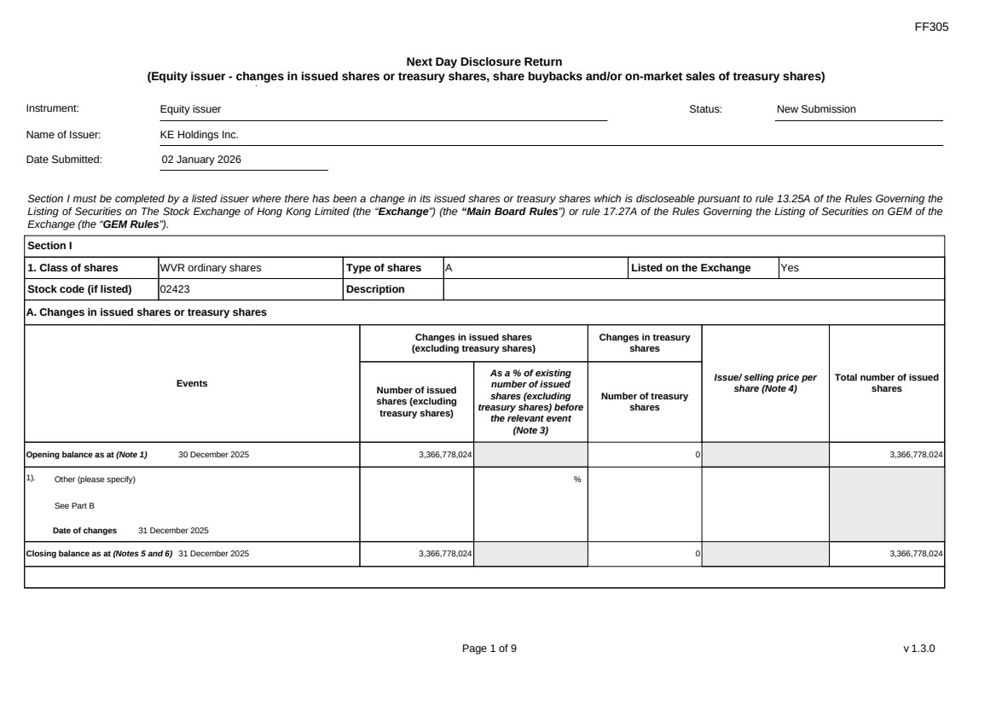 | FF305 Page 1 of 9 v 1.3.0 Next Day Disclosure Return (Equity issuer - changes in issued shares or treasury shares, share buybacks and/or on-market sales of treasury shares) Instrument: Equity issuer Status: New Submission Name of Issuer: KE Holdings Inc. Date Submitted: 02 January 2026 Section I must be completed by a listed issuer where there has been a change in its issued shares or treasury shares which is discloseable pursuant to rule 13.25A of the Rules Governing the Listing of Securities on The Stock Exchange of Hong Kong Limited (the “Exchange”) (the “Main Board Rules”) or rule 17.27A of the Rules Governing the Listing of Securities on GEM of the Exchange (the “GEM Rules”). Section I 1. Class of shares WVR ordinary shares Type of shares A Listed on the Exchange Yes Stock code (if listed) 02423 Description A. Changes in issued shares or treasury shares Events Changes in issued shares (excluding treasury shares) Number of issued shares (excluding treasury shares) As a % of existing number of issued shares (excluding treasury shares) before the relevant event (Note 3) Changes in treasury shares Number of treasury shares Issue/ selling price per share (Note 4) Total number of issued shares Opening balance as at (Note 1) 30 December 2025 3,366,778,024 0 3,366,778,024 1). Other (please specify) See Part B Date of changes 31 December 2025 % Closing balance as at (Notes 5 and 6) 31 December 2025 3,366,778,024 0 3,366,778,024
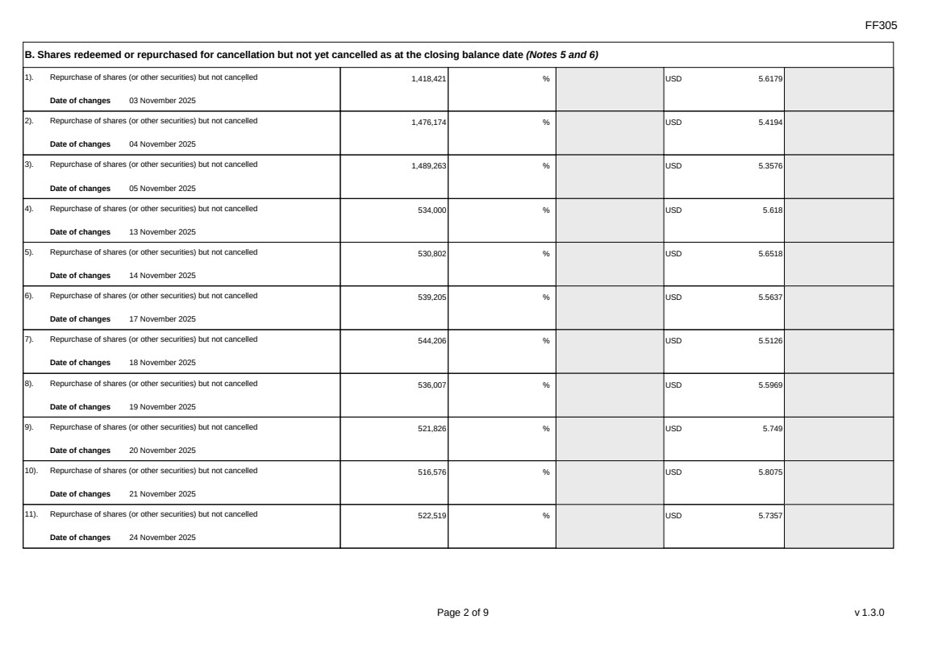 | FF305 Page 2 of 9 v 1.3.0 B. Shares redeemed or repurchased for cancellation but not yet cancelled as at the closing balance date (Notes 5 and 6) 1). Repurchase of shares (or other securities) but not cancelled Date of changes 03 November 2025 1,418,421 % USD 5.6179 2). Repurchase of shares (or other securities) but not cancelled Date of changes 04 November 2025 1,476,174 % USD 5.4194 3). Repurchase of shares (or other securities) but not cancelled Date of changes 05 November 2025 1,489,263 % USD 5.3576 4). Repurchase of shares (or other securities) but not cancelled Date of changes 13 November 2025 534,000 % USD 5.618 5). Repurchase of shares (or other securities) but not cancelled Date of changes 14 November 2025 530,802 % USD 5.6518 6). Repurchase of shares (or other securities) but not cancelled Date of changes 17 November 2025 539,205 % USD 5.5637 7). Repurchase of shares (or other securities) but not cancelled Date of changes 18 November 2025 544,206 % USD 5.5126 8). Repurchase of shares (or other securities) but not cancelled Date of changes 19 November 2025 536,007 % USD 5.5969 9). Repurchase of shares (or other securities) but not cancelled Date of changes 20 November 2025 521,826 % USD 5.749 10). Repurchase of shares (or other securities) but not cancelled Date of changes 21 November 2025 516,576 % USD 5.8075 11). Repurchase of shares (or other securities) but not cancelled Date of changes 24 November 2025 522,519 % USD 5.7357
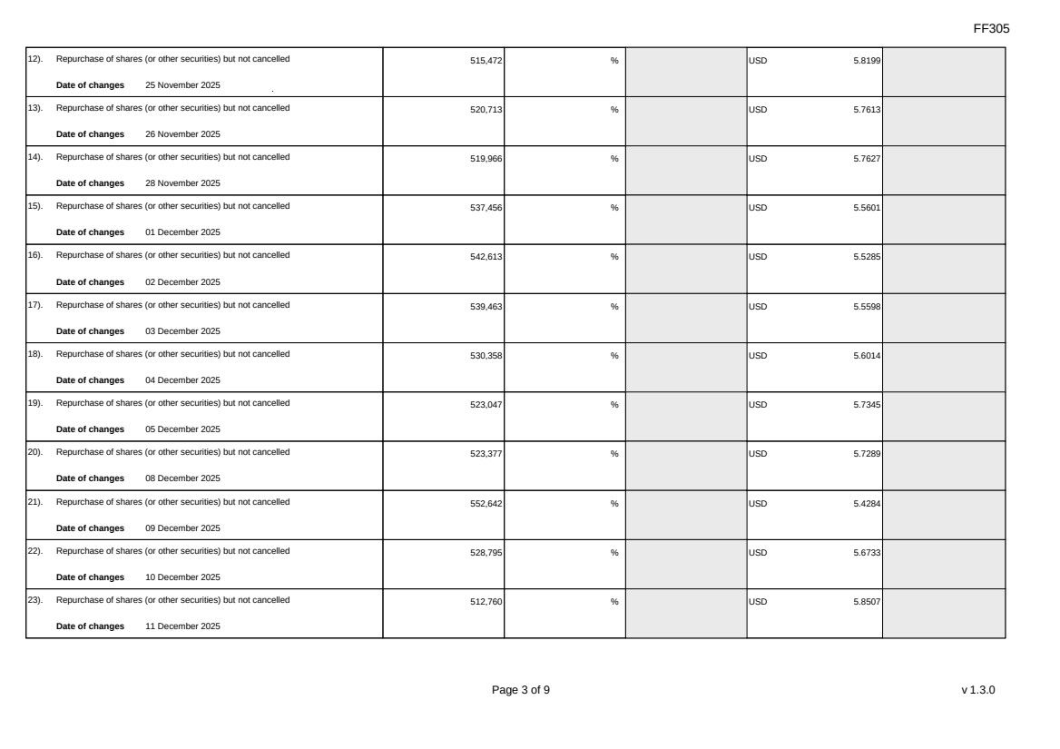 | FF305 Page 3 of 9 v 1.3.0 12). Repurchase of shares (or other securities) but not cancelled Date of changes 25 November 2025 515,472 % USD 5.8199 13). Repurchase of shares (or other securities) but not cancelled Date of changes 26 November 2025 520,713 % USD 5.7613 14). Repurchase of shares (or other securities) but not cancelled Date of changes 28 November 2025 519,966 % USD 5.7627 15). Repurchase of shares (or other securities) but not cancelled Date of changes 01 December 2025 537,456 % USD 5.5601 16). Repurchase of shares (or other securities) but not cancelled Date of changes 02 December 2025 542,613 % USD 5.5285 17). Repurchase of shares (or other securities) but not cancelled Date of changes 03 December 2025 539,463 % USD 5.5598 18). Repurchase of shares (or other securities) but not cancelled Date of changes 04 December 2025 530,358 % USD 5.6014 19). Repurchase of shares (or other securities) but not cancelled Date of changes 05 December 2025 523,047 % USD 5.7345 20). Repurchase of shares (or other securities) but not cancelled Date of changes 08 December 2025 523,377 % USD 5.7289 21). Repurchase of shares (or other securities) but not cancelled Date of changes 09 December 2025 552,642 % USD 5.4284 22). Repurchase of shares (or other securities) but not cancelled Date of changes 10 December 2025 528,795 % USD 5.6733 23). Repurchase of shares (or other securities) but not cancelled Date of changes 11 December 2025 512,760 % USD 5.8507
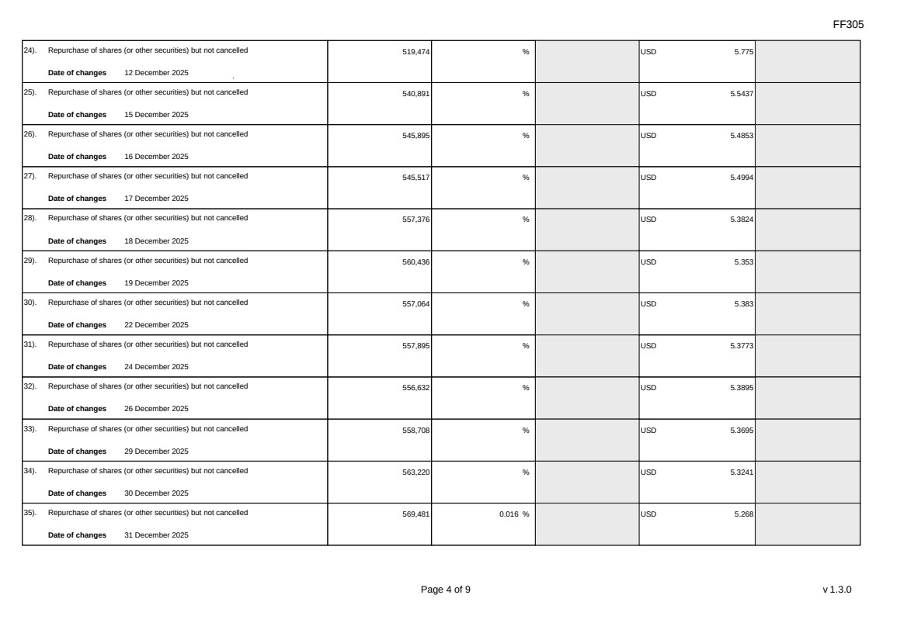 | FF305 Page 4 of 9 v 1.3.0 24). Repurchase of shares (or other securities) but not cancelled Date of changes 12 December 2025 519,474 % USD 5.775 25). Repurchase of shares (or other securities) but not cancelled Date of changes 15 December 2025 540,891 % USD 5.5437 26). Repurchase of shares (or other securities) but not cancelled Date of changes 16 December 2025 545,895 % USD 5.4853 27). Repurchase of shares (or other securities) but not cancelled Date of changes 17 December 2025 545,517 % USD 5.4994 28). Repurchase of shares (or other securities) but not cancelled Date of changes 18 December 2025 557,376 % USD 5.3824 29). Repurchase of shares (or other securities) but not cancelled Date of changes 19 December 2025 560,436 % USD 5.353 30). Repurchase of shares (or other securities) but not cancelled Date of changes 22 December 2025 557,064 % USD 5.383 31). Repurchase of shares (or other securities) but not cancelled Date of changes 24 December 2025 557,895 % USD 5.3773 32). Repurchase of shares (or other securities) but not cancelled Date of changes 26 December 2025 556,632 % USD 5.3895 33). Repurchase of shares (or other securities) but not cancelled Date of changes 29 December 2025 558,708 % USD 5.3695 34). Repurchase of shares (or other securities) but not cancelled Date of changes 30 December 2025 563,220 % USD 5.3241 35). Repurchase of shares (or other securities) but not cancelled Date of changes 31 December 2025 569,481 0.016 % USD 5.268
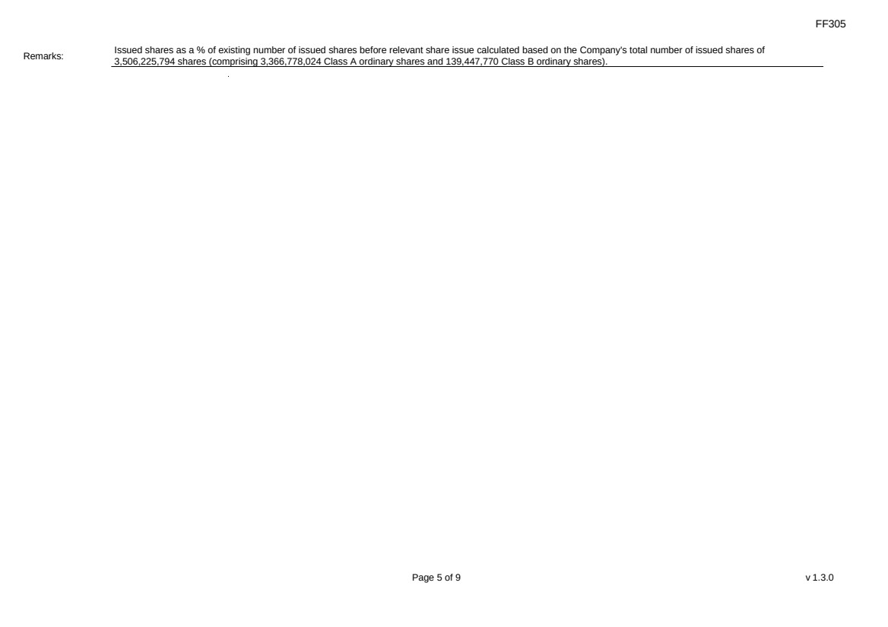 | FF305 Page 5 of 9 v 1.3.0 Remarks: Issued shares as a % of existing number of issued shares before relevant share issue calculated based on the Company's total number of issued shares of 3,506,225,794 shares (comprising 3,366,778,024 Class A ordinary shares and 139,447,770 Class B ordinary shares).
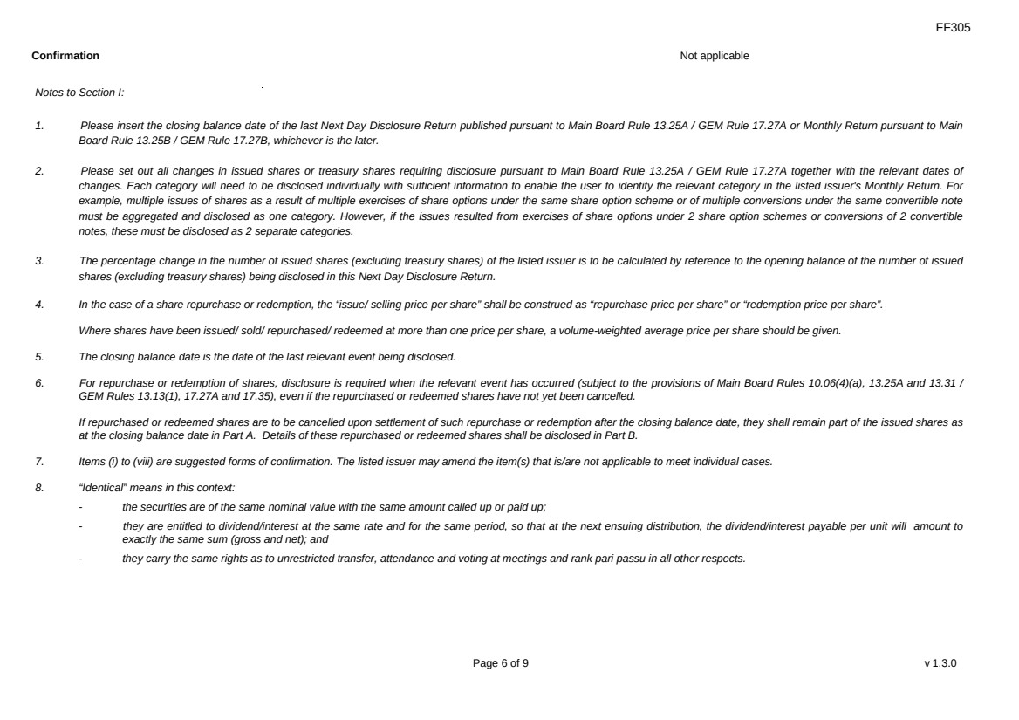 | FF305 Page 6 of 9 v 1.3.0 Confirmation Not applicable Notes to Section I: 1. Please insert the closing balance date of the last Next Day Disclosure Return published pursuant to Main Board Rule 13.25A / GEM Rule 17.27A or Monthly Return pursuant to Main Board Rule 13.25B / GEM Rule 17.27B, whichever is the later. 2. Please set out all changes in issued shares or treasury shares requiring disclosure pursuant to Main Board Rule 13.25A / GEM Rule 17.27A together with the relevant dates of changes. Each category will need to be disclosed individually with sufficient information to enable the user to identify the relevant category in the listed issuer's Monthly Return. For example, multiple issues of shares as a result of multiple exercises of share options under the same share option scheme or of multiple conversions under the same convertible note must be aggregated and disclosed as one category. However, if the issues resulted from exercises of share options under 2 share option schemes or conversions of 2 convertible notes, these must be disclosed as 2 separate categories. 3. The percentage change in the number of issued shares (excluding treasury shares) of the listed issuer is to be calculated by reference to the opening balance of the number of issued shares (excluding treasury shares) being disclosed in this Next Day Disclosure Return. 4. In the case of a share repurchase or redemption, the “issue/ selling price per share” shall be construed as “repurchase price per share” or “redemption price per share”. Where shares have been issued/ sold/ repurchased/ redeemed at more than one price per share, a volume-weighted average price per share should be given. 5. The closing balance date is the date of the last relevant event being disclosed. 6. For repurchase or redemption of shares, disclosure is required when the relevant event has occurred (subject to the provisions of Main Board Rules 10.06(4)(a), 13.25A and 13.31 / GEM Rules 13.13(1), 17.27A and 17.35), even if the repurchased or redeemed shares have not yet been cancelled. If repurchased or redeemed shares are to be cancelled upon settlement of such repurchase or redemption after the closing balance date, they shall remain part of the issued shares as at the closing balance date in Part A. Details of these repurchased or redeemed shares shall be disclosed in Part B. 7. Items (i) to (viii) are suggested forms of confirmation. The listed issuer may amend the item(s) that is/are not applicable to meet individual cases. 8. “Identical” means in this context: - the securities are of the same nominal value with the same amount called up or paid up; - they are entitled to dividend/interest at the same rate and for the same period, so that at the next ensuing distribution, the dividend/interest payable per unit will amount to exactly the same sum (gross and net); and - they carry the same rights as to unrestricted transfer, attendance and voting at meetings and rank pari passu in all other respects.
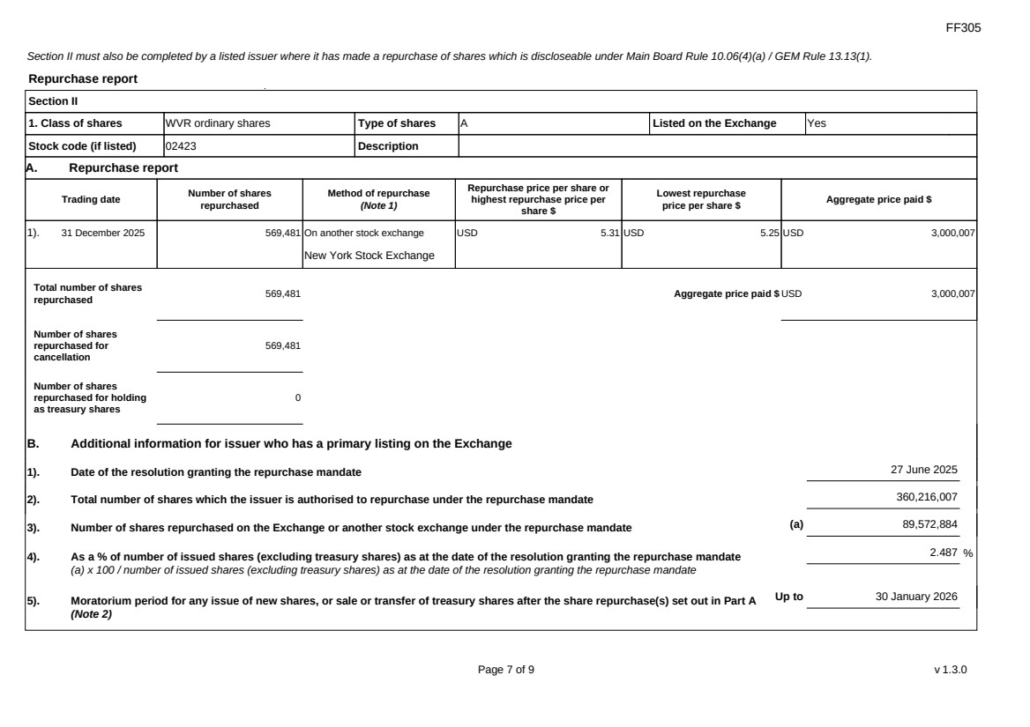 | FF305 Page 7 of 9 v 1.3.0 Section II must also be completed by a listed issuer where it has made a repurchase of shares which is discloseable under Main Board Rule 10.06(4)(a) / GEM Rule 13.13(1). Repurchase report Section II 1. Class of shares WVR ordinary shares Type of shares A Listed on the Exchange Yes Stock code (if listed) 02423 Description A. Repurchase report Trading date Number of shares repurchased Method of repurchase (Note 1) Repurchase price per share or highest repurchase price per share $ Lowest repurchase price per share $ Aggregate price paid $ 1). 31 December 2025 569,481 On another stock exchange New York Stock Exchange USD 5.31 USD 5.25 USD 3,000,007 Total number of shares repurchased 569,481 Aggregate price paid $ USD 3,000,007 Number of shares repurchased for cancellation 569,481 Number of shares repurchased for holding as treasury shares 0 B. Additional information for issuer who has a primary listing on the Exchange 1). Date of the resolution granting the repurchase mandate 27 June 2025 2). Total number of shares which the issuer is authorised to repurchase under the repurchase mandate 360,216,007 3). Number of shares repurchased on the Exchange or another stock exchange under the repurchase mandate (a) 89,572,884 4). As a % of number of issued shares (excluding treasury shares) as at the date of the resolution granting the repurchase mandate (a) x 100 / number of issued shares (excluding treasury shares) as at the date of the resolution granting the repurchase mandate 2.487 % 5). Moratorium period for any issue of new shares, or sale or transfer of treasury shares after the share repurchase(s) set out in Part A (Note 2) Up to 30 January 2026
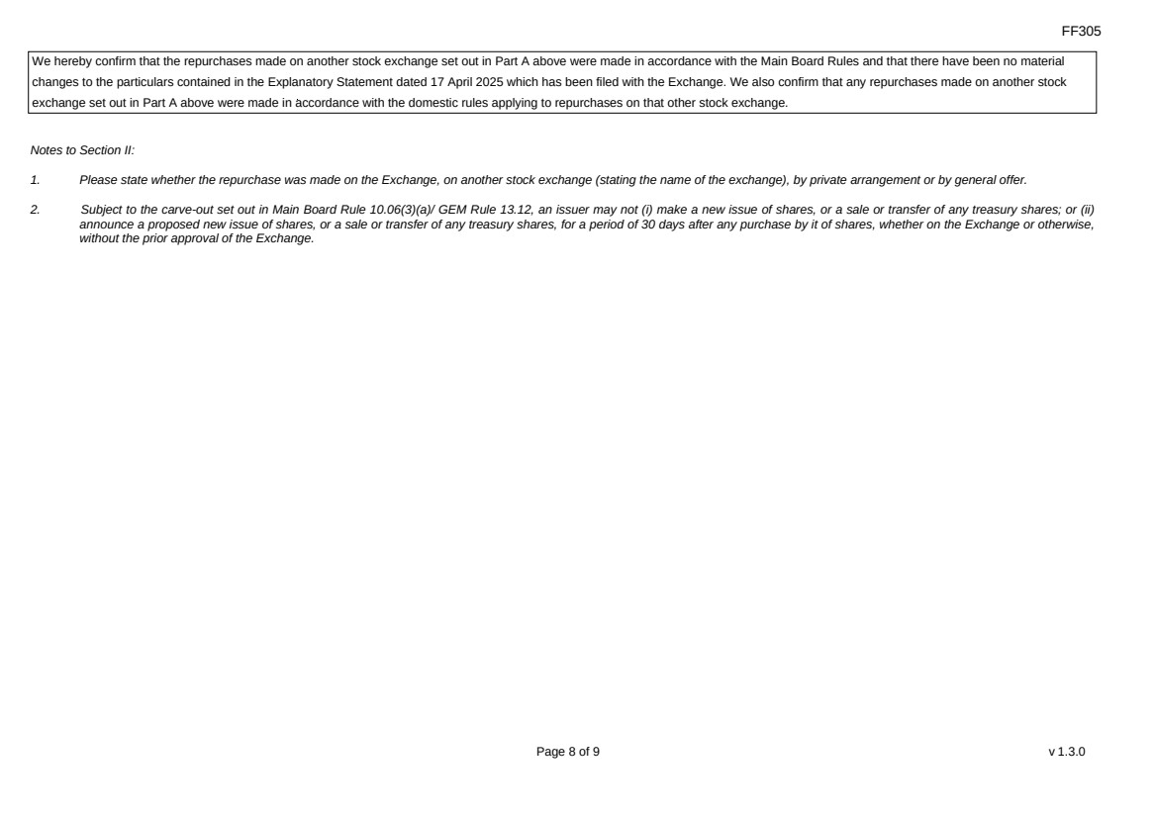 | FF305 Page 8 of 9 v 1.3.0 We hereby confirm that the repurchases made on another stock exchange set out in Part A above were made in accordance with the Main Board Rules and that there have been no material changes to the particulars contained in the Explanatory Statement dated 17 April 2025 which has been filed with the Exchange. We also confirm that any repurchases made on another stock exchange set out in Part A above were made in accordance with the domestic rules applying to repurchases on that other stock exchange. Notes to Section II: 1. Please state whether the repurchase was made on the Exchange, on another stock exchange (stating the name of the exchange), by private arrangement or by general offer. 2. Subject to the carve-out set out in Main Board Rule 10.06(3)(a)/ GEM Rule 13.12, an issuer may not (i) make a new issue of shares, or a sale or transfer of any treasury shares; or (ii) announce a proposed new issue of shares, or a sale or transfer of any treasury shares, for a period of 30 days after any purchase by it of shares, whether on the Exchange or otherwise, without the prior approval of the Exchange.
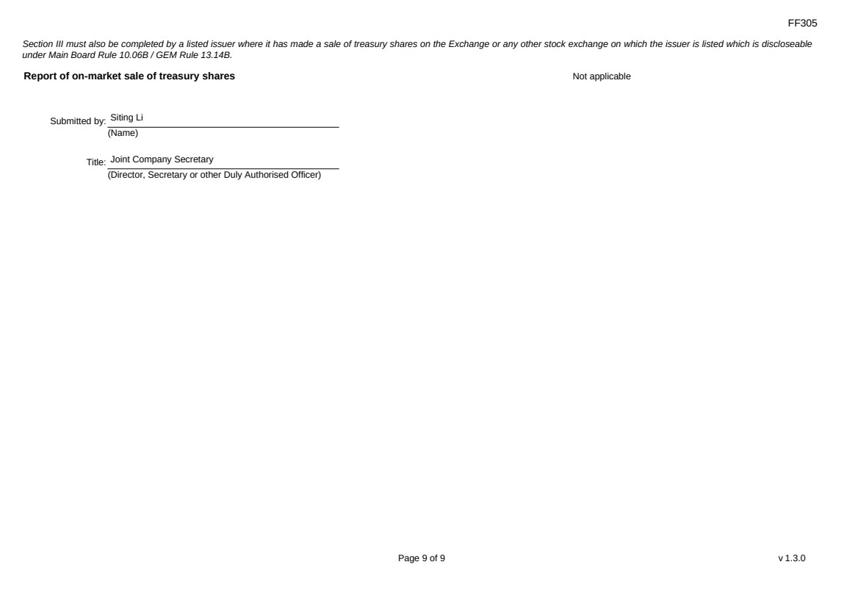 | FF305 Page 9 of 9 v 1.3.0 Section III must also be completed by a listed issuer where it has made a sale of treasury shares on the Exchange or any other stock exchange on which the issuer is listed which is discloseable under Main Board Rule 10.06B / GEM Rule 13.14B. Report of on-market sale of treasury shares Not applicable Submitted by: Siting Li (Name) Title: Joint Company Secretary (Director, Secretary or other Duly Authorised Officer)

