UNITED STATES

SECURITIES AND EXCHANGE COMMISSION

Washington, D.C. 20549

FORM 6-K

REPORT OF FOREIGN PRIVATE ISSUER

PURSUANT TO RULE 13a-16 OR 15d-16 UNDER

THE SECURITIES EXCHANGE ACT OF 1934

For the month of April 2026

Commission File Number: 001-39436

KE Holdings Inc.

(Registrant’s Name)

Oriental Electronic Technology Building,

No. 2 Chuangye Road, Haidian District,

Beijing 100086

People’s Republic of China

(Address of Principal Executive Offices)

Indicate by check mark whether the registrant files or will file annual reports under cover Form 20-F or Form 40-F.

Form 20-F ☒ Form 40-F o

 |  |  |  |  |  |  | EXHIBIT INDEX
Exhibit No. |  |  |  |  |  |  | Description
 | 99.1 |  |  | Next Day Disclosure Return Dated March 30, 2026
 | 99.2 |  |  | Next Day Disclosure Return Dated March 31, 2026
 | 99.3 |  |  | Next Day Disclosure Return Dated April 1, 2026
 | 99.4 |  |  | Next Day Disclosure Return Dated April 2, 2026

SIGNATURES

Pursuant to the requirements of the Securities Exchange Act of 1934, the registrant has duly caused this report to be signed on its behalf by the undersigned, thereunto duly authorized.

KE Holdings Inc.

By | : | /s/ XU Tao
Name | : | XU Tao
Title | : | Chief Financial Officer

Date: April 8, 2026

Exhibit 99.1
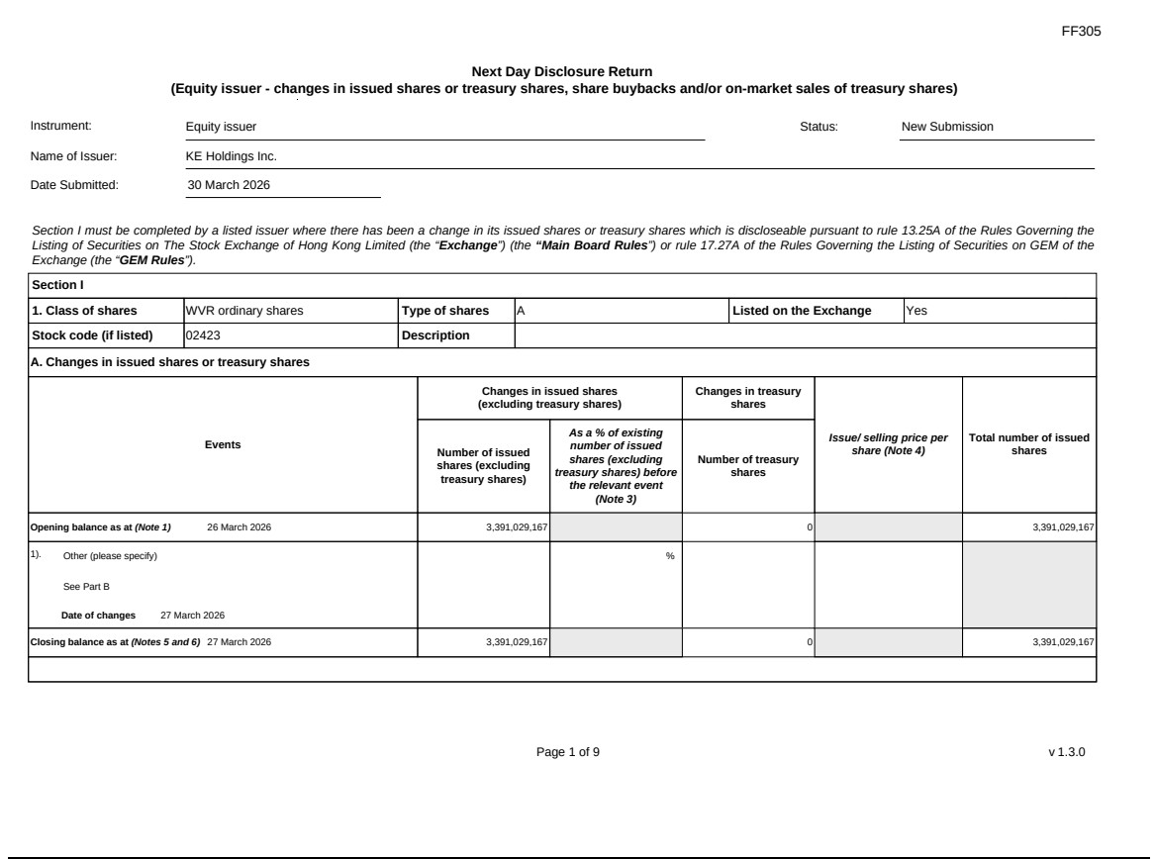

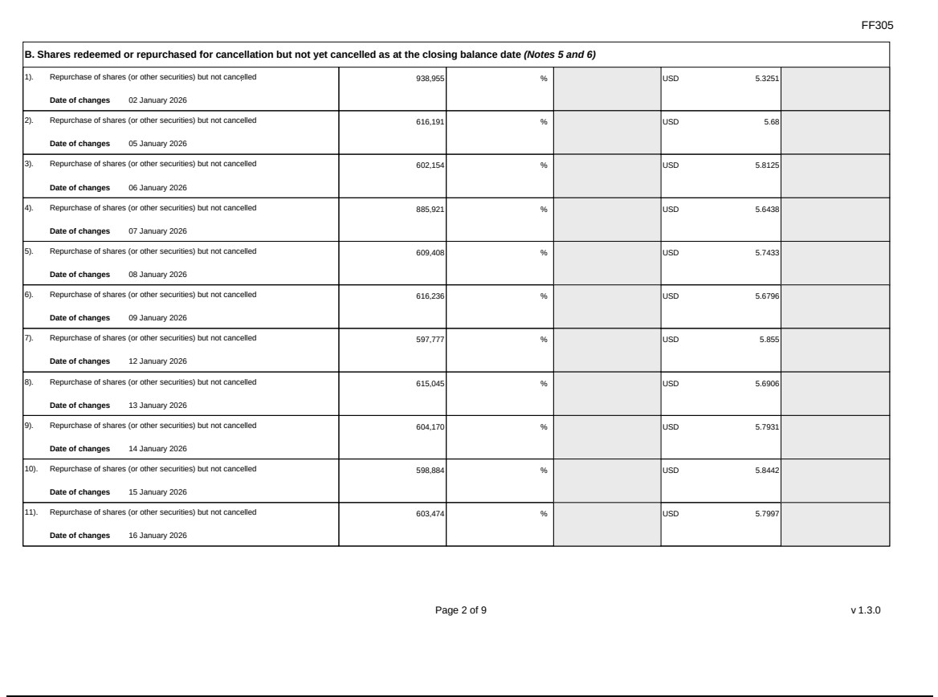

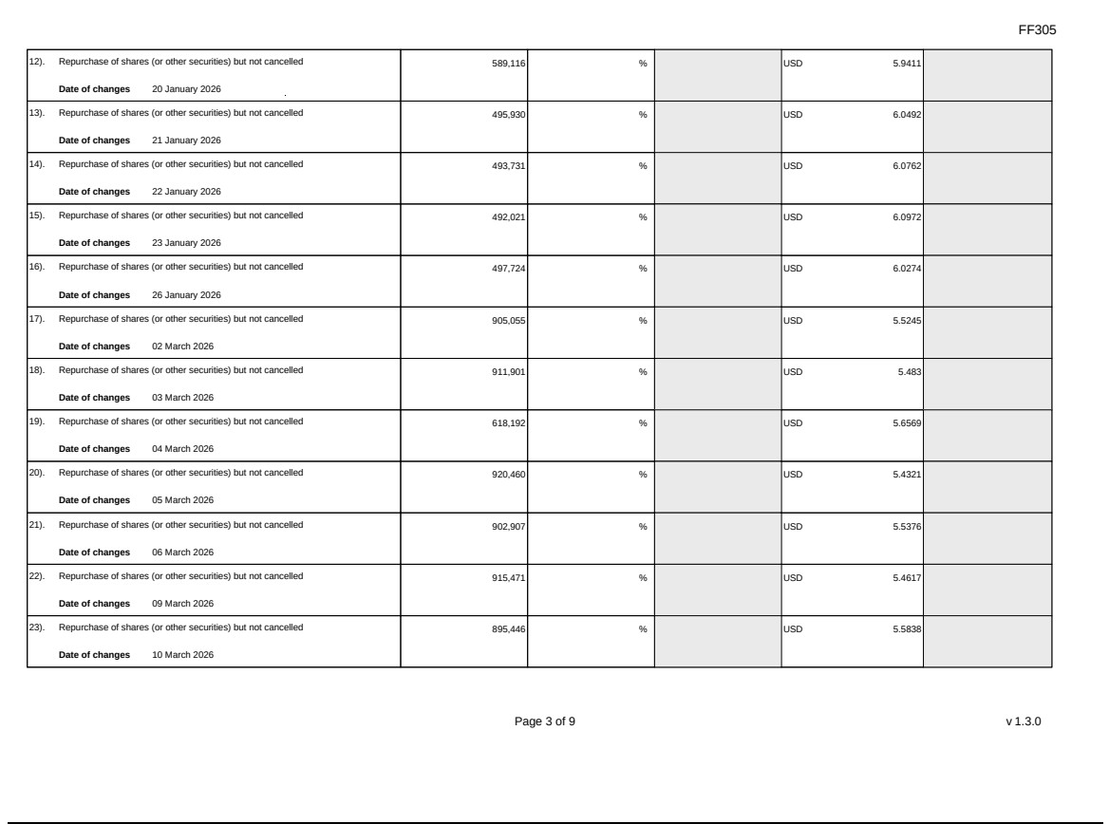

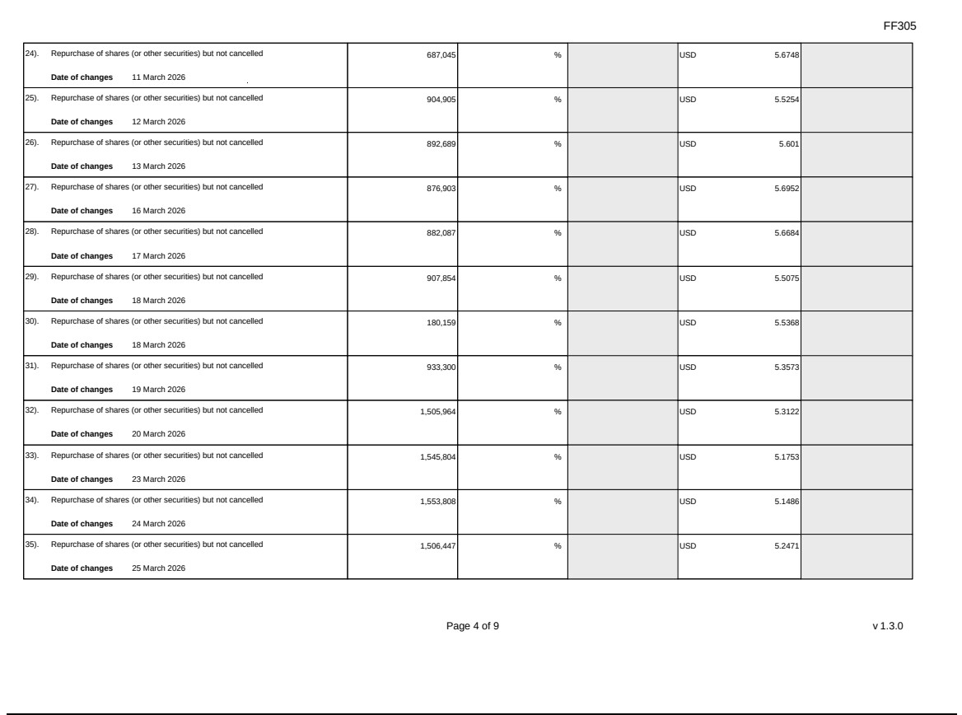

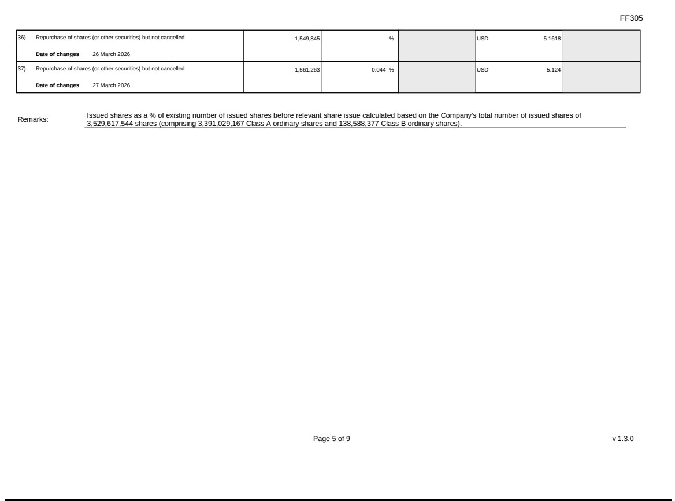

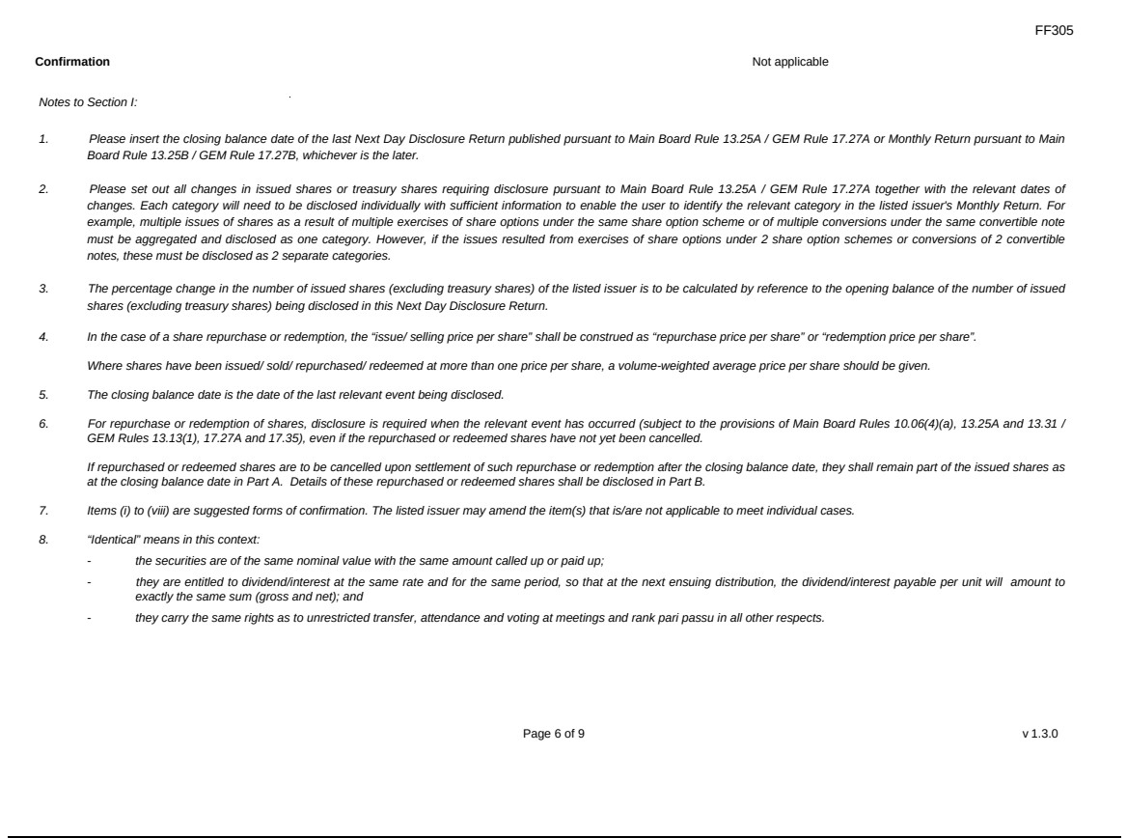

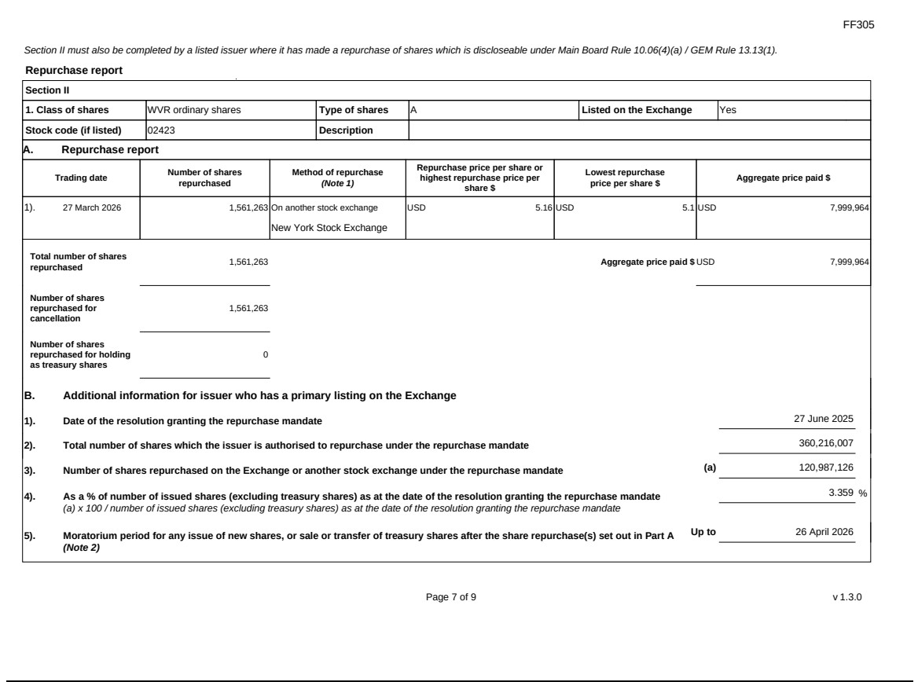

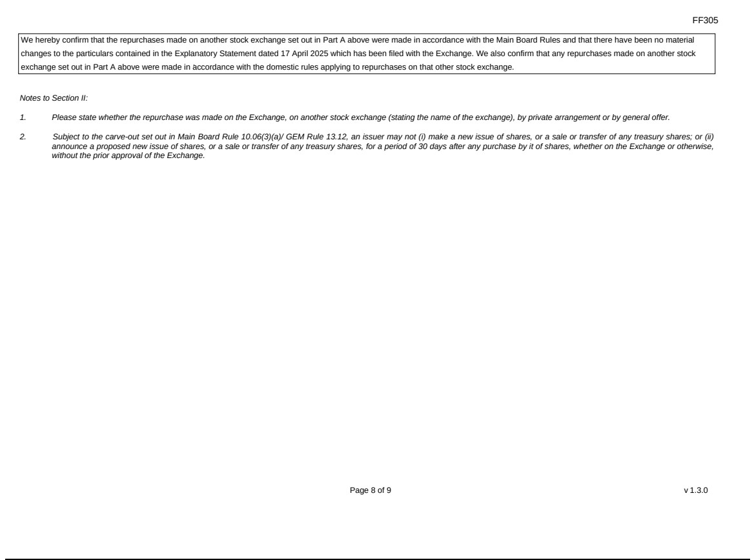

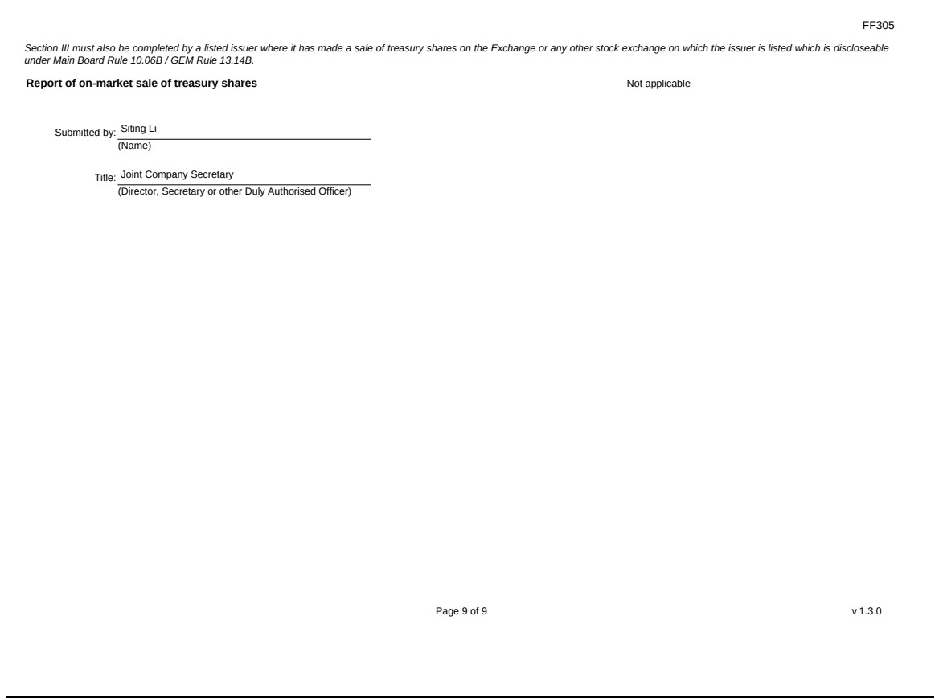

Exhibit 99.2
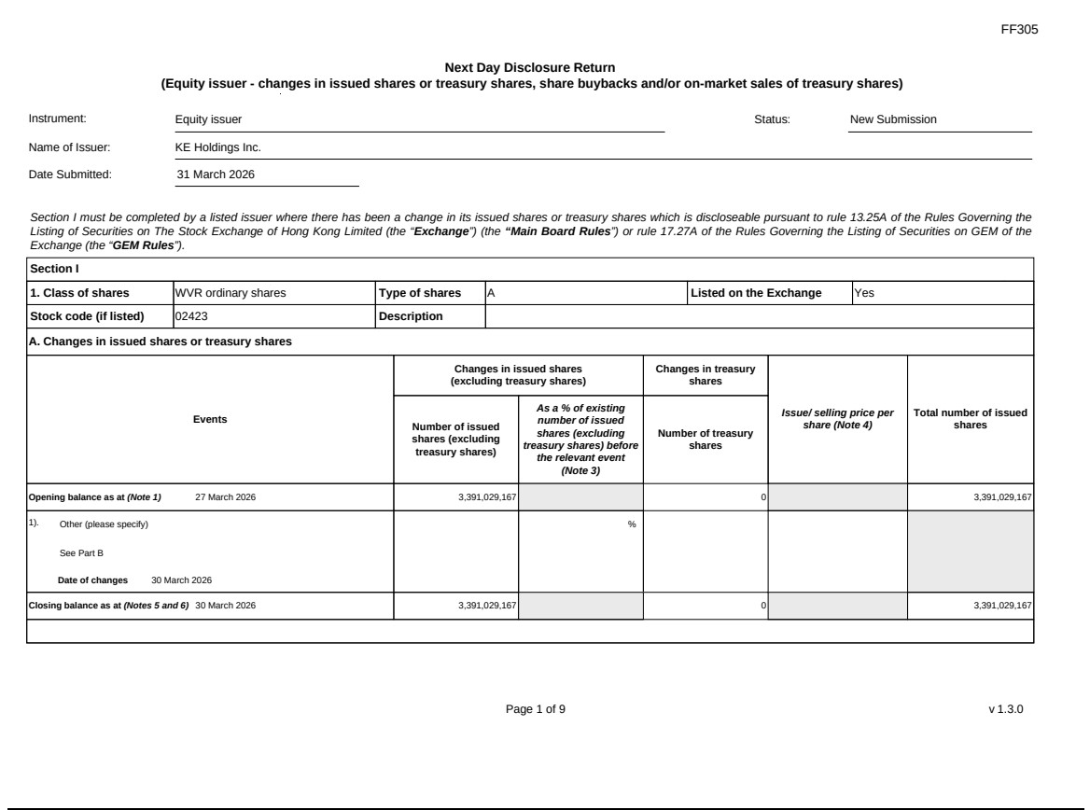

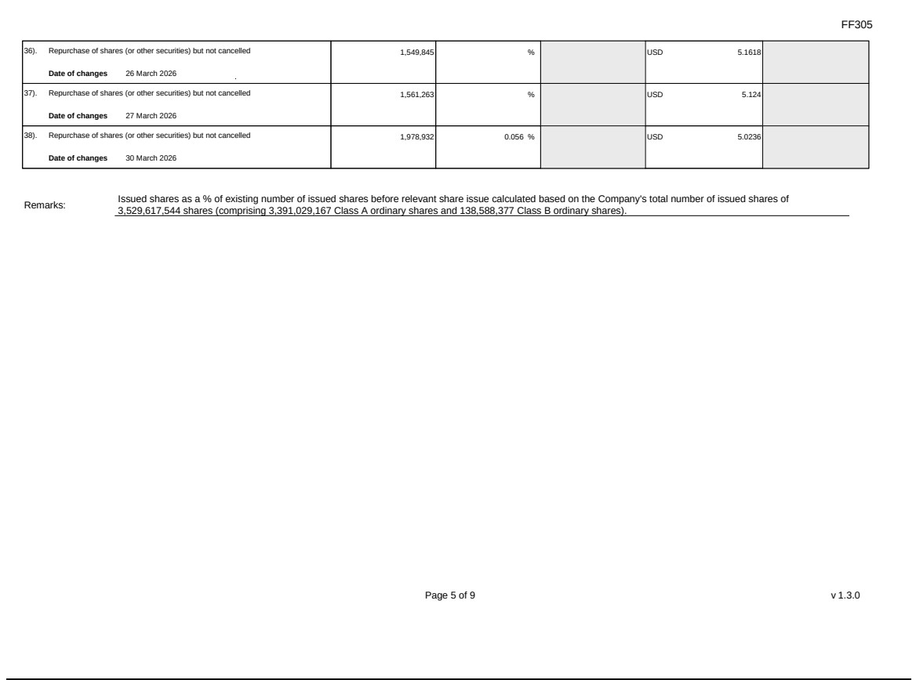

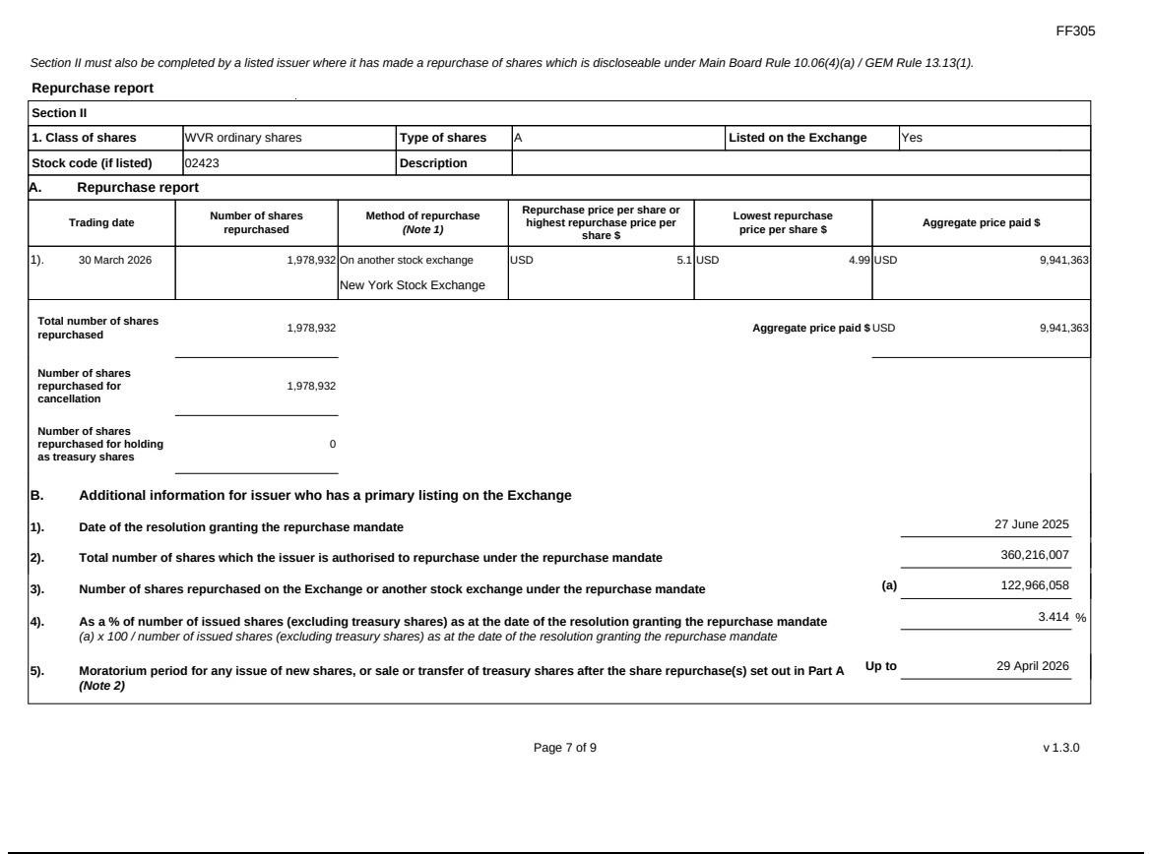

Exhibit 99.3
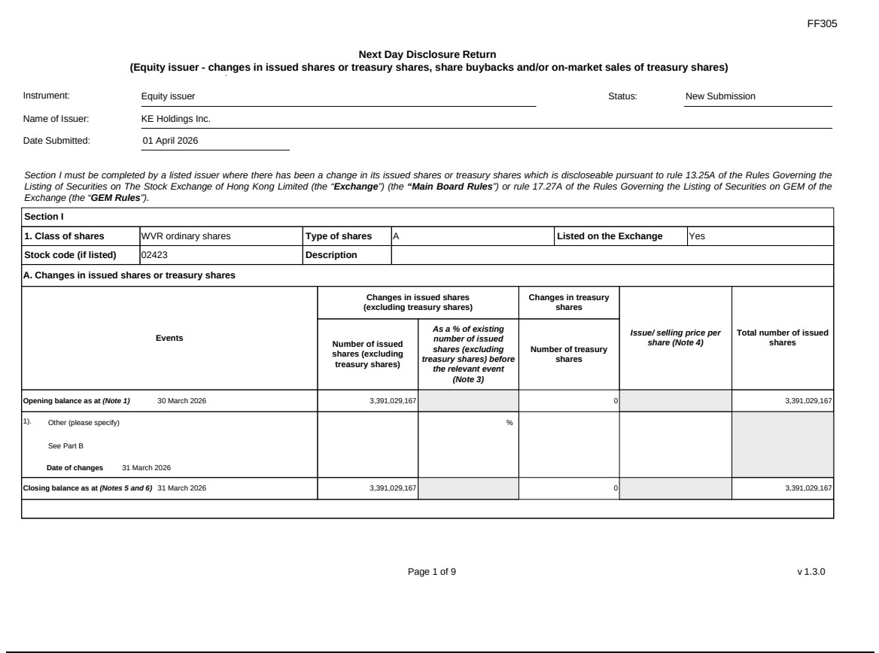

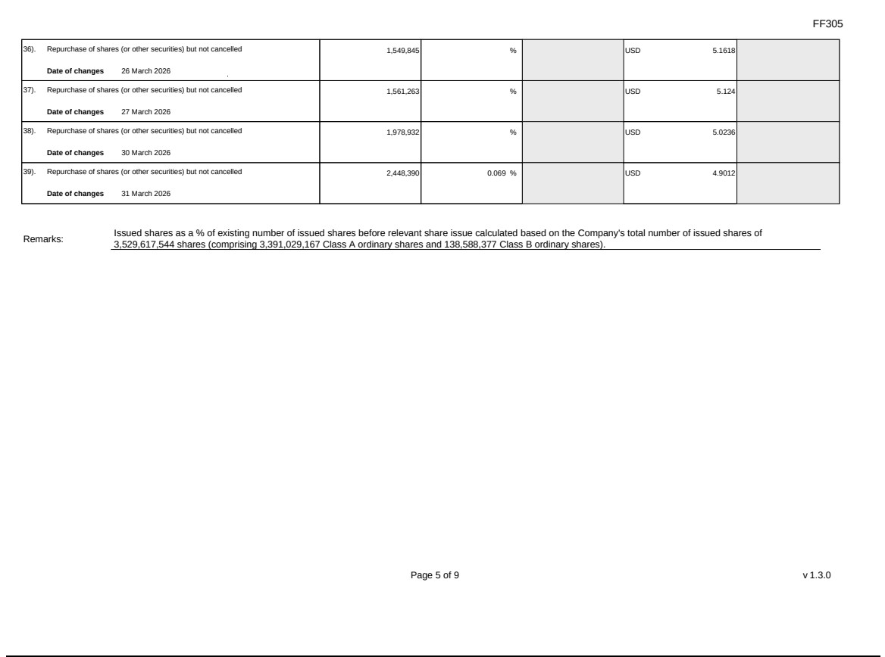

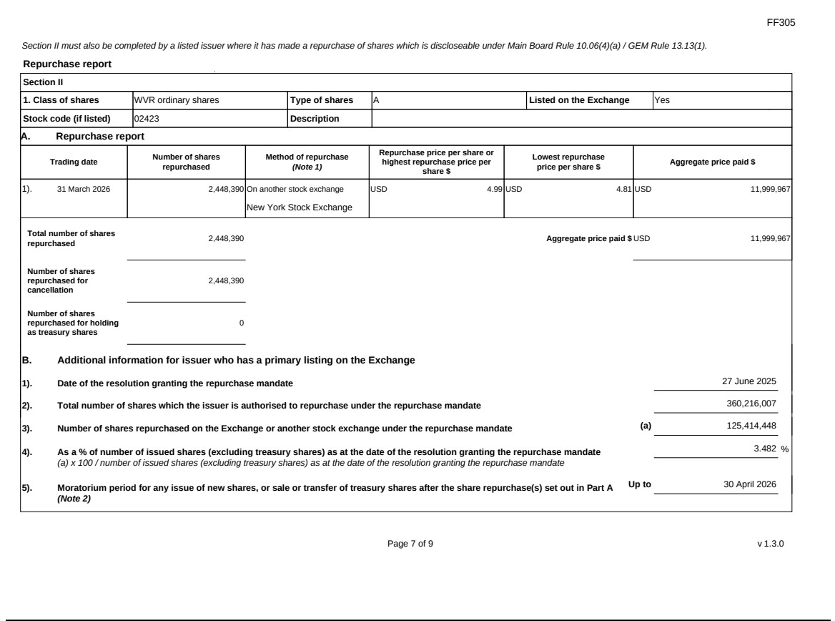

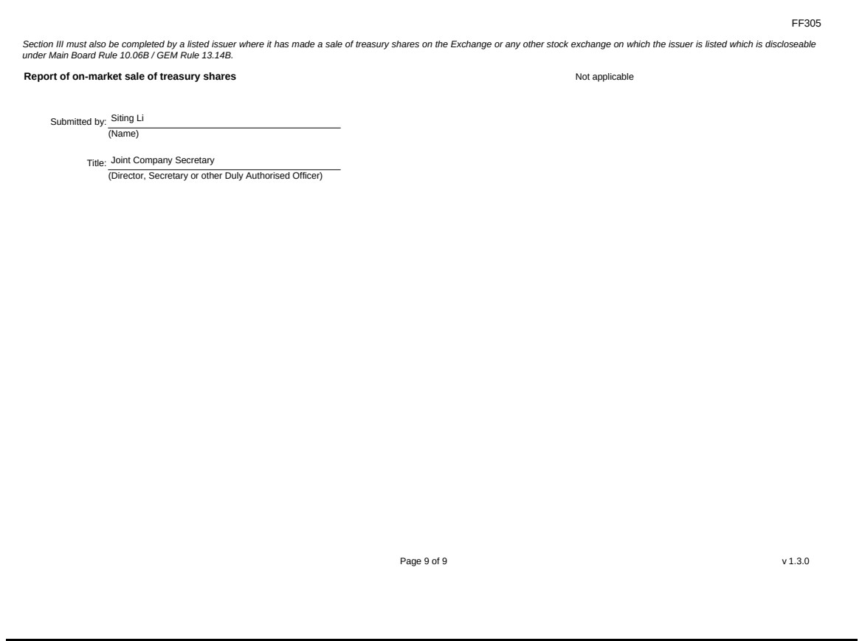

Exhibit 99.4


