UNITED STATES
SECURITIES AND EXCHANGE COMMISSION
Washington, D.C. 20549

FORM 6-K

REPORT OF FOREIGN PRIVATE ISSUER
PURSUANT TO RULE 13a-16 OR 15d-16 UNDER
THE SECURITIES EXCHANGE ACT OF 1934

For the month of November 2025

Commission File Number: 001-39436

KE Holdings Inc.
(Registrant’s Name)

Oriental Electronic Technology Building,
No. 2 Chuangye Road, Haidian District,
Beijing 100086
People’s Republic of China
(Address of Principal Executive Offices)

Indicate by check mark whether the registrant files or will file annual reports under cover Form 20-F or Form 40-F.

Form 20-F ☒ Form 40-F ☐

EXHIBIT INDEX

Exhibit No. |  | Description
99.1 |  | Next Day Disclosure Return Dated October 27, 2025
99.2 |  | Next Day Disclosure Return Dated October 28, 2025
99.3 |  | Next Day Disclosure Return Dated October 30, 2025
99.4 |  | Next Day Disclosure Return Dated October 30, 2025
99.5 |  | Next Day Disclosure Return Dated October 31, 2025

SIGNATURES

Pursuant to the requirements of the Securities Exchange Act of 1934, the registrant has duly caused this report to be signed on its behalf by the undersigned, thereunto duly authorized.

 | KE Holdings Inc.
 | By | : | /s/ XU Tao
 | Name | : | XU Tao
 | Title | : | Chief Financial Officer

Date: November 3, 2025

Exhibit 99.1
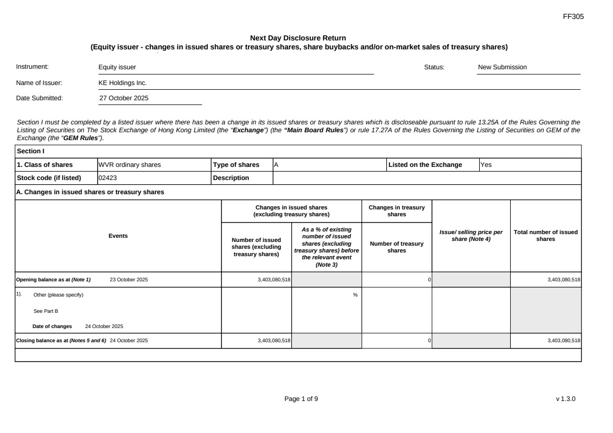 | FF305 Page 1 of 9 v 1.3.0 Next Day Disclosure Return (Equity issuer - changes in issued shares or treasury shares, share buybacks and/or on-market sales of treasury shares) Instrument: Equity issuer Status: New Submission Name of Issuer: KE Holdings Inc. Date Submitted: 27 October 2025 Section I must be completed by a listed issuer where there has been a change in its issued shares or treasury shares which is discloseable pursuant to rule 13.25A of the Rules Governing the Listing of Securities on The Stock Exchange of Hong Kong Limited (the “Exchange”) (the “Main Board Rules”) or rule 17.27A of the Rules Governing the Listing of Securities on GEM of the Exchange (the “GEM Rules”). Section I 1. Class of shares WVR ordinary shares Type of shares A Listed on the Exchange Yes Stock code (if listed) 02423 Description A. Changes in issued shares or treasury shares Events Changes in issued shares (excluding treasury shares) Number of issued shares (excluding treasury shares) As a % of existing number of issued shares (excluding treasury shares) before the relevant event (Note 3) Changes in treasury shares Number of treasury shares Issue/ selling price per share (Note 4) Total number of issued shares Opening balance as at (Note 1) 23 October 2025 3,403,080,518 0 3,403,080,518 1). Other (please specify) See Part B Date of changes 24 October 2025 % Closing balance as at (Notes 5 and 6) 24 October 2025 3,403,080,518 0 3,403,080,518
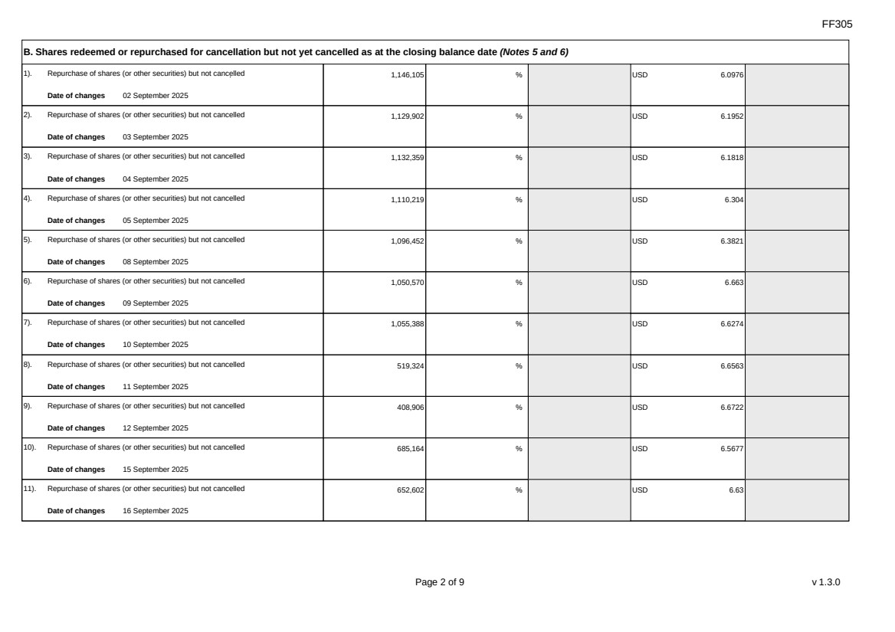 | FF305 Page 2 of 9 v 1.3.0 B. Shares redeemed or repurchased for cancellation but not yet cancelled as at the closing balance date (Notes 5 and 6) 1). Repurchase of shares (or other securities) but not cancelled Date of changes 02 September 2025 1,146,105 % USD 6.0976 2). Repurchase of shares (or other securities) but not cancelled Date of changes 03 September 2025 1,129,902 % USD 6.1952 3). Repurchase of shares (or other securities) but not cancelled Date of changes 04 September 2025 1,132,359 % USD 6.1818 4). Repurchase of shares (or other securities) but not cancelled Date of changes 05 September 2025 1,110,219 % USD 6.304 5). Repurchase of shares (or other securities) but not cancelled Date of changes 08 September 2025 1,096,452 % USD 6.3821 6). Repurchase of shares (or other securities) but not cancelled Date of changes 09 September 2025 1,050,570 % USD 6.663 7). Repurchase of shares (or other securities) but not cancelled Date of changes 10 September 2025 1,055,388 % USD 6.6274 8). Repurchase of shares (or other securities) but not cancelled Date of changes 11 September 2025 519,324 % USD 6.6563 9). Repurchase of shares (or other securities) but not cancelled Date of changes 12 September 2025 408,906 % USD 6.6722 10). Repurchase of shares (or other securities) but not cancelled Date of changes 15 September 2025 685,164 % USD 6.5677 11). Repurchase of shares (or other securities) but not cancelled Date of changes 16 September 2025 652,602 % USD 6.63
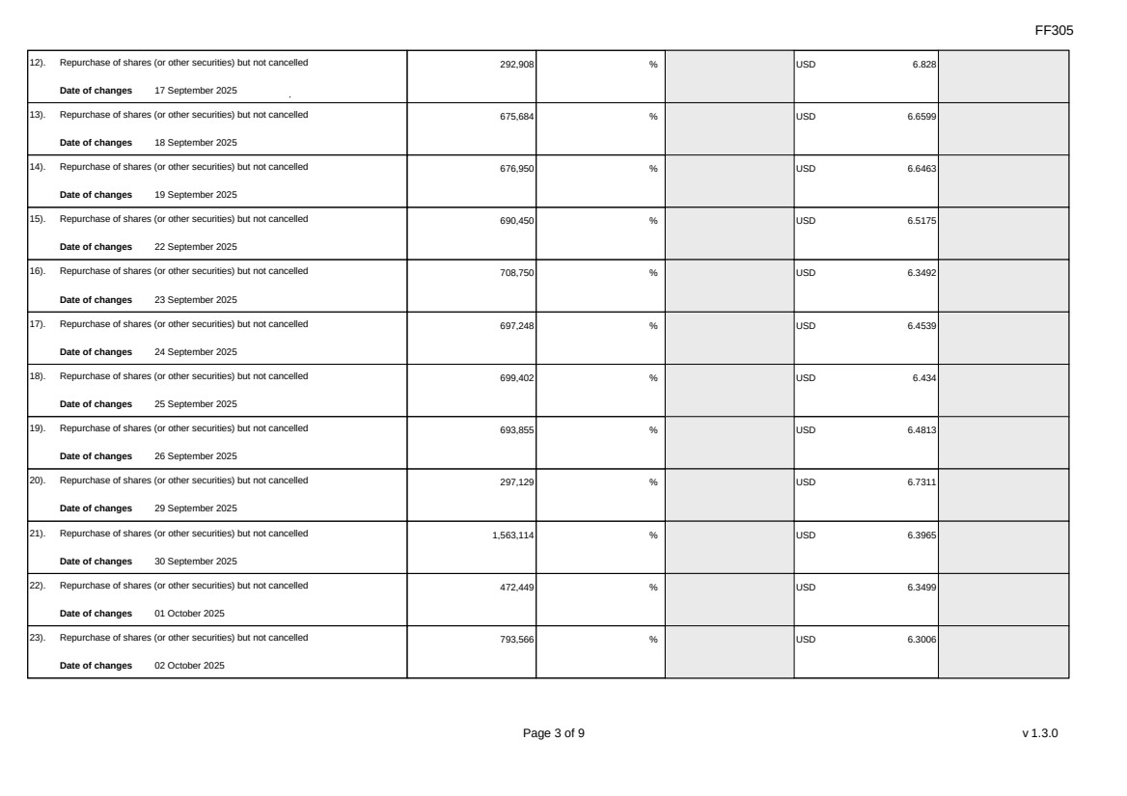 | FF305 Page 3 of 9 v 1.3.0 12). Repurchase of shares (or other securities) but not cancelled Date of changes 17 September 2025 292,908 % USD 6.828 13). Repurchase of shares (or other securities) but not cancelled Date of changes 18 September 2025 675,684 % USD 6.6599 14). Repurchase of shares (or other securities) but not cancelled Date of changes 19 September 2025 676,950 % USD 6.6463 15). Repurchase of shares (or other securities) but not cancelled Date of changes 22 September 2025 690,450 % USD 6.5175 16). Repurchase of shares (or other securities) but not cancelled Date of changes 23 September 2025 708,750 % USD 6.3492 17). Repurchase of shares (or other securities) but not cancelled Date of changes 24 September 2025 697,248 % USD 6.4539 18). Repurchase of shares (or other securities) but not cancelled Date of changes 25 September 2025 699,402 % USD 6.434 19). Repurchase of shares (or other securities) but not cancelled Date of changes 26 September 2025 693,855 % USD 6.4813 20). Repurchase of shares (or other securities) but not cancelled Date of changes 29 September 2025 297,129 % USD 6.7311 21). Repurchase of shares (or other securities) but not cancelled Date of changes 30 September 2025 1,563,114 % USD 6.3965 22). Repurchase of shares (or other securities) but not cancelled Date of changes 01 October 2025 472,449 % USD 6.3499 23). Repurchase of shares (or other securities) but not cancelled Date of changes 02 October 2025 793,566 % USD 6.3006
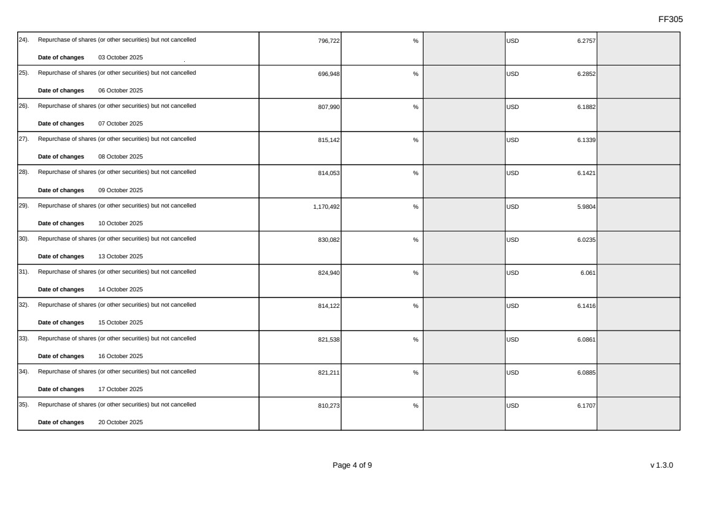 | FF305 Page 4 of 9 v 1.3.0 24). Repurchase of shares (or other securities) but not cancelled Date of changes 03 October 2025 796,722 % USD 6.2757 25). Repurchase of shares (or other securities) but not cancelled Date of changes 06 October 2025 696,948 % USD 6.2852 26). Repurchase of shares (or other securities) but not cancelled Date of changes 07 October 2025 807,990 % USD 6.1882 27). Repurchase of shares (or other securities) but not cancelled Date of changes 08 October 2025 815,142 % USD 6.1339 28). Repurchase of shares (or other securities) but not cancelled Date of changes 09 October 2025 814,053 % USD 6.1421 29). Repurchase of shares (or other securities) but not cancelled Date of changes 10 October 2025 1,170,492 % USD 5.9804 30). Repurchase of shares (or other securities) but not cancelled Date of changes 13 October 2025 830,082 % USD 6.0235 31). Repurchase of shares (or other securities) but not cancelled Date of changes 14 October 2025 824,940 % USD 6.061 32). Repurchase of shares (or other securities) but not cancelled Date of changes 15 October 2025 814,122 % USD 6.1416 33). Repurchase of shares (or other securities) but not cancelled Date of changes 16 October 2025 821,538 % USD 6.0861 34). Repurchase of shares (or other securities) but not cancelled Date of changes 17 October 2025 821,211 % USD 6.0885 35). Repurchase of shares (or other securities) but not cancelled Date of changes 20 October 2025 810,273 % USD 6.1707
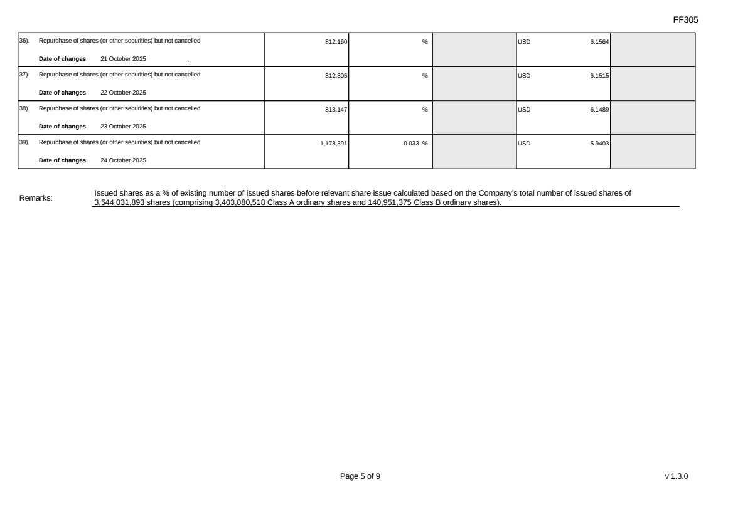 | FF305 Page 5 of 9 v 1.3.0 36). Repurchase of shares (or other securities) but not cancelled Date of changes 21 October 2025 812,160 % USD 6.1564 37). Repurchase of shares (or other securities) but not cancelled Date of changes 22 October 2025 812,805 % USD 6.1515 38). Repurchase of shares (or other securities) but not cancelled Date of changes 23 October 2025 813,147 % USD 6.1489 39). Repurchase of shares (or other securities) but not cancelled Date of changes 24 October 2025 1,178,391 0.033 % USD 5.9403 Remarks: Issued shares as a % of existing number of issued shares before relevant share issue calculated based on the Company's total number of issued shares of 3,544,031,893 shares (comprising 3,403,080,518 Class A ordinary shares and 140,951,375 Class B ordinary shares).
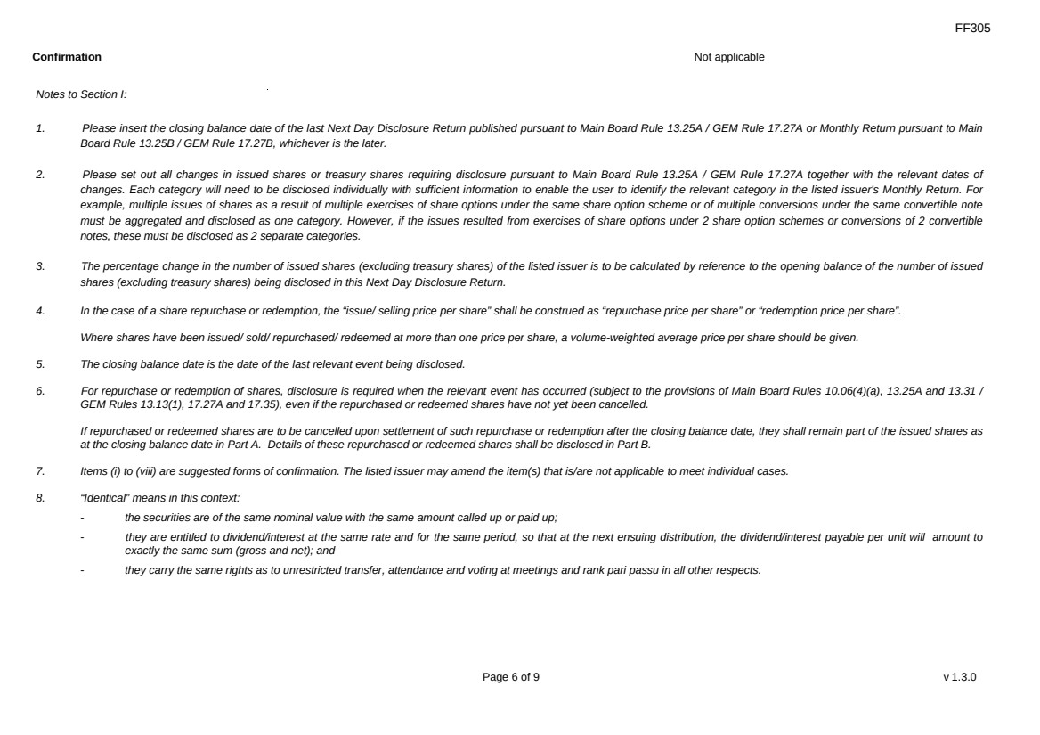 | FF305 Page 6 of 9 v 1.3.0 Confirmation Not applicable Notes to Section I: 1. Please insert the closing balance date of the last Next Day Disclosure Return published pursuant to Main Board Rule 13.25A / GEM Rule 17.27A or Monthly Return pursuant to Main Board Rule 13.25B / GEM Rule 17.27B, whichever is the later. 2. Please set out all changes in issued shares or treasury shares requiring disclosure pursuant to Main Board Rule 13.25A / GEM Rule 17.27A together with the relevant dates of changes. Each category will need to be disclosed individually with sufficient information to enable the user to identify the relevant category in the listed issuer's Monthly Return. For example, multiple issues of shares as a result of multiple exercises of share options under the same share option scheme or of multiple conversions under the same convertible note must be aggregated and disclosed as one category. However, if the issues resulted from exercises of share options under 2 share option schemes or conversions of 2 convertible notes, these must be disclosed as 2 separate categories. 3. The percentage change in the number of issued shares (excluding treasury shares) of the listed issuer is to be calculated by reference to the opening balance of the number of issued shares (excluding treasury shares) being disclosed in this Next Day Disclosure Return. 4. In the case of a share repurchase or redemption, the “issue/ selling price per share” shall be construed as “repurchase price per share” or “redemption price per share”. Where shares have been issued/ sold/ repurchased/ redeemed at more than one price per share, a volume-weighted average price per share should be given. 5. The closing balance date is the date of the last relevant event being disclosed. 6. For repurchase or redemption of shares, disclosure is required when the relevant event has occurred (subject to the provisions of Main Board Rules 10.06(4)(a), 13.25A and 13.31 / GEM Rules 13.13(1), 17.27A and 17.35), even if the repurchased or redeemed shares have not yet been cancelled. If repurchased or redeemed shares are to be cancelled upon settlement of such repurchase or redemption after the closing balance date, they shall remain part of the issued shares as at the closing balance date in Part A. Details of these repurchased or redeemed shares shall be disclosed in Part B. 7. Items (i) to (viii) are suggested forms of confirmation. The listed issuer may amend the item(s) that is/are not applicable to meet individual cases. 8. “Identical” means in this context: - the securities are of the same nominal value with the same amount called up or paid up; - they are entitled to dividend/interest at the same rate and for the same period, so that at the next ensuing distribution, the dividend/interest payable per unit will amount to exactly the same sum (gross and net); and - they carry the same rights as to unrestricted transfer, attendance and voting at meetings and rank pari passu in all other respects.
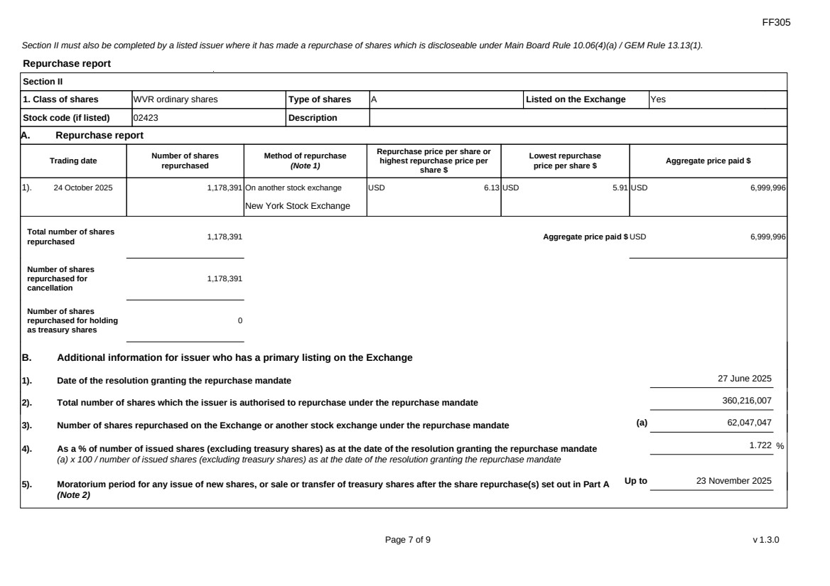 | FF305 Page 7 of 9 v 1.3.0 Section II must also be completed by a listed issuer where it has made a repurchase of shares which is discloseable under Main Board Rule 10.06(4)(a) / GEM Rule 13.13(1). Repurchase report Section II 1. Class of shares WVR ordinary shares Type of shares A Listed on the Exchange Yes Stock code (if listed) 02423 Description A. Repurchase report Trading date Number of shares repurchased Method of repurchase (Note 1) Repurchase price per share or highest repurchase price per share $ Lowest repurchase price per share $ Aggregate price paid $ 1). 24 October 2025 1,178,391 On another stock exchange New York Stock Exchange USD 6.13 USD 5.91 USD 6,999,996 Total number of shares repurchased 1,178,391 Aggregate price paid $ USD 6,999,996 Number of shares repurchased for cancellation 1,178,391 Number of shares repurchased for holding as treasury shares 0 B. Additional information for issuer who has a primary listing on the Exchange 1). Date of the resolution granting the repurchase mandate 27 June 2025 2). Total number of shares which the issuer is authorised to repurchase under the repurchase mandate 360,216,007 3). Number of shares repurchased on the Exchange or another stock exchange under the repurchase mandate (a) 62,047,047 4). As a % of number of issued shares (excluding treasury shares) as at the date of the resolution granting the repurchase mandate (a) x 100 / number of issued shares (excluding treasury shares) as at the date of the resolution granting the repurchase mandate 1.722 % 5). Moratorium period for any issue of new shares, or sale or transfer of treasury shares after the share repurchase(s) set out in Part A (Note 2) Up to 23 November 2025
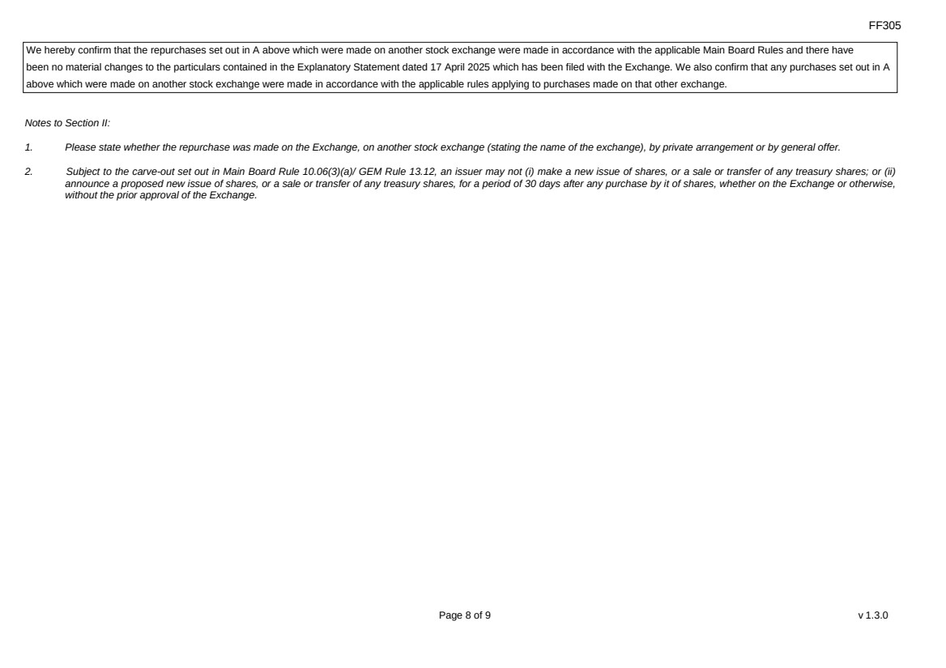 | FF305 Page 8 of 9 v 1.3.0 We hereby confirm that the repurchases set out in A above which were made on another stock exchange were made in accordance with the applicable Main Board Rules and there have been no material changes to the particulars contained in the Explanatory Statement dated 17 April 2025 which has been filed with the Exchange. We also confirm that any purchases set out in A above which were made on another stock exchange were made in accordance with the applicable rules applying to purchases made on that other exchange. Notes to Section II: 1. Please state whether the repurchase was made on the Exchange, on another stock exchange (stating the name of the exchange), by private arrangement or by general offer. 2. Subject to the carve-out set out in Main Board Rule 10.06(3)(a)/ GEM Rule 13.12, an issuer may not (i) make a new issue of shares, or a sale or transfer of any treasury shares; or (ii) announce a proposed new issue of shares, or a sale or transfer of any treasury shares, for a period of 30 days after any purchase by it of shares, whether on the Exchange or otherwise, without the prior approval of the Exchange.
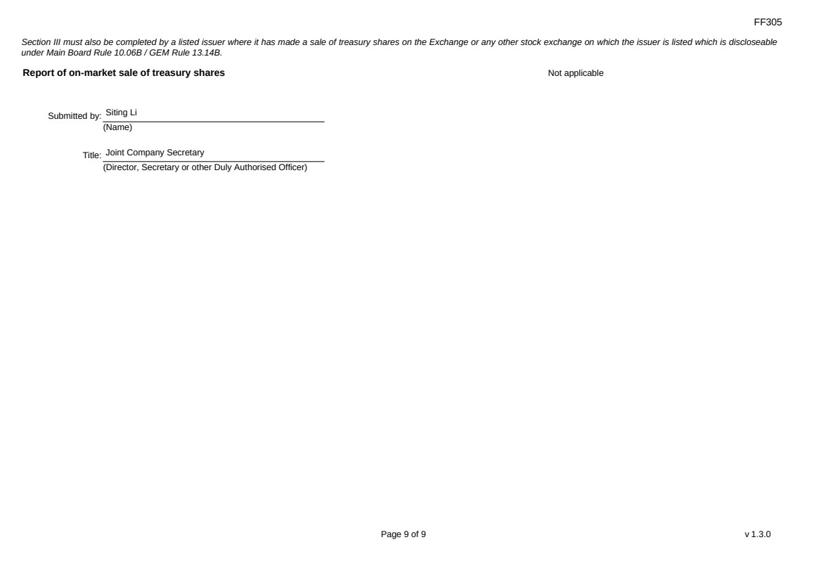 | FF305 Page 9 of 9 v 1.3.0 Section III must also be completed by a listed issuer where it has made a sale of treasury shares on the Exchange or any other stock exchange on which the issuer is listed which is discloseable under Main Board Rule 10.06B / GEM Rule 13.14B. Report of on-market sale of treasury shares Not applicable Submitted by: Siting Li (Name) Title: Joint Company Secretary (Director, Secretary or other Duly Authorised Officer)
Exhibit 99.2
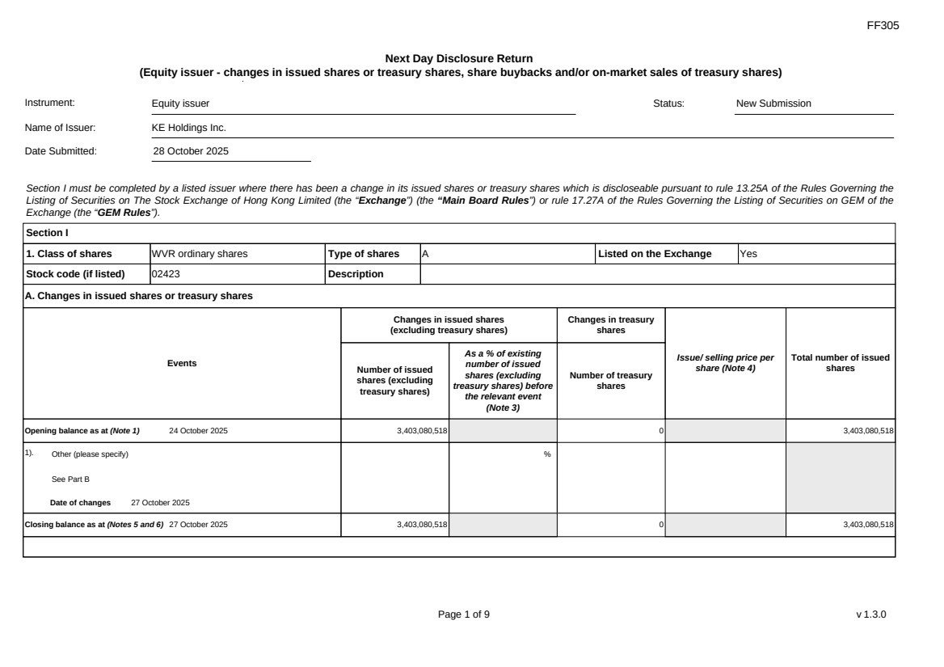 | FF305 Page 1 of 9 v 1.3.0 Next Day Disclosure Return (Equity issuer - changes in issued shares or treasury shares, share buybacks and/or on-market sales of treasury shares) Instrument: Equity issuer Status: New Submission Name of Issuer: KE Holdings Inc. Date Submitted: 28 October 2025 Section I must be completed by a listed issuer where there has been a change in its issued shares or treasury shares which is discloseable pursuant to rule 13.25A of the Rules Governing the Listing of Securities on The Stock Exchange of Hong Kong Limited (the “Exchange”) (the “Main Board Rules”) or rule 17.27A of the Rules Governing the Listing of Securities on GEM of the Exchange (the “GEM Rules”). Section I 1. Class of shares WVR ordinary shares Type of shares A Listed on the Exchange Yes Stock code (if listed) 02423 Description A. Changes in issued shares or treasury shares Events Changes in issued shares (excluding treasury shares) Number of issued shares (excluding treasury shares) As a % of existing number of issued shares (excluding treasury shares) before the relevant event (Note 3) Changes in treasury shares Number of treasury shares Issue/ selling price per share (Note 4) Total number of issued shares Opening balance as at (Note 1) 24 October 2025 3,403,080,518 0 3,403,080,518 1). Other (please specify) See Part B Date of changes 27 October 2025 % Closing balance as at (Notes 5 and 6) 27 October 2025 3,403,080,518 0 3,403,080,518
FF305 Page 2 of 9 v 1.3.0 B. Shares redeemed or repurchased for cancellation but not yet cancelled as at the closing balance date (Notes 5 and 6) 1). Repurchase of shares (or other securities) but not cancelled Date of changes 02 September 2025 1,146,105 % USD 6.0976 2). Repurchase of shares (or other securities) but not cancelled Date of changes 03 September 2025 1,129,902 % USD 6.1952 3). Repurchase of shares (or other securities) but not cancelled Date of changes 04 September 2025 1,132,359 % USD 6.1818 4). Repurchase of shares (or other securities) but not cancelled Date of changes 05 September 2025 1,110,219 % USD 6.304 5). Repurchase of shares (or other securities) but not cancelled Date of changes 08 September 2025 1,096,452 % USD 6.3821 6). Repurchase of shares (or other securities) but not cancelled Date of changes 09 September 2025 1,050,570 % USD 6.663 7). Repurchase of shares (or other securities) but not cancelled Date of changes 10 September 2025 1,055,388 % USD 6.6274 8). Repurchase of shares (or other securities) but not cancelled Date of changes 11 September 2025 519,324 % USD 6.6563 9). Repurchase of shares (or other securities) but not cancelled Date of changes 12 September 2025 408,906 % USD 6.6722 10). Repurchase of shares (or other securities) but not cancelled Date of changes 15 September 2025 685,164 % USD 6.5677 11). Repurchase of shares (or other securities) but not cancelled Date of changes 16 September 2025 652,602 % USD 6.63
FF305 Page 3 of 9 v 1.3.0 12). Repurchase of shares (or other securities) but not cancelled Date of changes 17 September 2025 292,908 % USD 6.828 13). Repurchase of shares (or other securities) but not cancelled Date of changes 18 September 2025 675,684 % USD 6.6599 14). Repurchase of shares (or other securities) but not cancelled Date of changes 19 September 2025 676,950 % USD 6.6463 15). Repurchase of shares (or other securities) but not cancelled Date of changes 22 September 2025 690,450 % USD 6.5175 16). Repurchase of shares (or other securities) but not cancelled Date of changes 23 September 2025 708,750 % USD 6.3492 17). Repurchase of shares (or other securities) but not cancelled Date of changes 24 September 2025 697,248 % USD 6.4539 18). Repurchase of shares (or other securities) but not cancelled Date of changes 25 September 2025 699,402 % USD 6.434 19). Repurchase of shares (or other securities) but not cancelled Date of changes 26 September 2025 693,855 % USD 6.4813 20). Repurchase of shares (or other securities) but not cancelled Date of changes 29 September 2025 297,129 % USD 6.7311 21). Repurchase of shares (or other securities) but not cancelled Date of changes 30 September 2025 1,563,114 % USD 6.3965 22). Repurchase of shares (or other securities) but not cancelled Date of changes 01 October 2025 472,449 % USD 6.3499 23). Repurchase of shares (or other securities) but not cancelled Date of changes 02 October 2025 793,566 % USD 6.3006
FF305 Page 4 of 9 v 1.3.0 24). Repurchase of shares (or other securities) but not cancelled Date of changes 03 October 2025 796,722 % USD 6.2757 25). Repurchase of shares (or other securities) but not cancelled Date of changes 06 October 2025 696,948 % USD 6.2852 26). Repurchase of shares (or other securities) but not cancelled Date of changes 07 October 2025 807,990 % USD 6.1882 27). Repurchase of shares (or other securities) but not cancelled Date of changes 08 October 2025 815,142 % USD 6.1339 28). Repurchase of shares (or other securities) but not cancelled Date of changes 09 October 2025 814,053 % USD 6.1421 29). Repurchase of shares (or other securities) but not cancelled Date of changes 10 October 2025 1,170,492 % USD 5.9804 30). Repurchase of shares (or other securities) but not cancelled Date of changes 13 October 2025 830,082 % USD 6.0235 31). Repurchase of shares (or other securities) but not cancelled Date of changes 14 October 2025 824,940 % USD 6.061 32). Repurchase of shares (or other securities) but not cancelled Date of changes 15 October 2025 814,122 % USD 6.1416 33). Repurchase of shares (or other securities) but not cancelled Date of changes 16 October 2025 821,538 % USD 6.0861 34). Repurchase of shares (or other securities) but not cancelled Date of changes 17 October 2025 821,211 % USD 6.0885 35). Repurchase of shares (or other securities) but not cancelled Date of changes 20 October 2025 810,273 % USD 6.1707
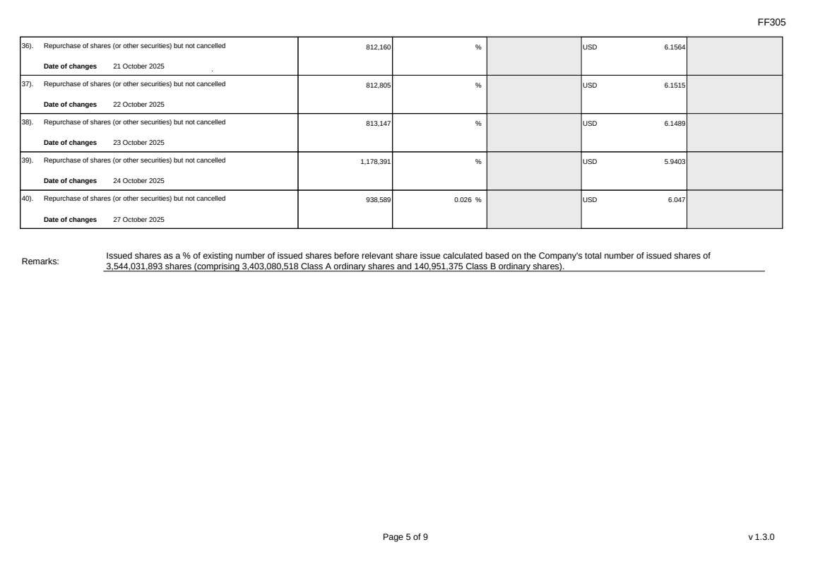 | FF305 Page 5 of 9 v 1.3.0 36). Repurchase of shares (or other securities) but not cancelled Date of changes 21 October 2025 812,160 % USD 6.1564 37). Repurchase of shares (or other securities) but not cancelled Date of changes 22 October 2025 812,805 % USD 6.1515 38). Repurchase of shares (or other securities) but not cancelled Date of changes 23 October 2025 813,147 % USD 6.1489 39). Repurchase of shares (or other securities) but not cancelled Date of changes 24 October 2025 1,178,391 % USD 5.9403 40). Repurchase of shares (or other securities) but not cancelled Date of changes 27 October 2025 938,589 0.026 % USD 6.047 Remarks: Issued shares as a % of existing number of issued shares before relevant share issue calculated based on the Company's total number of issued shares of 3,544,031,893 shares (comprising 3,403,080,518 Class A ordinary shares and 140,951,375 Class B ordinary shares).
FF305 Page 6 of 9 v 1.3.0 Confirmation Not applicable Notes to Section I: 1. Please insert the closing balance date of the last Next Day Disclosure Return published pursuant to Main Board Rule 13.25A / GEM Rule 17.27A or Monthly Return pursuant to Main Board Rule 13.25B / GEM Rule 17.27B, whichever is the later. 2. Please set out all changes in issued shares or treasury shares requiring disclosure pursuant to Main Board Rule 13.25A / GEM Rule 17.27A together with the relevant dates of changes. Each category will need to be disclosed individually with sufficient information to enable the user to identify the relevant category in the listed issuer's Monthly Return. For example, multiple issues of shares as a result of multiple exercises of share options under the same share option scheme or of multiple conversions under the same convertible note must be aggregated and disclosed as one category. However, if the issues resulted from exercises of share options under 2 share option schemes or conversions of 2 convertible notes, these must be disclosed as 2 separate categories. 3. The percentage change in the number of issued shares (excluding treasury shares) of the listed issuer is to be calculated by reference to the opening balance of the number of issued shares (excluding treasury shares) being disclosed in this Next Day Disclosure Return. 4. In the case of a share repurchase or redemption, the “issue/ selling price per share” shall be construed as “repurchase price per share” or “redemption price per share”. Where shares have been issued/ sold/ repurchased/ redeemed at more than one price per share, a volume-weighted average price per share should be given. 5. The closing balance date is the date of the last relevant event being disclosed. 6. For repurchase or redemption of shares, disclosure is required when the relevant event has occurred (subject to the provisions of Main Board Rules 10.06(4)(a), 13.25A and 13.31 / GEM Rules 13.13(1), 17.27A and 17.35), even if the repurchased or redeemed shares have not yet been cancelled. If repurchased or redeemed shares are to be cancelled upon settlement of such repurchase or redemption after the closing balance date, they shall remain part of the issued shares as at the closing balance date in Part A. Details of these repurchased or redeemed shares shall be disclosed in Part B. 7. Items (i) to (viii) are suggested forms of confirmation. The listed issuer may amend the item(s) that is/are not applicable to meet individual cases. 8. “Identical” means in this context: - the securities are of the same nominal value with the same amount called up or paid up; - they are entitled to dividend/interest at the same rate and for the same period, so that at the next ensuing distribution, the dividend/interest payable per unit will amount to exactly the same sum (gross and net); and - they carry the same rights as to unrestricted transfer, attendance and voting at meetings and rank pari passu in all other respects.
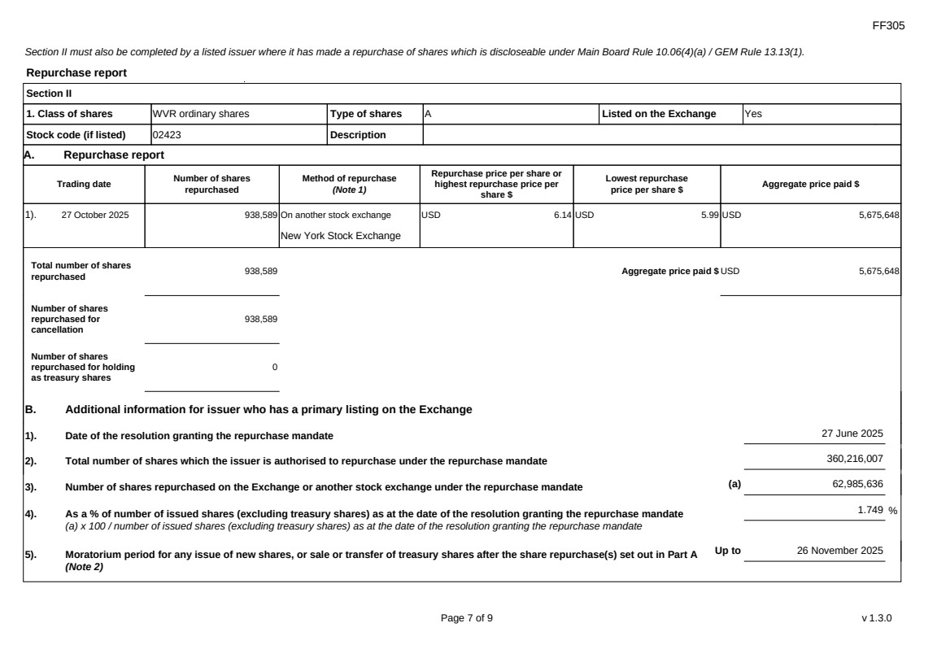 | FF305 Page 7 of 9 v 1.3.0 Section II must also be completed by a listed issuer where it has made a repurchase of shares which is discloseable under Main Board Rule 10.06(4)(a) / GEM Rule 13.13(1). Repurchase report Section II 1. Class of shares WVR ordinary shares Type of shares A Listed on the Exchange Yes Stock code (if listed) 02423 Description A. Repurchase report Trading date Number of shares repurchased Method of repurchase (Note 1) Repurchase price per share or highest repurchase price per share $ Lowest repurchase price per share $ Aggregate price paid $ 1). 27 October 2025 938,589 On another stock exchange New York Stock Exchange USD 6.14 USD 5.99 USD 5,675,648 Total number of shares repurchased 938,589 Aggregate price paid $ USD 5,675,648 Number of shares repurchased for cancellation 938,589 Number of shares repurchased for holding as treasury shares 0 B. Additional information for issuer who has a primary listing on the Exchange 1). Date of the resolution granting the repurchase mandate 27 June 2025 2). Total number of shares which the issuer is authorised to repurchase under the repurchase mandate 360,216,007 3). Number of shares repurchased on the Exchange or another stock exchange under the repurchase mandate (a) 62,985,636 4). As a % of number of issued shares (excluding treasury shares) as at the date of the resolution granting the repurchase mandate (a) x 100 / number of issued shares (excluding treasury shares) as at the date of the resolution granting the repurchase mandate 1.749 % 5). Moratorium period for any issue of new shares, or sale or transfer of treasury shares after the share repurchase(s) set out in Part A (Note 2) Up to 26 November 2025
FF305 Page 8 of 9 v 1.3.0 We hereby confirm that the repurchases set out in A above which were made on another stock exchange were made in accordance with the applicable Main Board Rules and there have been no material changes to the particulars contained in the Explanatory Statement dated 17 April 2025 which has been filed with the Exchange. We also confirm that any purchases set out in A above which were made on another stock exchange were made in accordance with the applicable rules applying to purchases made on that other exchange. Notes to Section II: 1. Please state whether the repurchase was made on the Exchange, on another stock exchange (stating the name of the exchange), by private arrangement or by general offer. 2. Subject to the carve-out set out in Main Board Rule 10.06(3)(a)/ GEM Rule 13.12, an issuer may not (i) make a new issue of shares, or a sale or transfer of any treasury shares; or (ii) announce a proposed new issue of shares, or a sale or transfer of any treasury shares, for a period of 30 days after any purchase by it of shares, whether on the Exchange or otherwise, without the prior approval of the Exchange.
FF305 Page 9 of 9 v 1.3.0 Section III must also be completed by a listed issuer where it has made a sale of treasury shares on the Exchange or any other stock exchange on which the issuer is listed which is discloseable under Main Board Rule 10.06B / GEM Rule 13.14B. Report of on-market sale of treasury shares Not applicable Submitted by: Siting Li (Name) Title: Joint Company Secretary (Director, Secretary or other Duly Authorised Officer)
Exhibit 99.3
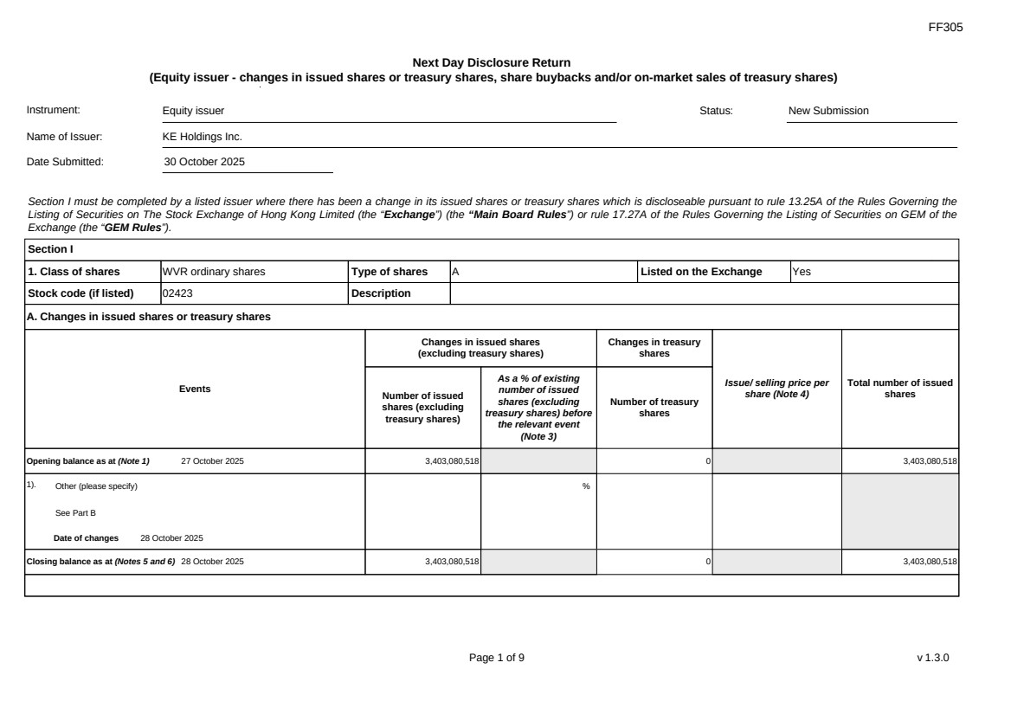 | FF305 Page 1 of 9 v 1.3.0 Next Day Disclosure Return (Equity issuer - changes in issued shares or treasury shares, share buybacks and/or on-market sales of treasury shares) Instrument: Equity issuer Status: New Submission Name of Issuer: KE Holdings Inc. Date Submitted: 30 October 2025 Section I must be completed by a listed issuer where there has been a change in its issued shares or treasury shares which is discloseable pursuant to rule 13.25A of the Rules Governing the Listing of Securities on The Stock Exchange of Hong Kong Limited (the “Exchange”) (the “Main Board Rules”) or rule 17.27A of the Rules Governing the Listing of Securities on GEM of the Exchange (the “GEM Rules”). Section I 1. Class of shares WVR ordinary shares Type of shares A Listed on the Exchange Yes Stock code (if listed) 02423 Description A. Changes in issued shares or treasury shares Events Changes in issued shares (excluding treasury shares) Number of issued shares (excluding treasury shares) As a % of existing number of issued shares (excluding treasury shares) before the relevant event (Note 3) Changes in treasury shares Number of treasury shares Issue/ selling price per share (Note 4) Total number of issued shares Opening balance as at (Note 1) 27 October 2025 3,403,080,518 0 3,403,080,518 1). Other (please specify) See Part B Date of changes 28 October 2025 % Closing balance as at (Notes 5 and 6) 28 October 2025 3,403,080,518 0 3,403,080,518
FF305 Page 2 of 9 v 1.3.0 B. Shares redeemed or repurchased for cancellation but not yet cancelled as at the closing balance date (Notes 5 and 6) 1). Repurchase of shares (or other securities) but not cancelled Date of changes 02 September 2025 1,146,105 % USD 6.0976 2). Repurchase of shares (or other securities) but not cancelled Date of changes 03 September 2025 1,129,902 % USD 6.1952 3). Repurchase of shares (or other securities) but not cancelled Date of changes 04 September 2025 1,132,359 % USD 6.1818 4). Repurchase of shares (or other securities) but not cancelled Date of changes 05 September 2025 1,110,219 % USD 6.304 5). Repurchase of shares (or other securities) but not cancelled Date of changes 08 September 2025 1,096,452 % USD 6.3821 6). Repurchase of shares (or other securities) but not cancelled Date of changes 09 September 2025 1,050,570 % USD 6.663 7). Repurchase of shares (or other securities) but not cancelled Date of changes 10 September 2025 1,055,388 % USD 6.6274 8). Repurchase of shares (or other securities) but not cancelled Date of changes 11 September 2025 519,324 % USD 6.6563 9). Repurchase of shares (or other securities) but not cancelled Date of changes 12 September 2025 408,906 % USD 6.6722 10). Repurchase of shares (or other securities) but not cancelled Date of changes 15 September 2025 685,164 % USD 6.5677 11). Repurchase of shares (or other securities) but not cancelled Date of changes 16 September 2025 652,602 % USD 6.63
FF305 Page 3 of 9 v 1.3.0 12). Repurchase of shares (or other securities) but not cancelled Date of changes 17 September 2025 292,908 % USD 6.828 13). Repurchase of shares (or other securities) but not cancelled Date of changes 18 September 2025 675,684 % USD 6.6599 14). Repurchase of shares (or other securities) but not cancelled Date of changes 19 September 2025 676,950 % USD 6.6463 15). Repurchase of shares (or other securities) but not cancelled Date of changes 22 September 2025 690,450 % USD 6.5175 16). Repurchase of shares (or other securities) but not cancelled Date of changes 23 September 2025 708,750 % USD 6.3492 17). Repurchase of shares (or other securities) but not cancelled Date of changes 24 September 2025 697,248 % USD 6.4539 18). Repurchase of shares (or other securities) but not cancelled Date of changes 25 September 2025 699,402 % USD 6.434 19). Repurchase of shares (or other securities) but not cancelled Date of changes 26 September 2025 693,855 % USD 6.4813 20). Repurchase of shares (or other securities) but not cancelled Date of changes 29 September 2025 297,129 % USD 6.7311 21). Repurchase of shares (or other securities) but not cancelled Date of changes 30 September 2025 1,563,114 % USD 6.3965 22). Repurchase of shares (or other securities) but not cancelled Date of changes 01 October 2025 472,449 % USD 6.3499 23). Repurchase of shares (or other securities) but not cancelled Date of changes 02 October 2025 793,566 % USD 6.3006
FF305 Page 4 of 9 v 1.3.0 24). Repurchase of shares (or other securities) but not cancelled Date of changes 03 October 2025 796,722 % USD 6.2757 25). Repurchase of shares (or other securities) but not cancelled Date of changes 06 October 2025 696,948 % USD 6.2852 26). Repurchase of shares (or other securities) but not cancelled Date of changes 07 October 2025 807,990 % USD 6.1882 27). Repurchase of shares (or other securities) but not cancelled Date of changes 08 October 2025 815,142 % USD 6.1339 28). Repurchase of shares (or other securities) but not cancelled Date of changes 09 October 2025 814,053 % USD 6.1421 29). Repurchase of shares (or other securities) but not cancelled Date of changes 10 October 2025 1,170,492 % USD 5.9804 30). Repurchase of shares (or other securities) but not cancelled Date of changes 13 October 2025 830,082 % USD 6.0235 31). Repurchase of shares (or other securities) but not cancelled Date of changes 14 October 2025 824,940 % USD 6.061 32). Repurchase of shares (or other securities) but not cancelled Date of changes 15 October 2025 814,122 % USD 6.1416 33). Repurchase of shares (or other securities) but not cancelled Date of changes 16 October 2025 821,538 % USD 6.0861 34). Repurchase of shares (or other securities) but not cancelled Date of changes 17 October 2025 821,211 % USD 6.0885 35). Repurchase of shares (or other securities) but not cancelled Date of changes 20 October 2025 810,273 % USD 6.1707
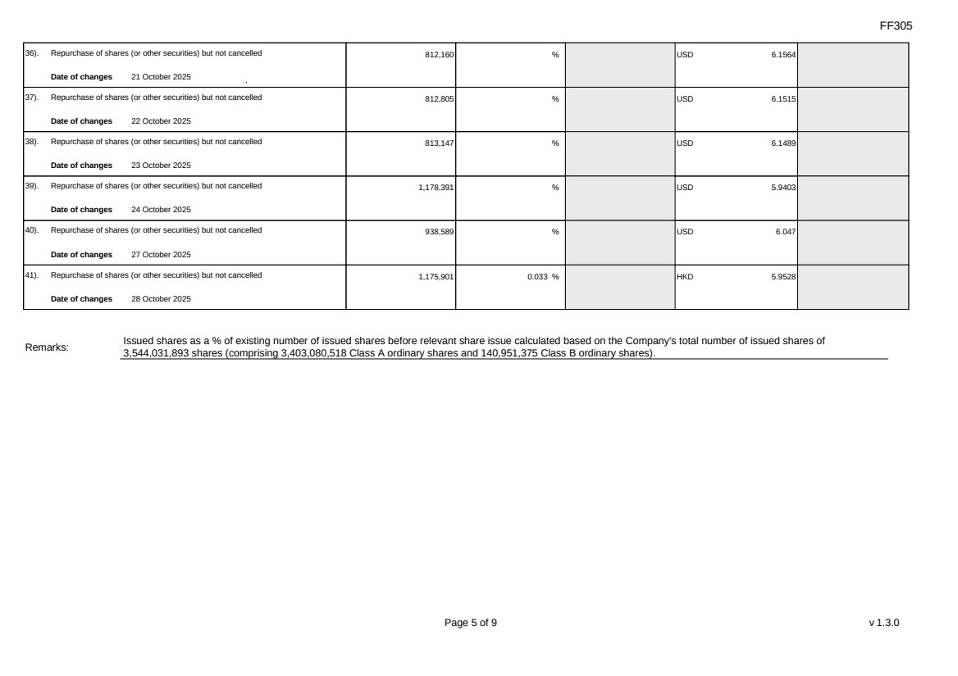 | FF305 Page 5 of 9 v 1.3.0 36). Repurchase of shares (or other securities) but not cancelled Date of changes 21 October 2025 812,160 % USD 6.1564 37). Repurchase of shares (or other securities) but not cancelled Date of changes 22 October 2025 812,805 % USD 6.1515 38). Repurchase of shares (or other securities) but not cancelled Date of changes 23 October 2025 813,147 % USD 6.1489 39). Repurchase of shares (or other securities) but not cancelled Date of changes 24 October 2025 1,178,391 % USD 5.9403 40). Repurchase of shares (or other securities) but not cancelled Date of changes 27 October 2025 938,589 % USD 6.047 41). Repurchase of shares (or other securities) but not cancelled Date of changes 28 October 2025 1,175,901 0.033 % HKD 5.9528 Remarks: Issued shares as a % of existing number of issued shares before relevant share issue calculated based on the Company's total number of issued shares of 3,544,031,893 shares (comprising 3,403,080,518 Class A ordinary shares and 140,951,375 Class B ordinary shares).
FF305 Page 6 of 9 v 1.3.0 Confirmation Not applicable Notes to Section I: 1. Please insert the closing balance date of the last Next Day Disclosure Return published pursuant to Main Board Rule 13.25A / GEM Rule 17.27A or Monthly Return pursuant to Main Board Rule 13.25B / GEM Rule 17.27B, whichever is the later. 2. Please set out all changes in issued shares or treasury shares requiring disclosure pursuant to Main Board Rule 13.25A / GEM Rule 17.27A together with the relevant dates of changes. Each category will need to be disclosed individually with sufficient information to enable the user to identify the relevant category in the listed issuer's Monthly Return. For example, multiple issues of shares as a result of multiple exercises of share options under the same share option scheme or of multiple conversions under the same convertible note must be aggregated and disclosed as one category. However, if the issues resulted from exercises of share options under 2 share option schemes or conversions of 2 convertible notes, these must be disclosed as 2 separate categories. 3. The percentage change in the number of issued shares (excluding treasury shares) of the listed issuer is to be calculated by reference to the opening balance of the number of issued shares (excluding treasury shares) being disclosed in this Next Day Disclosure Return. 4. In the case of a share repurchase or redemption, the “issue/ selling price per share” shall be construed as “repurchase price per share” or “redemption price per share”. Where shares have been issued/ sold/ repurchased/ redeemed at more than one price per share, a volume-weighted average price per share should be given. 5. The closing balance date is the date of the last relevant event being disclosed. 6. For repurchase or redemption of shares, disclosure is required when the relevant event has occurred (subject to the provisions of Main Board Rules 10.06(4)(a), 13.25A and 13.31 / GEM Rules 13.13(1), 17.27A and 17.35), even if the repurchased or redeemed shares have not yet been cancelled. If repurchased or redeemed shares are to be cancelled upon settlement of such repurchase or redemption after the closing balance date, they shall remain part of the issued shares as at the closing balance date in Part A. Details of these repurchased or redeemed shares shall be disclosed in Part B. 7. Items (i) to (viii) are suggested forms of confirmation. The listed issuer may amend the item(s) that is/are not applicable to meet individual cases. 8. “Identical” means in this context: - the securities are of the same nominal value with the same amount called up or paid up; - they are entitled to dividend/interest at the same rate and for the same period, so that at the next ensuing distribution, the dividend/interest payable per unit will amount to exactly the same sum (gross and net); and - they carry the same rights as to unrestricted transfer, attendance and voting at meetings and rank pari passu in all other respects.
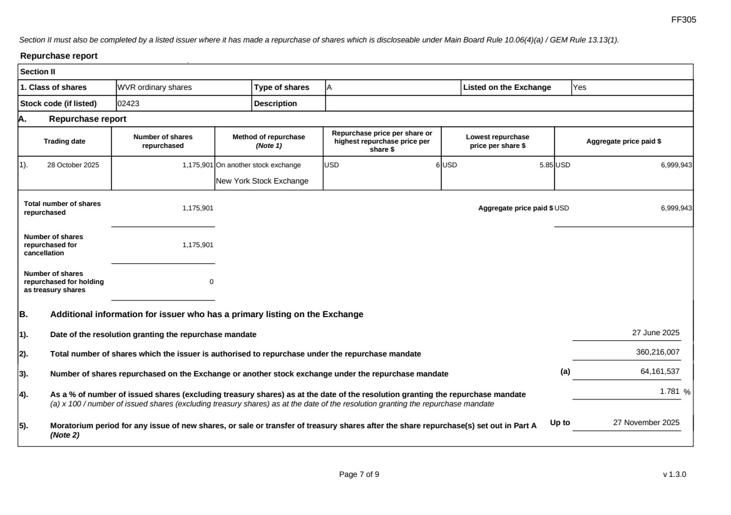 | FF305 Page 7 of 9 v 1.3.0 Section II must also be completed by a listed issuer where it has made a repurchase of shares which is discloseable under Main Board Rule 10.06(4)(a) / GEM Rule 13.13(1). Repurchase report Section II 1. Class of shares WVR ordinary shares Type of shares A Listed on the Exchange Yes Stock code (if listed) 02423 Description A. Repurchase report Trading date Number of shares repurchased Method of repurchase (Note 1) Repurchase price per share or highest repurchase price per share $ Lowest repurchase price per share $ Aggregate price paid $ 1). 28 October 2025 1,175,901 On another stock exchange New York Stock Exchange USD 6 USD 5.85 USD 6,999,943 Total number of shares repurchased 1,175,901 Aggregate price paid $ USD 6,999,943 Number of shares repurchased for cancellation 1,175,901 Number of shares repurchased for holding as treasury shares 0 B. Additional information for issuer who has a primary listing on the Exchange 1). Date of the resolution granting the repurchase mandate 27 June 2025 2). Total number of shares which the issuer is authorised to repurchase under the repurchase mandate 360,216,007 3). Number of shares repurchased on the Exchange or another stock exchange under the repurchase mandate (a) 64,161,537 4). As a % of number of issued shares (excluding treasury shares) as at the date of the resolution granting the repurchase mandate (a) x 100 / number of issued shares (excluding treasury shares) as at the date of the resolution granting the repurchase mandate 1.781 % 5). Moratorium period for any issue of new shares, or sale or transfer of treasury shares after the share repurchase(s) set out in Part A (Note 2) Up to 27 November 2025
FF305 Page 8 of 9 v 1.3.0 We hereby confirm that the repurchases set out in A above which were made on another stock exchange were made in accordance with the applicable Main Board Rules and there have been no material changes to the particulars contained in the Explanatory Statement dated 17 April 2025 which has been filed with the Exchange. We also confirm that any purchases set out in A above which were made on another stock exchange were made in accordance with the applicable rules applying to purchases made on that other exchange. Notes to Section II: 1. Please state whether the repurchase was made on the Exchange, on another stock exchange (stating the name of the exchange), by private arrangement or by general offer. 2. Subject to the carve-out set out in Main Board Rule 10.06(3)(a)/ GEM Rule 13.12, an issuer may not (i) make a new issue of shares, or a sale or transfer of any treasury shares; or (ii) announce a proposed new issue of shares, or a sale or transfer of any treasury shares, for a period of 30 days after any purchase by it of shares, whether on the Exchange or otherwise, without the prior approval of the Exchange.
FF305 Page 9 of 9 v 1.3.0 Section III must also be completed by a listed issuer where it has made a sale of treasury shares on the Exchange or any other stock exchange on which the issuer is listed which is discloseable under Main Board Rule 10.06B / GEM Rule 13.14B. Report of on-market sale of treasury shares Not applicable Submitted by: Siting Li (Name) Title: Joint Company Secretary (Director, Secretary or other Duly Authorised Officer)
Exhibit 99.4
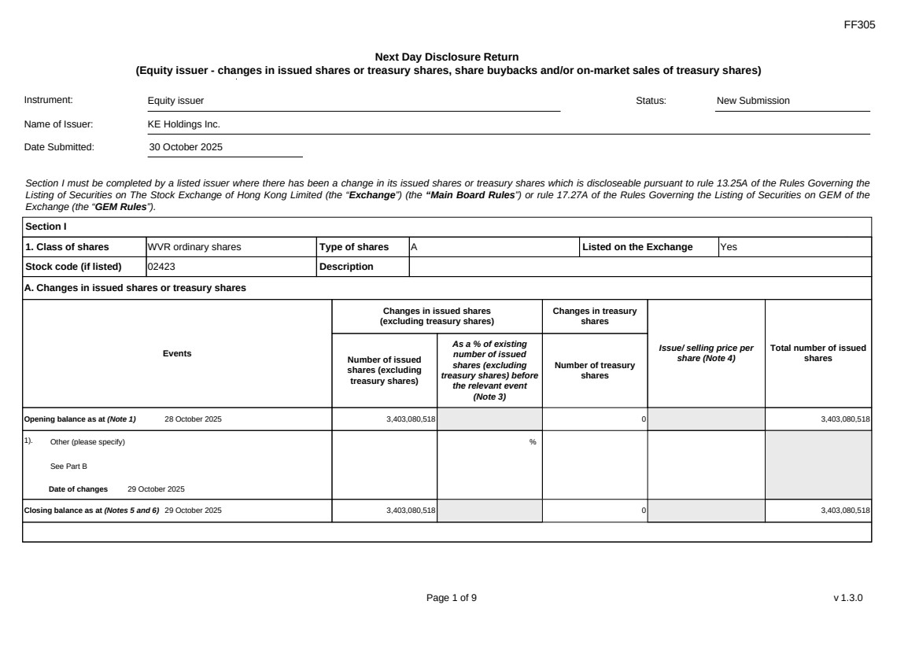 | FF305 Page 1 of 9 v 1.3.0 Next Day Disclosure Return (Equity issuer - changes in issued shares or treasury shares, share buybacks and/or on-market sales of treasury shares) Instrument: Equity issuer Status: New Submission Name of Issuer: KE Holdings Inc. Date Submitted: 30 October 2025 Section I must be completed by a listed issuer where there has been a change in its issued shares or treasury shares which is discloseable pursuant to rule 13.25A of the Rules Governing the Listing of Securities on The Stock Exchange of Hong Kong Limited (the “Exchange”) (the “Main Board Rules”) or rule 17.27A of the Rules Governing the Listing of Securities on GEM of the Exchange (the “GEM Rules”). Section I 1. Class of shares WVR ordinary shares Type of shares A Listed on the Exchange Yes Stock code (if listed) 02423 Description A. Changes in issued shares or treasury shares Events Changes in issued shares (excluding treasury shares) Number of issued shares (excluding treasury shares) As a % of existing number of issued shares (excluding treasury shares) before the relevant event (Note 3) Changes in treasury shares Number of treasury shares Issue/ selling price per share (Note 4) Total number of issued shares Opening balance as at (Note 1) 28 October 2025 3,403,080,518 0 3,403,080,518 1). Other (please specify) See Part B Date of changes 29 October 2025 % Closing balance as at (Notes 5 and 6) 29 October 2025 3,403,080,518 0 3,403,080,518
FF305 Page 2 of 9 v 1.3.0 B. Shares redeemed or repurchased for cancellation but not yet cancelled as at the closing balance date (Notes 5 and 6) 1). Repurchase of shares (or other securities) but not cancelled Date of changes 02 September 2025 1,146,105 % USD 6.0976 2). Repurchase of shares (or other securities) but not cancelled Date of changes 03 September 2025 1,129,902 % USD 6.1952 3). Repurchase of shares (or other securities) but not cancelled Date of changes 04 September 2025 1,132,359 % USD 6.1818 4). Repurchase of shares (or other securities) but not cancelled Date of changes 05 September 2025 1,110,219 % USD 6.304 5). Repurchase of shares (or other securities) but not cancelled Date of changes 08 September 2025 1,096,452 % USD 6.3821 6). Repurchase of shares (or other securities) but not cancelled Date of changes 09 September 2025 1,050,570 % USD 6.663 7). Repurchase of shares (or other securities) but not cancelled Date of changes 10 September 2025 1,055,388 % USD 6.6274 8). Repurchase of shares (or other securities) but not cancelled Date of changes 11 September 2025 519,324 % USD 6.6563 9). Repurchase of shares (or other securities) but not cancelled Date of changes 12 September 2025 408,906 % USD 6.6722 10). Repurchase of shares (or other securities) but not cancelled Date of changes 15 September 2025 685,164 % USD 6.5677 11). Repurchase of shares (or other securities) but not cancelled Date of changes 16 September 2025 652,602 % USD 6.63
FF305 Page 3 of 9 v 1.3.0 12). Repurchase of shares (or other securities) but not cancelled Date of changes 17 September 2025 292,908 % USD 6.828 13). Repurchase of shares (or other securities) but not cancelled Date of changes 18 September 2025 675,684 % USD 6.6599 14). Repurchase of shares (or other securities) but not cancelled Date of changes 19 September 2025 676,950 % USD 6.6463 15). Repurchase of shares (or other securities) but not cancelled Date of changes 22 September 2025 690,450 % USD 6.5175 16). Repurchase of shares (or other securities) but not cancelled Date of changes 23 September 2025 708,750 % USD 6.3492 17). Repurchase of shares (or other securities) but not cancelled Date of changes 24 September 2025 697,248 % USD 6.4539 18). Repurchase of shares (or other securities) but not cancelled Date of changes 25 September 2025 699,402 % USD 6.434 19). Repurchase of shares (or other securities) but not cancelled Date of changes 26 September 2025 693,855 % USD 6.4813 20). Repurchase of shares (or other securities) but not cancelled Date of changes 29 September 2025 297,129 % USD 6.7311 21). Repurchase of shares (or other securities) but not cancelled Date of changes 30 September 2025 1,563,114 % USD 6.3965 22). Repurchase of shares (or other securities) but not cancelled Date of changes 01 October 2025 472,449 % USD 6.3499 23). Repurchase of shares (or other securities) but not cancelled Date of changes 02 October 2025 793,566 % USD 6.3006
FF305 Page 4 of 9 v 1.3.0 24). Repurchase of shares (or other securities) but not cancelled Date of changes 03 October 2025 796,722 % USD 6.2757 25). Repurchase of shares (or other securities) but not cancelled Date of changes 06 October 2025 696,948 % USD 6.2852 26). Repurchase of shares (or other securities) but not cancelled Date of changes 07 October 2025 807,990 % USD 6.1882 27). Repurchase of shares (or other securities) but not cancelled Date of changes 08 October 2025 815,142 % USD 6.1339 28). Repurchase of shares (or other securities) but not cancelled Date of changes 09 October 2025 814,053 % USD 6.1421 29). Repurchase of shares (or other securities) but not cancelled Date of changes 10 October 2025 1,170,492 % USD 5.9804 30). Repurchase of shares (or other securities) but not cancelled Date of changes 13 October 2025 830,082 % USD 6.0235 31). Repurchase of shares (or other securities) but not cancelled Date of changes 14 October 2025 824,940 % USD 6.061 32). Repurchase of shares (or other securities) but not cancelled Date of changes 15 October 2025 814,122 % USD 6.1416 33). Repurchase of shares (or other securities) but not cancelled Date of changes 16 October 2025 821,538 % USD 6.0861 34). Repurchase of shares (or other securities) but not cancelled Date of changes 17 October 2025 821,211 % USD 6.0885 35). Repurchase of shares (or other securities) but not cancelled Date of changes 20 October 2025 810,273 % USD 6.1707
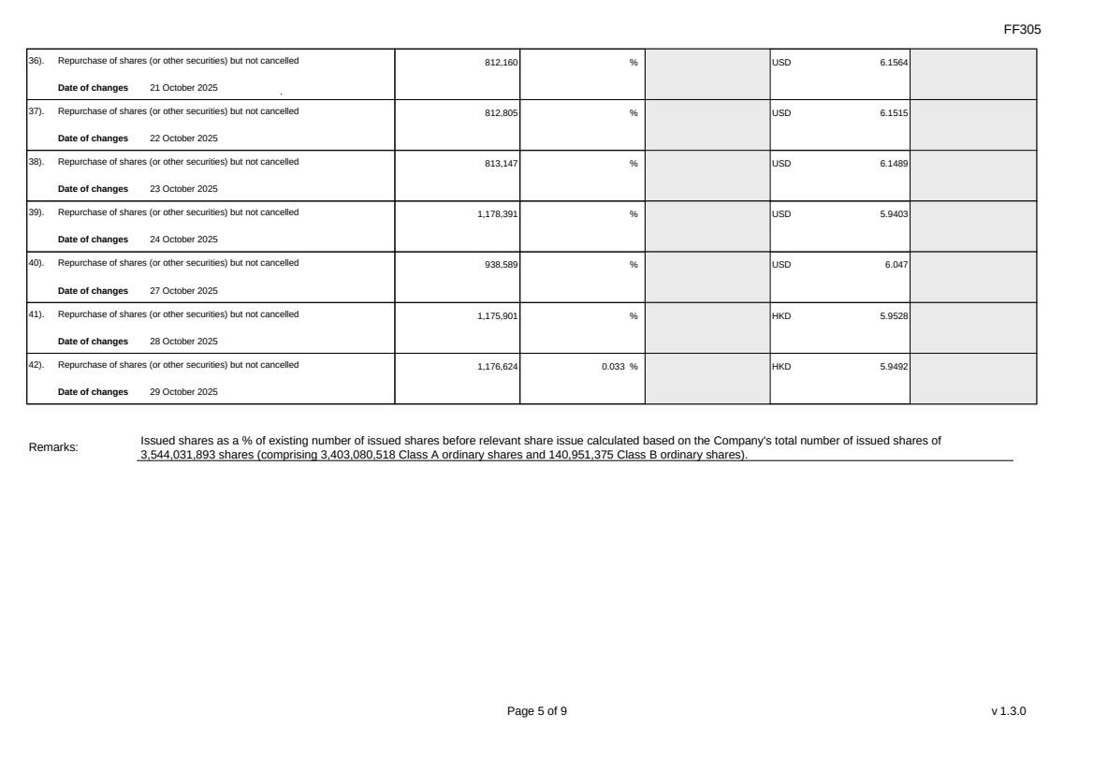 | FF305 Page 5 of 9 v 1.3.0 36). Repurchase of shares (or other securities) but not cancelled Date of changes 21 October 2025 812,160 % USD 6.1564 37). Repurchase of shares (or other securities) but not cancelled Date of changes 22 October 2025 812,805 % USD 6.1515 38). Repurchase of shares (or other securities) but not cancelled Date of changes 23 October 2025 813,147 % USD 6.1489 39). Repurchase of shares (or other securities) but not cancelled Date of changes 24 October 2025 1,178,391 % USD 5.9403 40). Repurchase of shares (or other securities) but not cancelled Date of changes 27 October 2025 938,589 % USD 6.047 41). Repurchase of shares (or other securities) but not cancelled Date of changes 28 October 2025 1,175,901 % HKD 5.9528 42). Repurchase of shares (or other securities) but not cancelled Date of changes 29 October 2025 1,176,624 0.033 % HKD 5.9492 Remarks: Issued shares as a % of existing number of issued shares before relevant share issue calculated based on the Company's total number of issued shares of 3,544,031,893 shares (comprising 3,403,080,518 Class A ordinary shares and 140,951,375 Class B ordinary shares).
FF305 Page 6 of 9 v 1.3.0 Confirmation Not applicable Notes to Section I: 1. Please insert the closing balance date of the last Next Day Disclosure Return published pursuant to Main Board Rule 13.25A / GEM Rule 17.27A or Monthly Return pursuant to Main Board Rule 13.25B / GEM Rule 17.27B, whichever is the later. 2. Please set out all changes in issued shares or treasury shares requiring disclosure pursuant to Main Board Rule 13.25A / GEM Rule 17.27A together with the relevant dates of changes. Each category will need to be disclosed individually with sufficient information to enable the user to identify the relevant category in the listed issuer's Monthly Return. For example, multiple issues of shares as a result of multiple exercises of share options under the same share option scheme or of multiple conversions under the same convertible note must be aggregated and disclosed as one category. However, if the issues resulted from exercises of share options under 2 share option schemes or conversions of 2 convertible notes, these must be disclosed as 2 separate categories. 3. The percentage change in the number of issued shares (excluding treasury shares) of the listed issuer is to be calculated by reference to the opening balance of the number of issued shares (excluding treasury shares) being disclosed in this Next Day Disclosure Return. 4. In the case of a share repurchase or redemption, the “issue/ selling price per share” shall be construed as “repurchase price per share” or “redemption price per share”. Where shares have been issued/ sold/ repurchased/ redeemed at more than one price per share, a volume-weighted average price per share should be given. 5. The closing balance date is the date of the last relevant event being disclosed. 6. For repurchase or redemption of shares, disclosure is required when the relevant event has occurred (subject to the provisions of Main Board Rules 10.06(4)(a), 13.25A and 13.31 / GEM Rules 13.13(1), 17.27A and 17.35), even if the repurchased or redeemed shares have not yet been cancelled. If repurchased or redeemed shares are to be cancelled upon settlement of such repurchase or redemption after the closing balance date, they shall remain part of the issued shares as at the closing balance date in Part A. Details of these repurchased or redeemed shares shall be disclosed in Part B. 7. Items (i) to (viii) are suggested forms of confirmation. The listed issuer may amend the item(s) that is/are not applicable to meet individual cases. 8. “Identical” means in this context: - the securities are of the same nominal value with the same amount called up or paid up; - they are entitled to dividend/interest at the same rate and for the same period, so that at the next ensuing distribution, the dividend/interest payable per unit will amount to exactly the same sum (gross and net); and - they carry the same rights as to unrestricted transfer, attendance and voting at meetings and rank pari passu in all other respects.
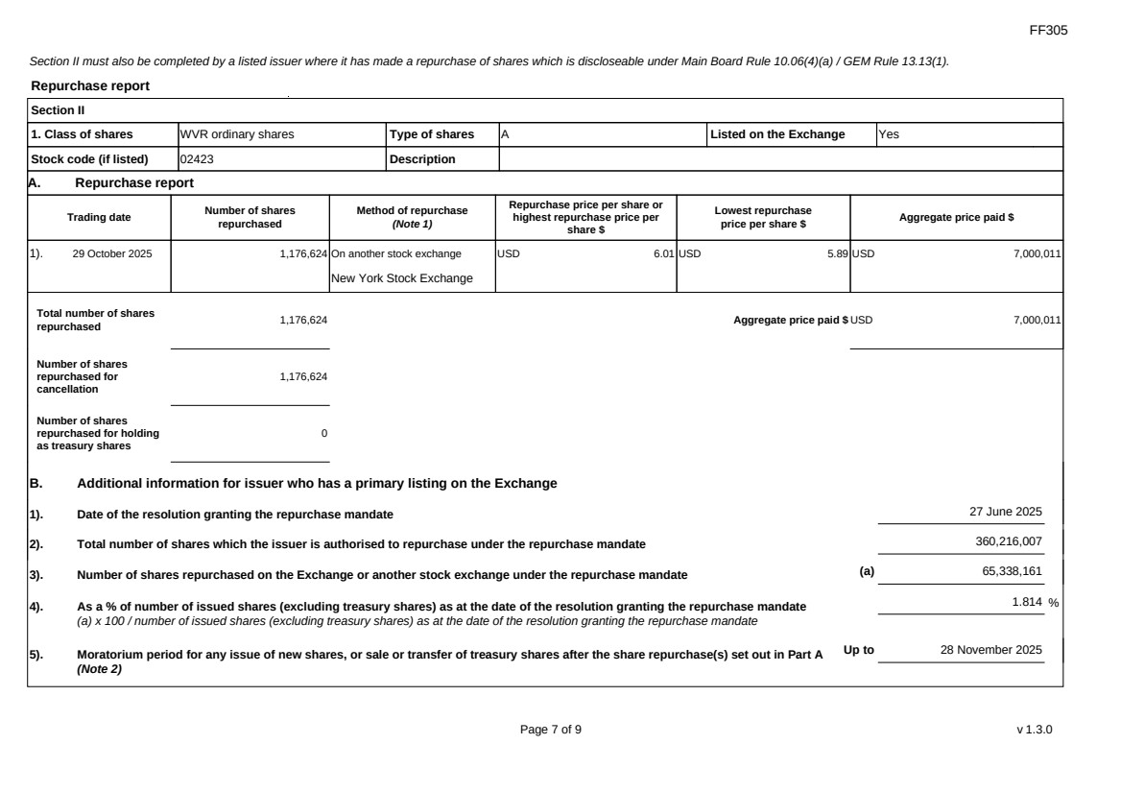 | FF305 Page 7 of 9 v 1.3.0 Section II must also be completed by a listed issuer where it has made a repurchase of shares which is discloseable under Main Board Rule 10.06(4)(a) / GEM Rule 13.13(1). Repurchase report Section II 1. Class of shares WVR ordinary shares Type of shares A Listed on the Exchange Yes Stock code (if listed) 02423 Description A. Repurchase report Trading date Number of shares repurchased Method of repurchase (Note 1) Repurchase price per share or highest repurchase price per share $ Lowest repurchase price per share $ Aggregate price paid $ 1). 29 October 2025 1,176,624 On another stock exchange New York Stock Exchange USD 6.01 USD 5.89 USD 7,000,011 Total number of shares repurchased 1,176,624 Aggregate price paid $ USD 7,000,011 Number of shares repurchased for cancellation 1,176,624 Number of shares repurchased for holding as treasury shares 0 B. Additional information for issuer who has a primary listing on the Exchange 1). Date of the resolution granting the repurchase mandate 27 June 2025 2). Total number of shares which the issuer is authorised to repurchase under the repurchase mandate 360,216,007 3). Number of shares repurchased on the Exchange or another stock exchange under the repurchase mandate (a) 65,338,161 4). As a % of number of issued shares (excluding treasury shares) as at the date of the resolution granting the repurchase mandate (a) x 100 / number of issued shares (excluding treasury shares) as at the date of the resolution granting the repurchase mandate 1.814 % 5). Moratorium period for any issue of new shares, or sale or transfer of treasury shares after the share repurchase(s) set out in Part A (Note 2) Up to 28 November 2025
FF305 Page 8 of 9 v 1.3.0 We hereby confirm that the repurchases set out in A above which were made on another stock exchange were made in accordance with the applicable Main Board Rules and there have been no material changes to the particulars contained in the Explanatory Statement dated 17 April 2025 which has been filed with the Exchange. We also confirm that any purchases set out in A above which were made on another stock exchange were made in accordance with the applicable rules applying to purchases made on that other exchange. Notes to Section II: 1. Please state whether the repurchase was made on the Exchange, on another stock exchange (stating the name of the exchange), by private arrangement or by general offer. 2. Subject to the carve-out set out in Main Board Rule 10.06(3)(a)/ GEM Rule 13.12, an issuer may not (i) make a new issue of shares, or a sale or transfer of any treasury shares; or (ii) announce a proposed new issue of shares, or a sale or transfer of any treasury shares, for a period of 30 days after any purchase by it of shares, whether on the Exchange or otherwise, without the prior approval of the Exchange.
FF305 Page 9 of 9 v 1.3.0 Section III must also be completed by a listed issuer where it has made a sale of treasury shares on the Exchange or any other stock exchange on which the issuer is listed which is discloseable under Main Board Rule 10.06B / GEM Rule 13.14B. Report of on-market sale of treasury shares Not applicable Submitted by: Siting Li (Name) Title: Joint Company Secretary (Director, Secretary or other Duly Authorised Officer)
Exhibit 99.5
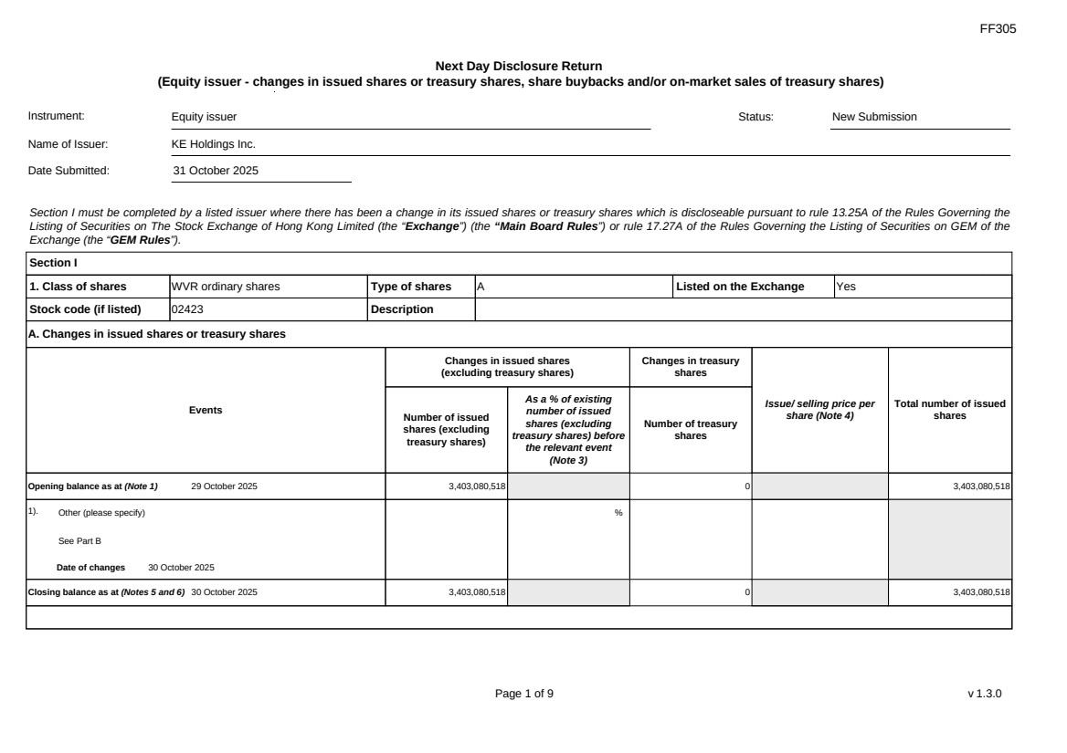 | FF305 Page 1 of 9 v 1.3.0 Next Day Disclosure Return (Equity issuer - changes in issued shares or treasury shares, share buybacks and/or on-market sales of treasury shares) Instrument: Equity issuer Status: New Submission Name of Issuer: KE Holdings Inc. Date Submitted: 31 October 2025 Section I must be completed by a listed issuer where there has been a change in its issued shares or treasury shares which is discloseable pursuant to rule 13.25A of the Rules Governing the Listing of Securities on The Stock Exchange of Hong Kong Limited (the “Exchange”) (the “Main Board Rules”) or rule 17.27A of the Rules Governing the Listing of Securities on GEM of the Exchange (the “GEM Rules”). Section I 1. Class of shares WVR ordinary shares Type of shares A Listed on the Exchange Yes Stock code (if listed) 02423 Description A. Changes in issued shares or treasury shares Events Changes in issued shares (excluding treasury shares) Number of issued shares (excluding treasury shares) As a % of existing number of issued shares (excluding treasury shares) before the relevant event (Note 3) Changes in treasury shares Number of treasury shares Issue/ selling price per share (Note 4) Total number of issued shares Opening balance as at (Note 1) 29 October 2025 3,403,080,518 0 3,403,080,518 1). Other (please specify) See Part B Date of changes 30 October 2025 % Closing balance as at (Notes 5 and 6) 30 October 2025 3,403,080,518 0 3,403,080,518
FF305 Page 2 of 9 v 1.3.0 B. Shares redeemed or repurchased for cancellation but not yet cancelled as at the closing balance date (Notes 5 and 6) 1). Repurchase of shares (or other securities) but not cancelled Date of changes 02 September 2025 1,146,105 % USD 6.0976 2). Repurchase of shares (or other securities) but not cancelled Date of changes 03 September 2025 1,129,902 % USD 6.1952 3). Repurchase of shares (or other securities) but not cancelled Date of changes 04 September 2025 1,132,359 % USD 6.1818 4). Repurchase of shares (or other securities) but not cancelled Date of changes 05 September 2025 1,110,219 % USD 6.304 5). Repurchase of shares (or other securities) but not cancelled Date of changes 08 September 2025 1,096,452 % USD 6.3821 6). Repurchase of shares (or other securities) but not cancelled Date of changes 09 September 2025 1,050,570 % USD 6.663 7). Repurchase of shares (or other securities) but not cancelled Date of changes 10 September 2025 1,055,388 % USD 6.6274 8). Repurchase of shares (or other securities) but not cancelled Date of changes 11 September 2025 519,324 % USD 6.6563 9). Repurchase of shares (or other securities) but not cancelled Date of changes 12 September 2025 408,906 % USD 6.6722 10). Repurchase of shares (or other securities) but not cancelled Date of changes 15 September 2025 685,164 % USD 6.5677 11). Repurchase of shares (or other securities) but not cancelled Date of changes 16 September 2025 652,602 % USD 6.63
FF305 Page 3 of 9 v 1.3.0 12). Repurchase of shares (or other securities) but not cancelled Date of changes 17 September 2025 292,908 % USD 6.828 13). Repurchase of shares (or other securities) but not cancelled Date of changes 18 September 2025 675,684 % USD 6.6599 14). Repurchase of shares (or other securities) but not cancelled Date of changes 19 September 2025 676,950 % USD 6.6463 15). Repurchase of shares (or other securities) but not cancelled Date of changes 22 September 2025 690,450 % USD 6.5175 16). Repurchase of shares (or other securities) but not cancelled Date of changes 23 September 2025 708,750 % USD 6.3492 17). Repurchase of shares (or other securities) but not cancelled Date of changes 24 September 2025 697,248 % USD 6.4539 18). Repurchase of shares (or other securities) but not cancelled Date of changes 25 September 2025 699,402 % USD 6.434 19). Repurchase of shares (or other securities) but not cancelled Date of changes 26 September 2025 693,855 % USD 6.4813 20). Repurchase of shares (or other securities) but not cancelled Date of changes 29 September 2025 297,129 % USD 6.7311 21). Repurchase of shares (or other securities) but not cancelled Date of changes 30 September 2025 1,563,114 % USD 6.3965 22). Repurchase of shares (or other securities) but not cancelled Date of changes 01 October 2025 472,449 % USD 6.3499 23). Repurchase of shares (or other securities) but not cancelled Date of changes 02 October 2025 793,566 % USD 6.3006
FF305 Page 4 of 9 v 1.3.0 24). Repurchase of shares (or other securities) but not cancelled Date of changes 03 October 2025 796,722 % USD 6.2757 25). Repurchase of shares (or other securities) but not cancelled Date of changes 06 October 2025 696,948 % USD 6.2852 26). Repurchase of shares (or other securities) but not cancelled Date of changes 07 October 2025 807,990 % USD 6.1882 27). Repurchase of shares (or other securities) but not cancelled Date of changes 08 October 2025 815,142 % USD 6.1339 28). Repurchase of shares (or other securities) but not cancelled Date of changes 09 October 2025 814,053 % USD 6.1421 29). Repurchase of shares (or other securities) but not cancelled Date of changes 10 October 2025 1,170,492 % USD 5.9804 30). Repurchase of shares (or other securities) but not cancelled Date of changes 13 October 2025 830,082 % USD 6.0235 31). Repurchase of shares (or other securities) but not cancelled Date of changes 14 October 2025 824,940 % USD 6.061 32). Repurchase of shares (or other securities) but not cancelled Date of changes 15 October 2025 814,122 % USD 6.1416 33). Repurchase of shares (or other securities) but not cancelled Date of changes 16 October 2025 821,538 % USD 6.0861 34). Repurchase of shares (or other securities) but not cancelled Date of changes 17 October 2025 821,211 % USD 6.0885 35). Repurchase of shares (or other securities) but not cancelled Date of changes 20 October 2025 810,273 % USD 6.1707
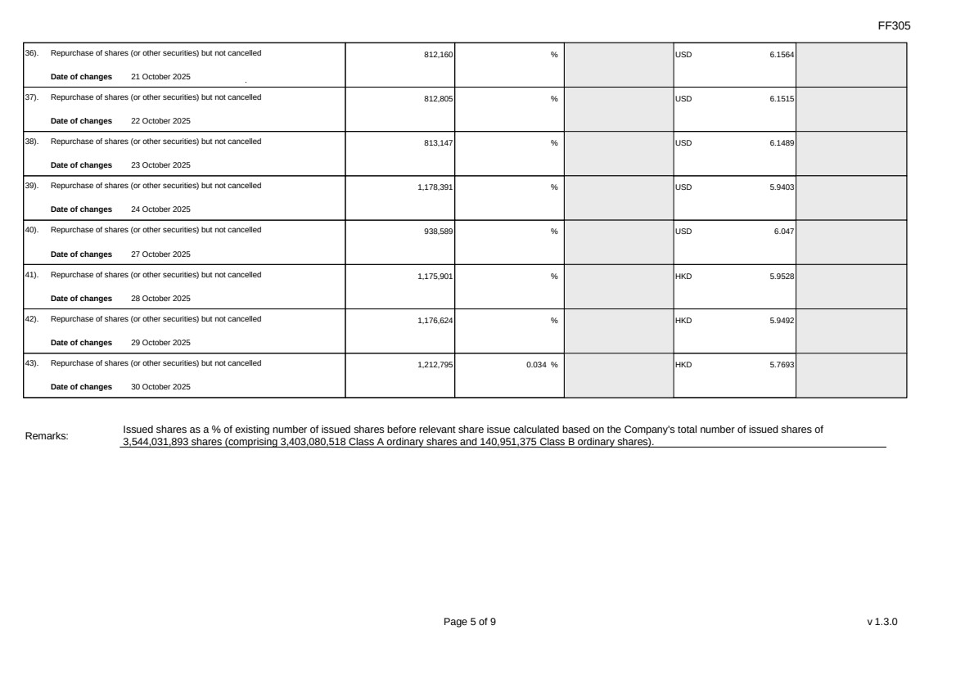 | FF305 Page 5 of 9 v 1.3.0 36). Repurchase of shares (or other securities) but not cancelled Date of changes 21 October 2025 812,160 % USD 6.1564 37). Repurchase of shares (or other securities) but not cancelled Date of changes 22 October 2025 812,805 % USD 6.1515 38). Repurchase of shares (or other securities) but not cancelled Date of changes 23 October 2025 813,147 % USD 6.1489 39). Repurchase of shares (or other securities) but not cancelled Date of changes 24 October 2025 1,178,391 % USD 5.9403 40). Repurchase of shares (or other securities) but not cancelled Date of changes 27 October 2025 938,589 % USD 6.047 41). Repurchase of shares (or other securities) but not cancelled Date of changes 28 October 2025 1,175,901 % HKD 5.9528 42). Repurchase of shares (or other securities) but not cancelled Date of changes 29 October 2025 1,176,624 % HKD 5.9492 43). Repurchase of shares (or other securities) but not cancelled Date of changes 30 October 2025 1,212,795 0.034 % HKD 5.7693 Remarks: Issued shares as a % of existing number of issued shares before relevant share issue calculated based on the Company's total number of issued shares of 3,544,031,893 shares (comprising 3,403,080,518 Class A ordinary shares and 140,951,375 Class B ordinary shares).
FF305 Page 6 of 9 v 1.3.0 Confirmation Not applicable Notes to Section I: 1. Please insert the closing balance date of the last Next Day Disclosure Return published pursuant to Main Board Rule 13.25A / GEM Rule 17.27A or Monthly Return pursuant to Main Board Rule 13.25B / GEM Rule 17.27B, whichever is the later. 2. Please set out all changes in issued shares or treasury shares requiring disclosure pursuant to Main Board Rule 13.25A / GEM Rule 17.27A together with the relevant dates of changes. Each category will need to be disclosed individually with sufficient information to enable the user to identify the relevant category in the listed issuer's Monthly Return. For example, multiple issues of shares as a result of multiple exercises of share options under the same share option scheme or of multiple conversions under the same convertible note must be aggregated and disclosed as one category. However, if the issues resulted from exercises of share options under 2 share option schemes or conversions of 2 convertible notes, these must be disclosed as 2 separate categories. 3. The percentage change in the number of issued shares (excluding treasury shares) of the listed issuer is to be calculated by reference to the opening balance of the number of issued shares (excluding treasury shares) being disclosed in this Next Day Disclosure Return. 4. In the case of a share repurchase or redemption, the “issue/ selling price per share” shall be construed as “repurchase price per share” or “redemption price per share”. Where shares have been issued/ sold/ repurchased/ redeemed at more than one price per share, a volume-weighted average price per share should be given. 5. The closing balance date is the date of the last relevant event being disclosed. 6. For repurchase or redemption of shares, disclosure is required when the relevant event has occurred (subject to the provisions of Main Board Rules 10.06(4)(a), 13.25A and 13.31 / GEM Rules 13.13(1), 17.27A and 17.35), even if the repurchased or redeemed shares have not yet been cancelled. If repurchased or redeemed shares are to be cancelled upon settlement of such repurchase or redemption after the closing balance date, they shall remain part of the issued shares as at the closing balance date in Part A. Details of these repurchased or redeemed shares shall be disclosed in Part B. 7. Items (i) to (viii) are suggested forms of confirmation. The listed issuer may amend the item(s) that is/are not applicable to meet individual cases. 8. “Identical” means in this context: - the securities are of the same nominal value with the same amount called up or paid up; - they are entitled to dividend/interest at the same rate and for the same period, so that at the next ensuing distribution, the dividend/interest payable per unit will amount to exactly the same sum (gross and net); and - they carry the same rights as to unrestricted transfer, attendance and voting at meetings and rank pari passu in all other respects.
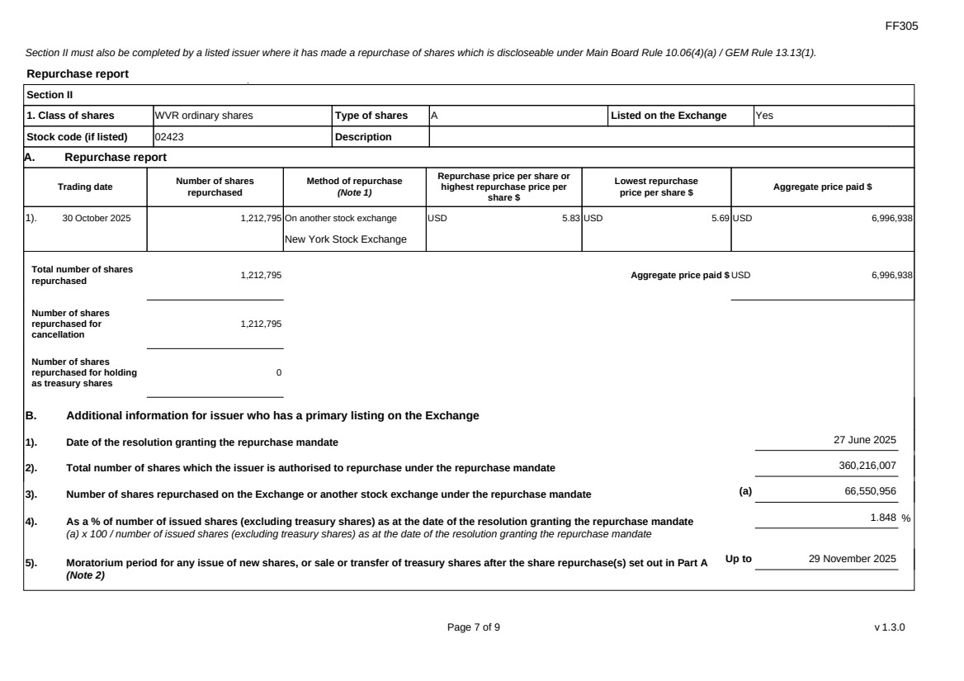 | FF305 Page 7 of 9 v 1.3.0 Section II must also be completed by a listed issuer where it has made a repurchase of shares which is discloseable under Main Board Rule 10.06(4)(a) / GEM Rule 13.13(1). Repurchase report Section II 1. Class of shares WVR ordinary shares Type of shares A Listed on the Exchange Yes Stock code (if listed) 02423 Description A. Repurchase report Trading date Number of shares repurchased Method of repurchase (Note 1) Repurchase price per share or highest repurchase price per share $ Lowest repurchase price per share $ Aggregate price paid $ 1). 30 October 2025 1,212,795 On another stock exchange New York Stock Exchange USD 5.83 USD 5.69 USD 6,996,938 Total number of shares repurchased 1,212,795 Aggregate price paid $ USD 6,996,938 Number of shares repurchased for cancellation 1,212,795 Number of shares repurchased for holding as treasury shares 0 B. Additional information for issuer who has a primary listing on the Exchange 1). Date of the resolution granting the repurchase mandate 27 June 2025 2). Total number of shares which the issuer is authorised to repurchase under the repurchase mandate 360,216,007 3). Number of shares repurchased on the Exchange or another stock exchange under the repurchase mandate (a) 66,550,956 4). As a % of number of issued shares (excluding treasury shares) as at the date of the resolution granting the repurchase mandate (a) x 100 / number of issued shares (excluding treasury shares) as at the date of the resolution granting the repurchase mandate 1.848 % 5). Moratorium period for any issue of new shares, or sale or transfer of treasury shares after the share repurchase(s) set out in Part A (Note 2) Up to 29 November 2025
FF305 Page 8 of 9 v 1.3.0 We hereby confirm that the repurchases set out in A above which were made on another stock exchange were made in accordance with the applicable Main Board Rules and there have been no material changes to the particulars contained in the Explanatory Statement dated 17 April 2025 which has been filed with the Exchange. We also confirm that any purchases set out in A above which were made on another stock exchange were made in accordance with the applicable rules applying to purchases made on that other exchange. Notes to Section II: 1. Please state whether the repurchase was made on the Exchange, on another stock exchange (stating the name of the exchange), by private arrangement or by general offer. 2. Subject to the carve-out set out in Main Board Rule 10.06(3)(a)/ GEM Rule 13.12, an issuer may not (i) make a new issue of shares, or a sale or transfer of any treasury shares; or (ii) announce a proposed new issue of shares, or a sale or transfer of any treasury shares, for a period of 30 days after any purchase by it of shares, whether on the Exchange or otherwise, without the prior approval of the Exchange.
FF305 Page 9 of 9 v 1.3.0 Section III must also be completed by a listed issuer where it has made a sale of treasury shares on the Exchange or any other stock exchange on which the issuer is listed which is discloseable under Main Board Rule 10.06B / GEM Rule 13.14B. Report of on-market sale of treasury shares Not applicable Submitted by: Siting Li (Name) Title: Joint Company Secretary (Director, Secretary or other Duly Authorised Officer)

